**Lab22– Understanding VNET Peering between Two Regions – Azure**

**Virtual network (VNET) peering:**

Virtual network peering enables you to seamlessly connect two Azure [virtual networks](https://docs.microsoft.com/en-us/azure/virtual-network/virtual-networks-overview). Once peered, the virtual networks appear as one, for connectivity purposes. The traffic between virtual machines in the peered virtual networks is routed through the Microsoft backbone infrastructure, much like traffic is routed between virtual machines in the same virtual network, through *private* IP addresses only. Azure supports:

* VNet peering - connecting VNets within the same Azure region
* Global VNet peering - connecting VNets across Azure regions

The benefits of using virtual network peering, whether local or global, include:

* Network traffic between peered virtual networks is private. Traffic between the virtual networks is kept on the Microsoft backbone network. No public Internet, gateways, or encryption is required in the communication between the virtual networks.
* A low-latency, high-bandwidth connection between resources in different virtual networks.
* The ability for resources in one virtual network to communicate with resources in a different virtual network, once the virtual networks are peered.
* The ability to transfer data across Azure subscriptions, deployment models, and across Azure regions.
* The ability to peer virtual networks created through the Azure Resource Manager or to peer one virtual network created through Resource Manager to a virtual network created through the classic deployment model. To learn more about Azure deployment models, see [Understand Azure deployment models](https://docs.microsoft.com/en-us/azure/azure-resource-manager/resource-manager-deployment-model?toc=%2fazure%2fvirtual-network%2ftoc.json).
* No downtime to resources in either virtual network when creating the peering, or after the peering is created.

**Connectivity**

After virtual networks are peered, resources in either virtual network can directly connect with resources in the peered virtual network.

The network latency between virtual machines in peered virtual networks in the same region is the same as the latency within a single virtual network. The network throughput is based on the bandwidth that's allowed for the virtual machine, proportionate to its size. There isn't any additional restriction on bandwidth within the peering.

The traffic between virtual machines in peered virtual networks is routed directly through the Microsoft backbone infrastructure, not through a gateway or over the public Internet.

Network security groups can be applied in either virtual network to block access to other virtual networks or subnets, if desired. When configuring virtual network peering, you can either open or close the network security group rules between the virtual networks. If you open full connectivity between peered virtual networks (which is the default option), you can apply network security groups to specific subnets or virtual machines to block or deny specific access.

**Topology**

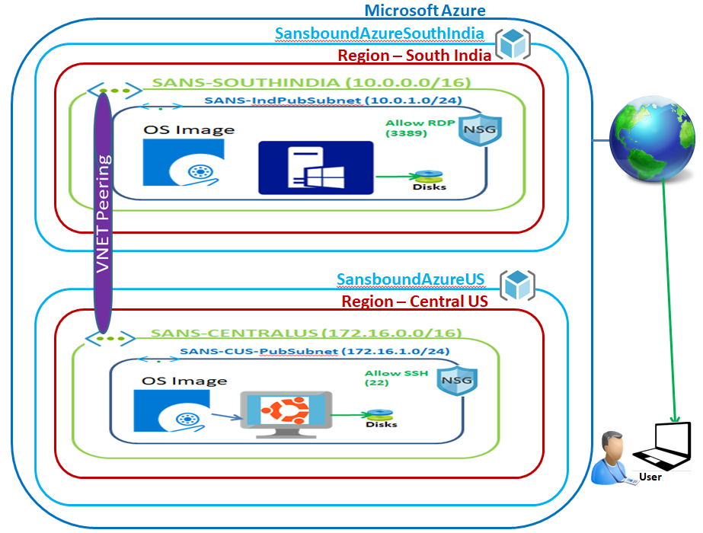

In Azure portal, click **“Resource group”**,

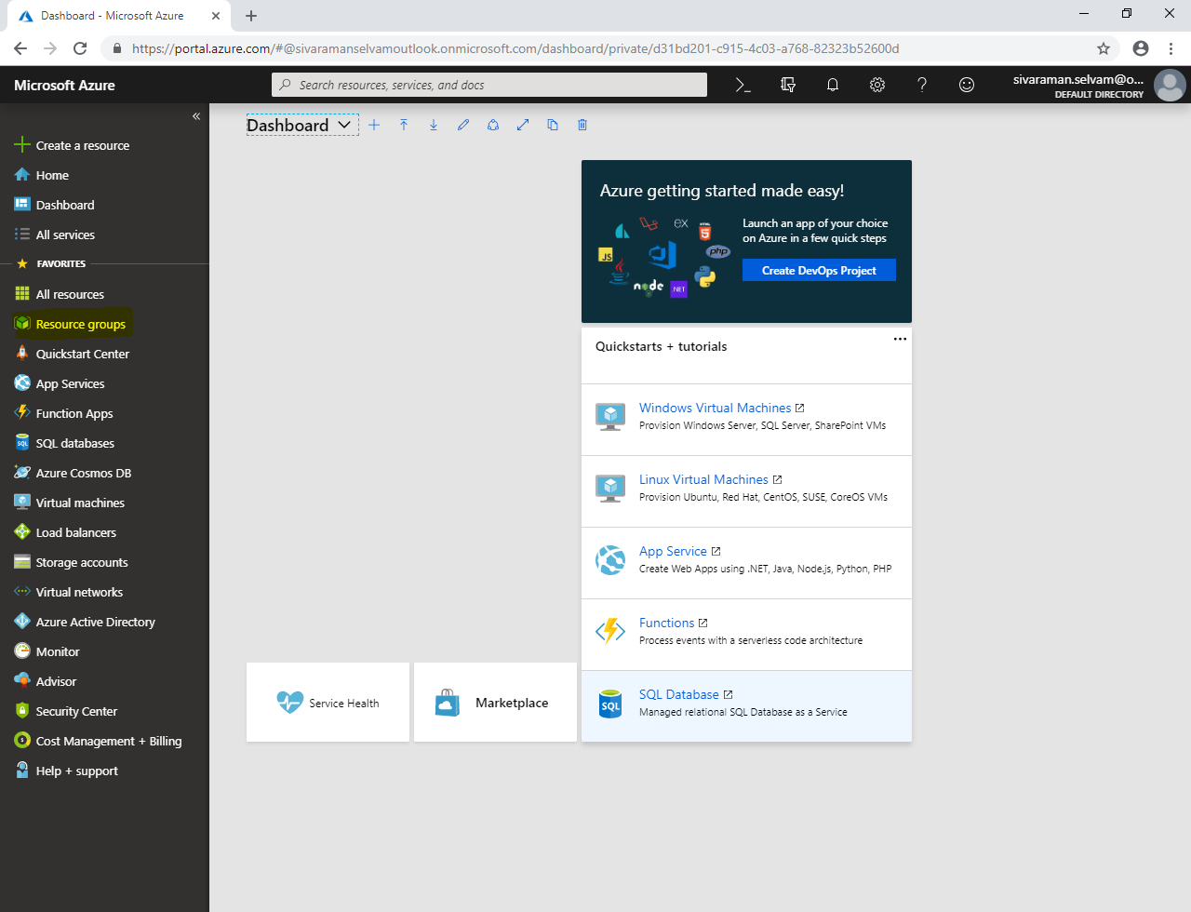

In **“Resource group”**, click **“Add”**.

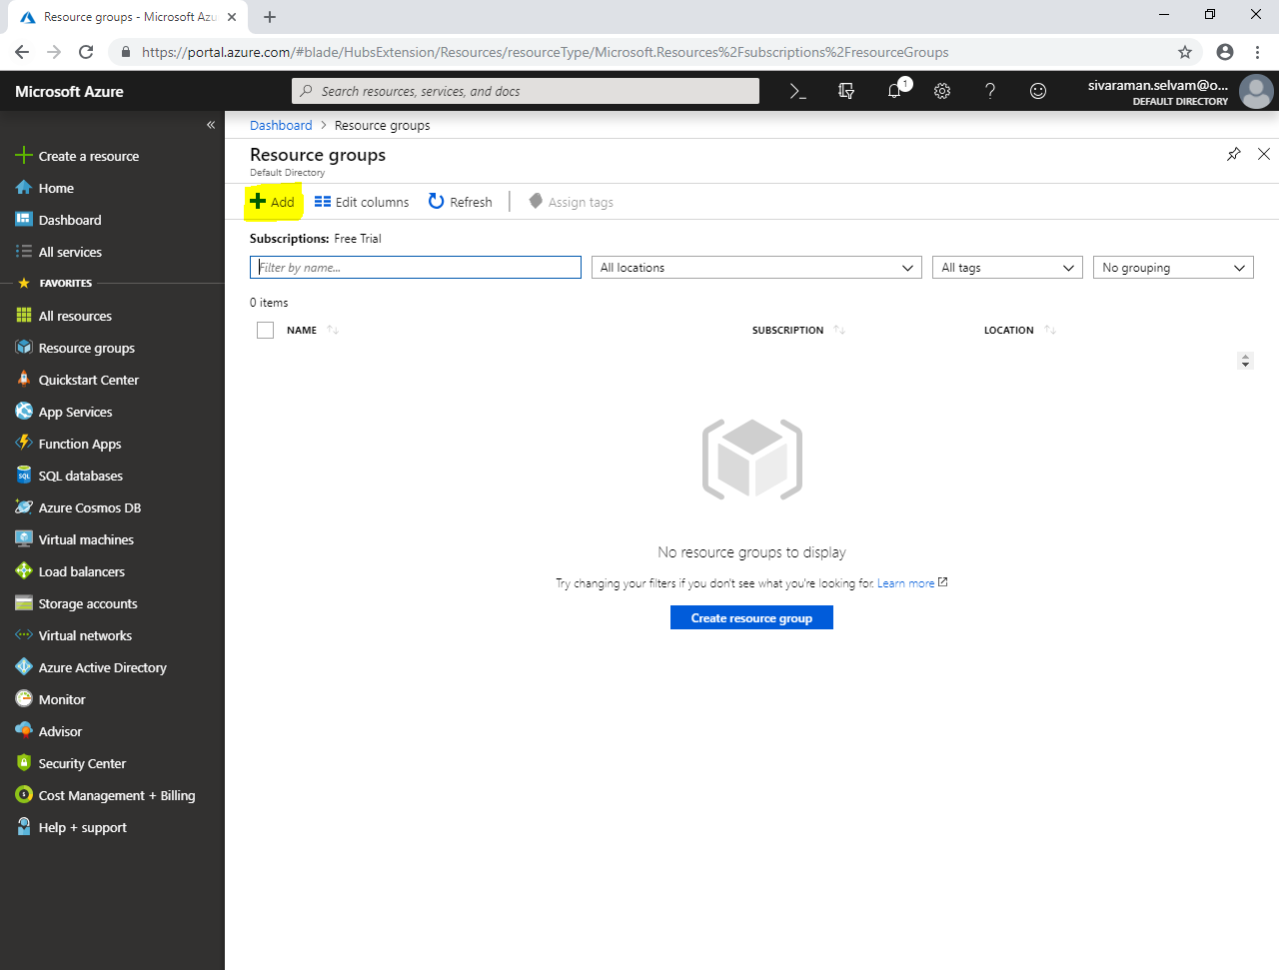

In **“Resource group”** type name as **“SansboundAzureSouthIndia”**.

Select **“Subscription”** as **“Free Trial”**.

Select **“Resource group location”** as **“South India”**.

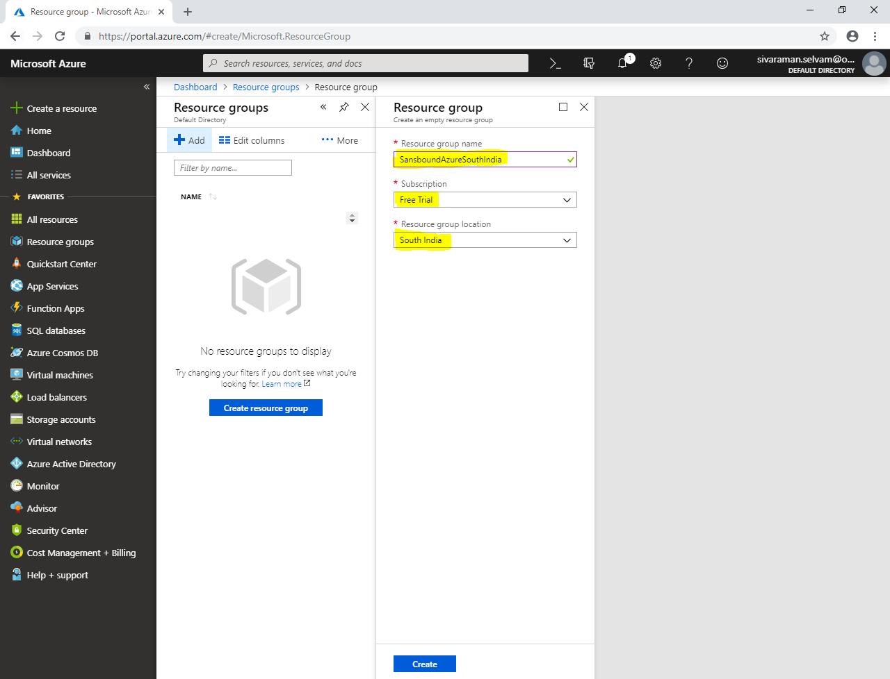

Click **“Create”**.

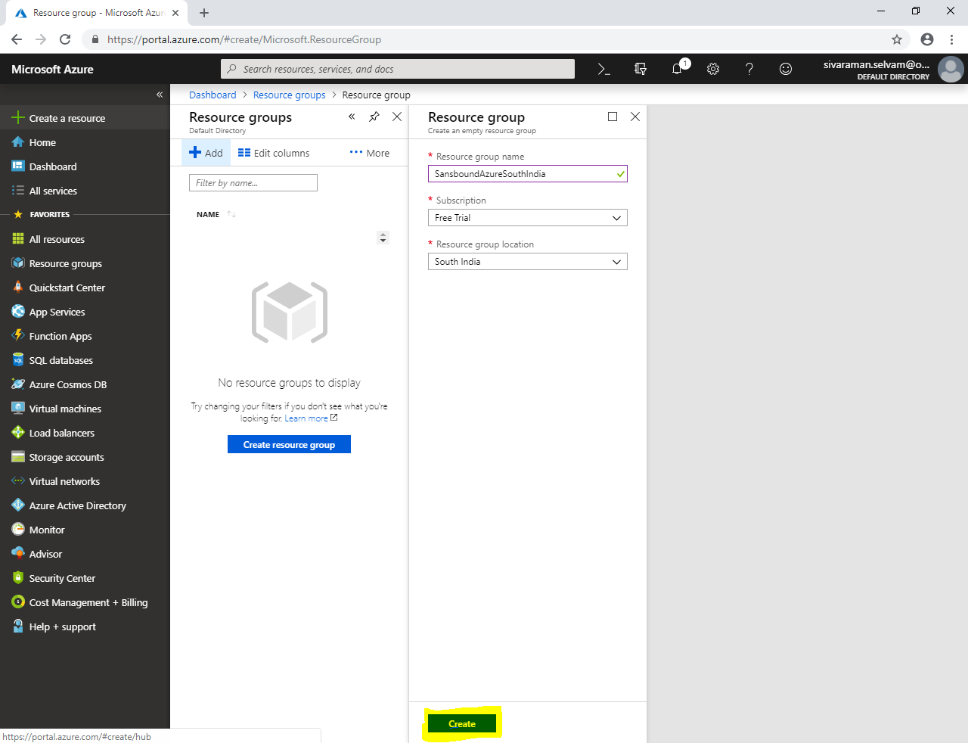

Click **“Virtual networks”** in left side panel.

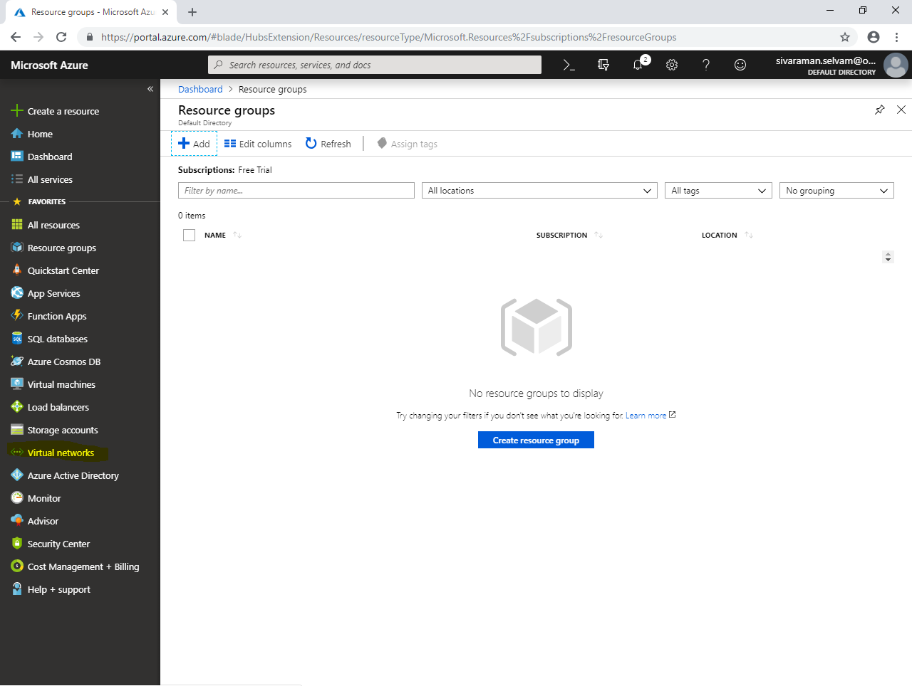

Type **“Virtual networks”** click **“Add”** to create a new virtual network.

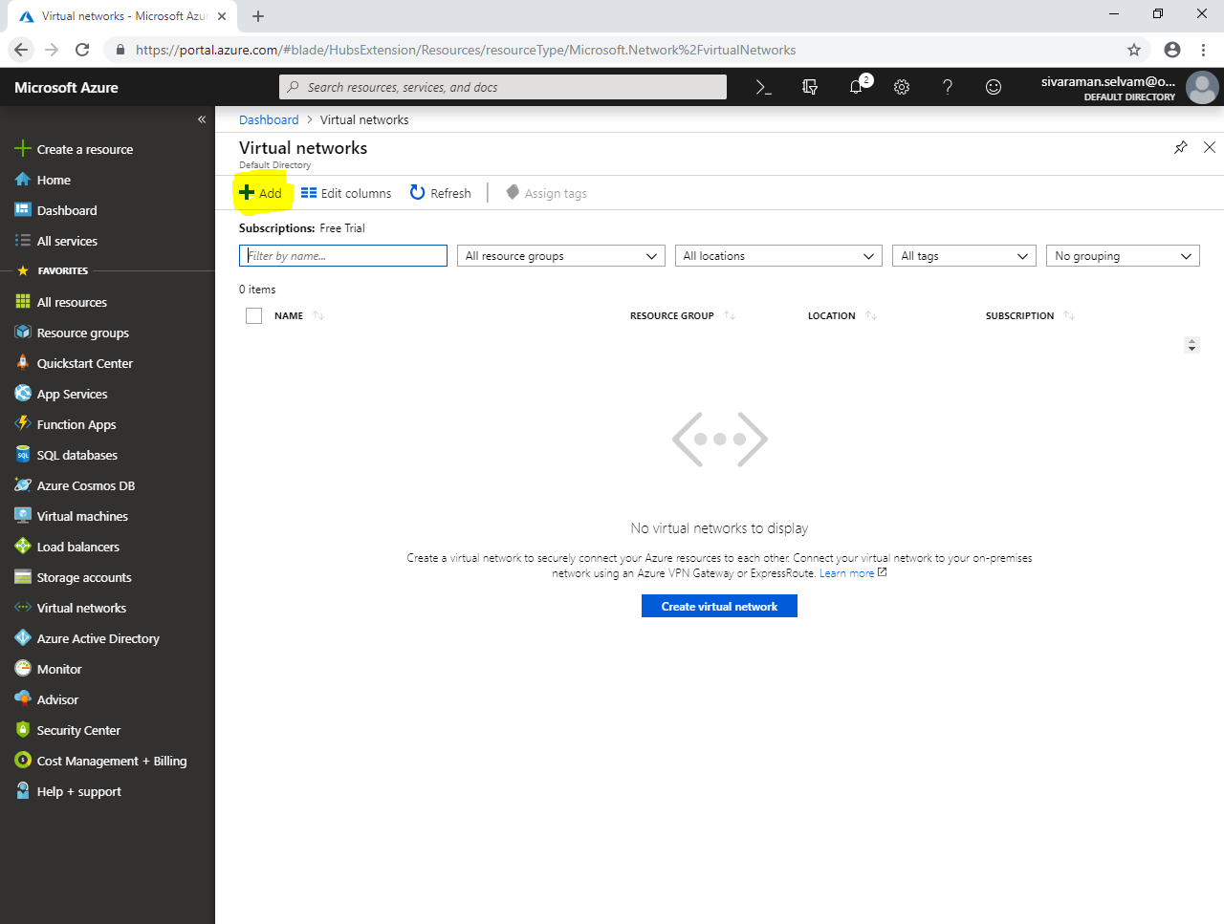

While create a virtual network, type **“Name”** as **“SANS-SOUTHINDIA”**.

Type **“Address space”** as **10.0.0.0/16**

Select **“Subscription”** as **“Free Trial”**.

Select **“Resource group”** as **“SansboundAzureSouthIndia”**.

Type **“Location”** as **“South India”**.

In **“Subnet”** name as **“Sans-IndPubSubnet”**.

Type **“Address range”** for the Subnet as **10.0.1.0/24**.

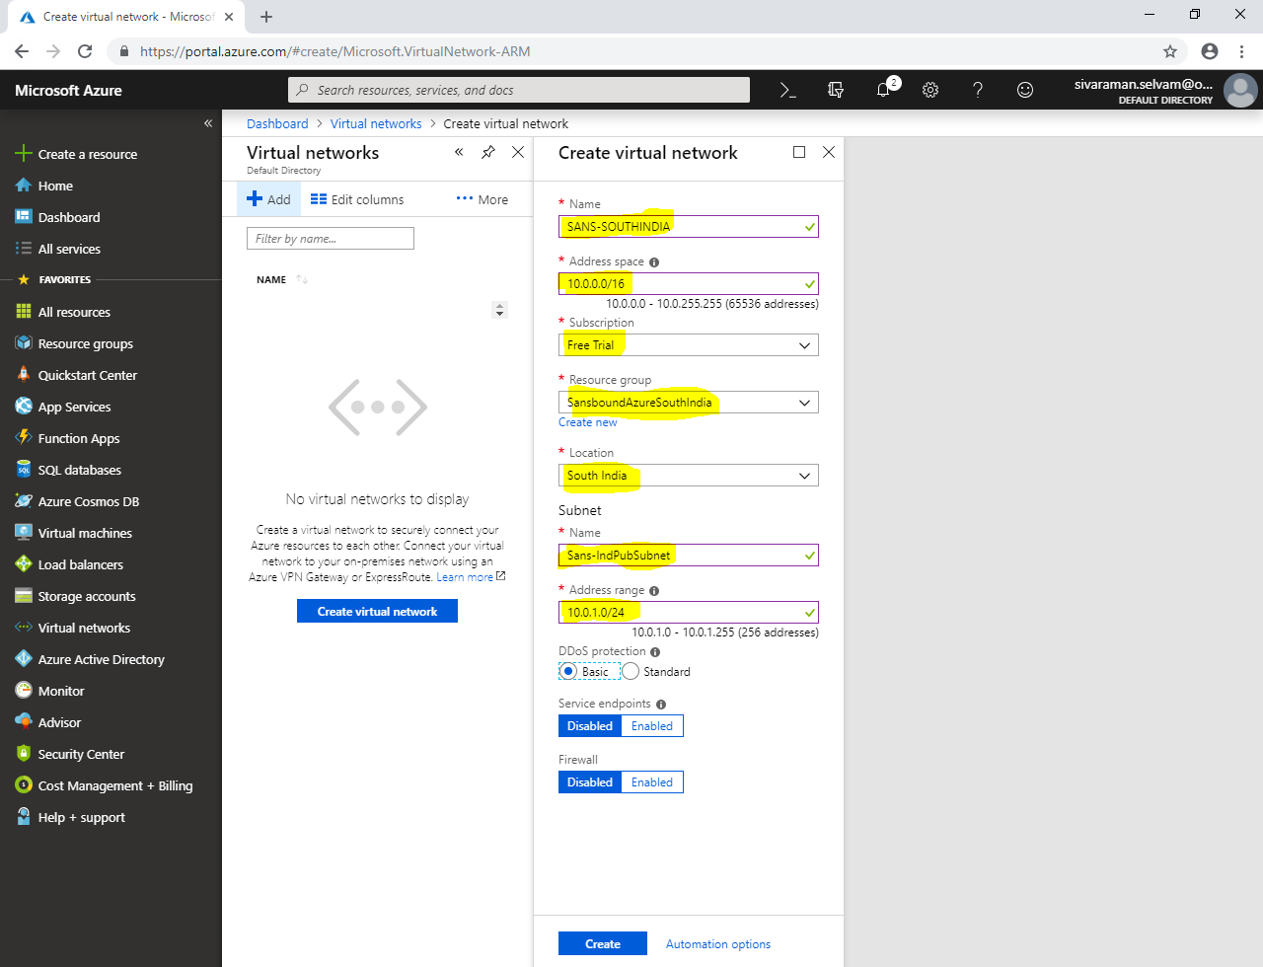

Click **“Create”**.

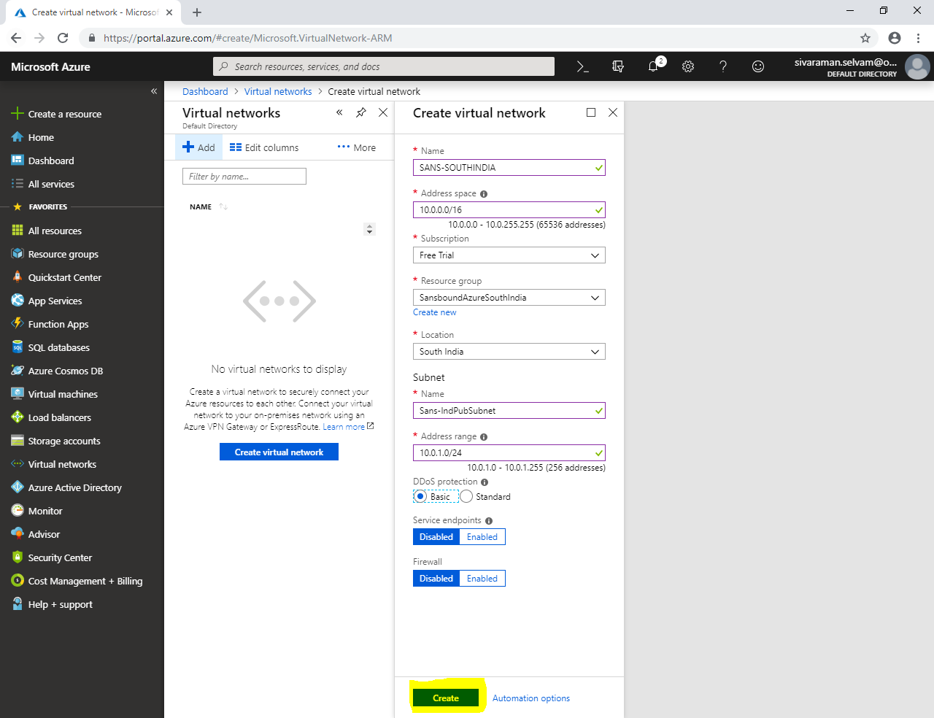

Click **“All resources”**.

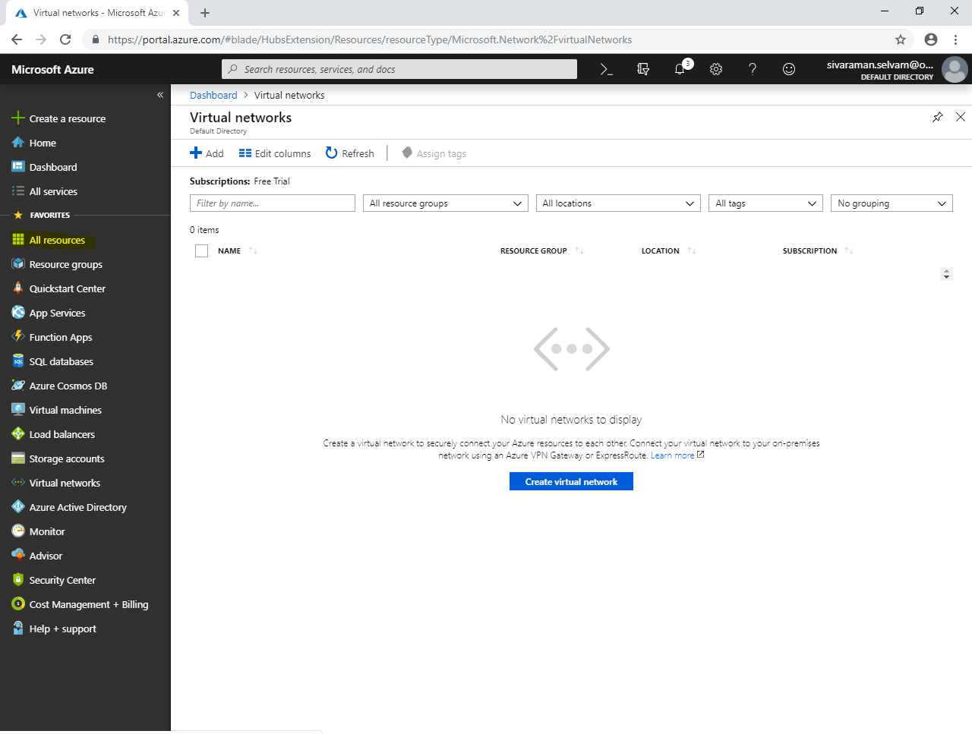

In **“All resources”**,

Click **“Add”**.

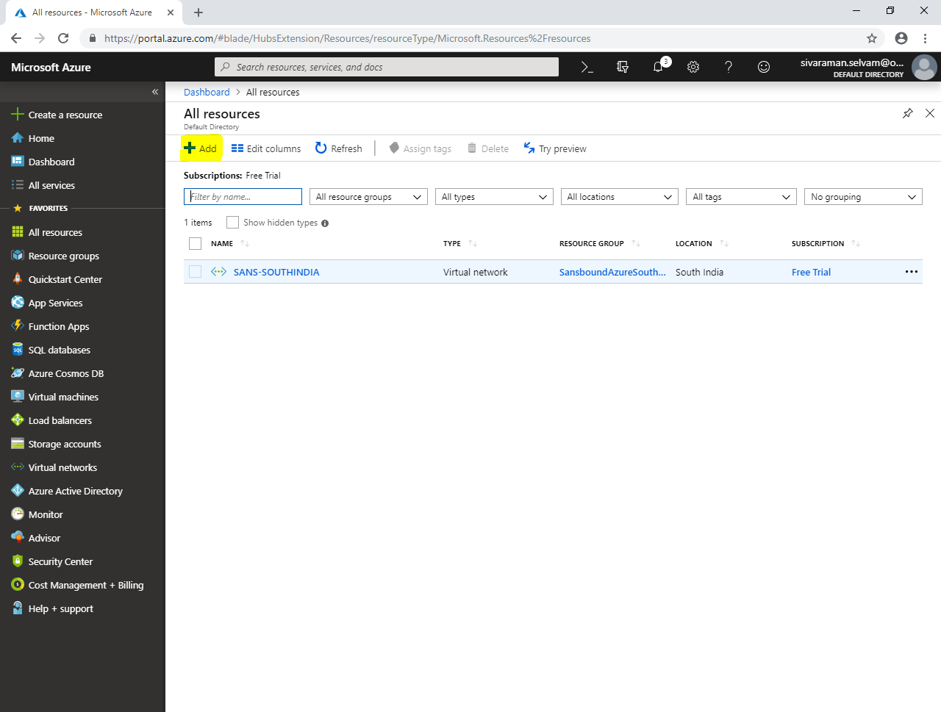

Click in **“Networking”**,

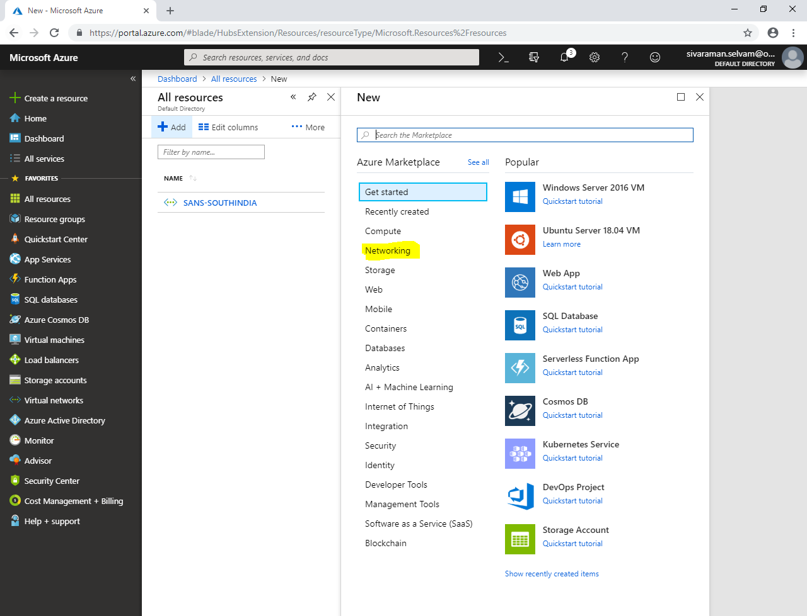

Click **“Network security group”**.

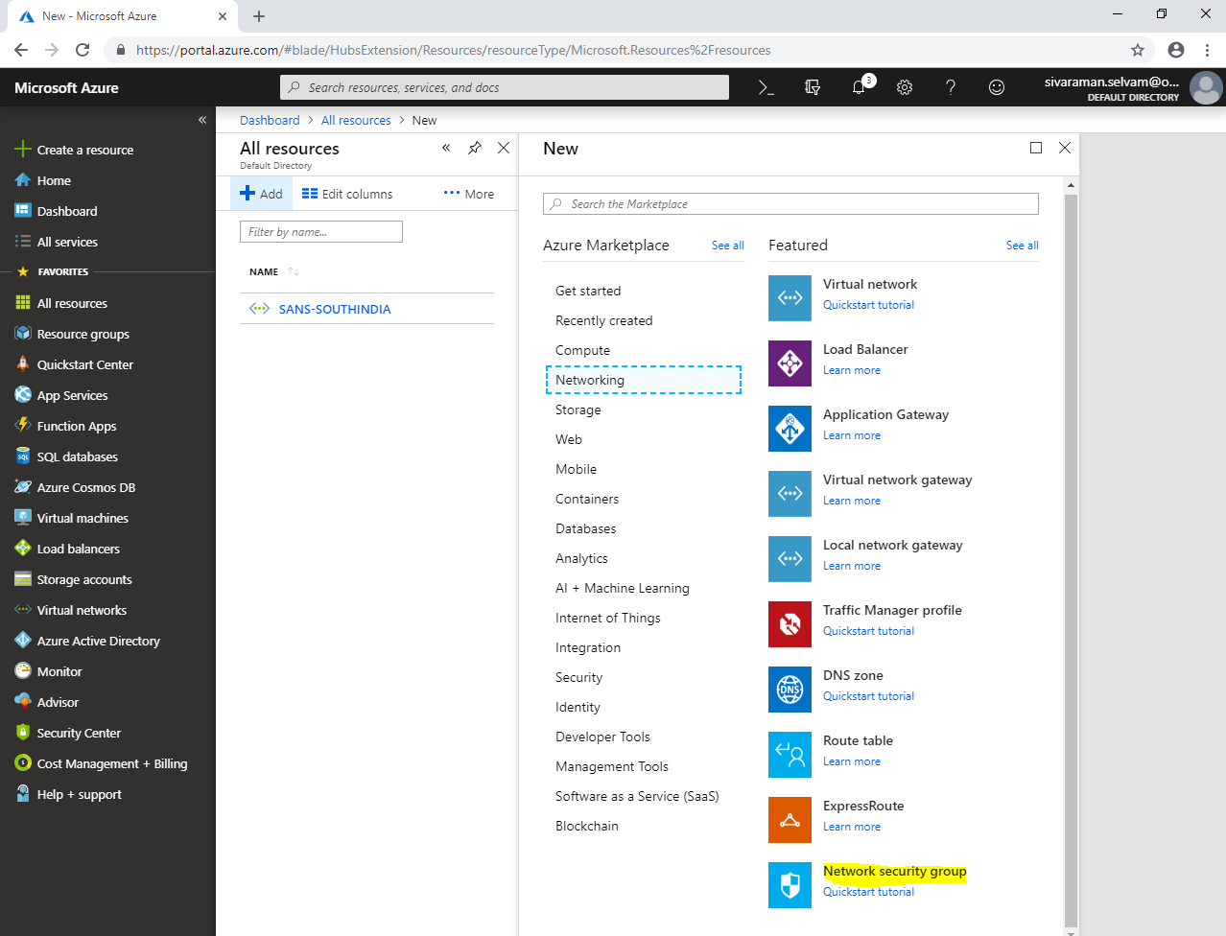

While create network security group,

Type **“Name”** as **“SANS-SI-NSG”**.

Select **“Subscription”** as **“Free Trial”**.

Select **“Resource group”** as **“SansboundAzureSouthIndia”**.

Select **“Location”** as **“South India”**.

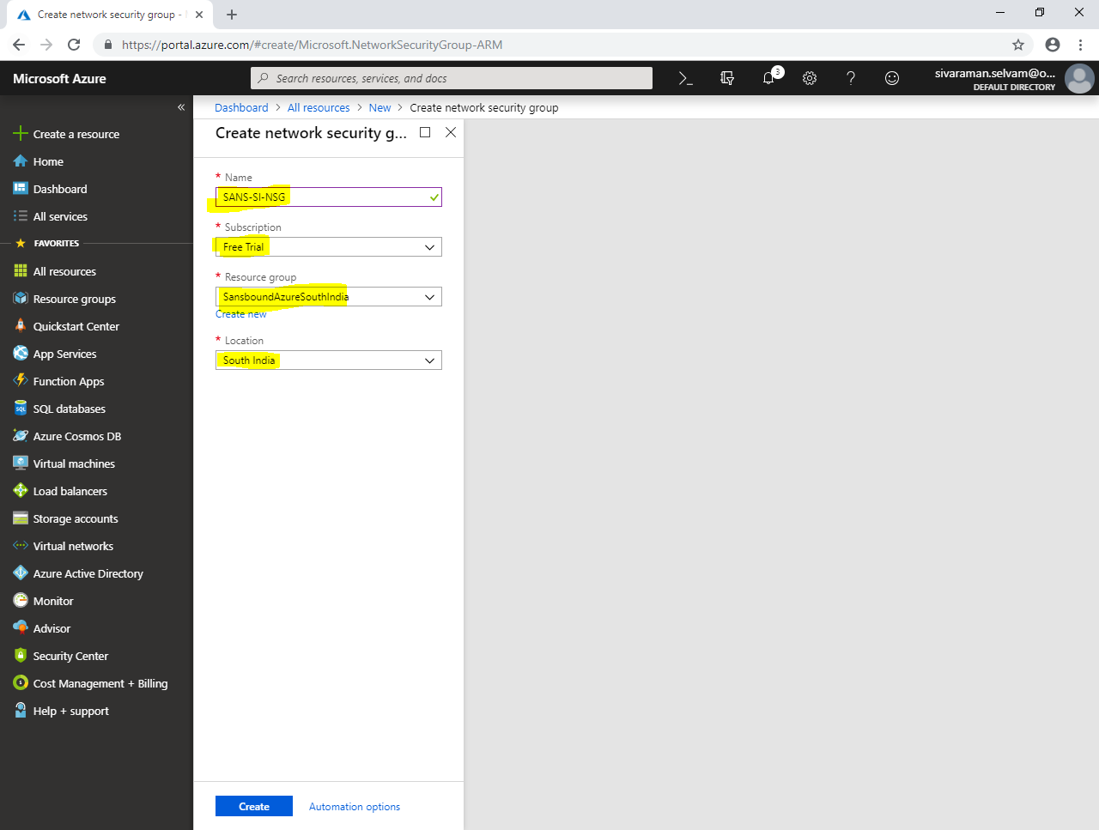

You are able to see that **“SANS-SI-NSG”** has been created.

Click **“SANS-SI-NSG”**.

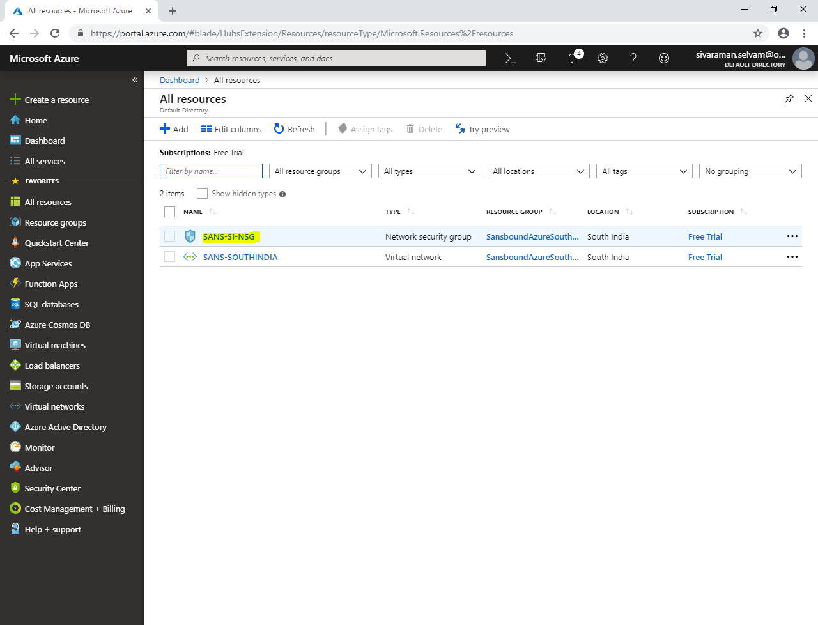

In **“SANS-SI-NSG”** network security group,

Click **“Inbound security rules”,**

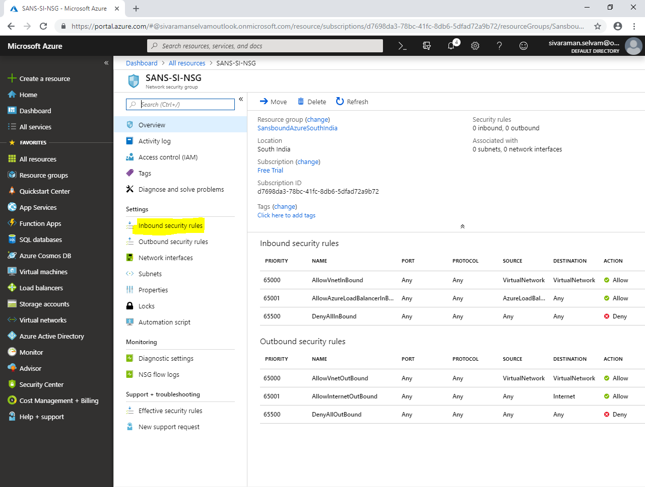

In **“Inbound security rules”**

Click **“Add”**.

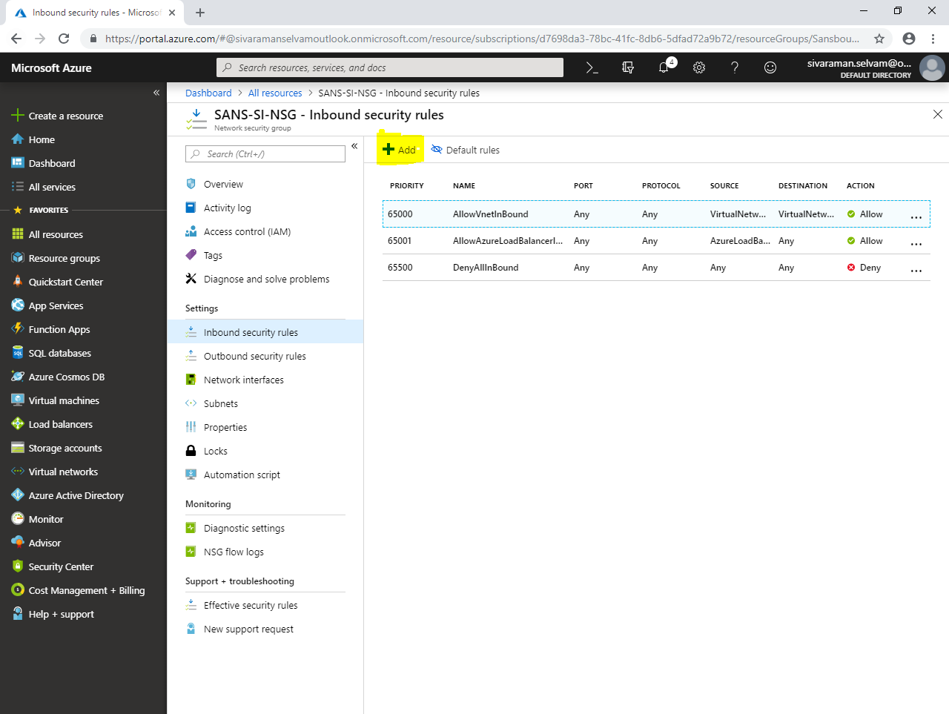

While **“Add inbound security rule”**,

Select **“Source”** as **“Any”**.

Specify **“Source port ranges”** at **“*”**.

Select **“Destination”** as **“Any”**.

Specify **“Destination port ranges”** as **“3389”**.

Click **“Protocol”** on **“TCP”.**

Ensure **“Priority”** as **“100”**

Type **“Name”** as **“Allow-RDP”**.

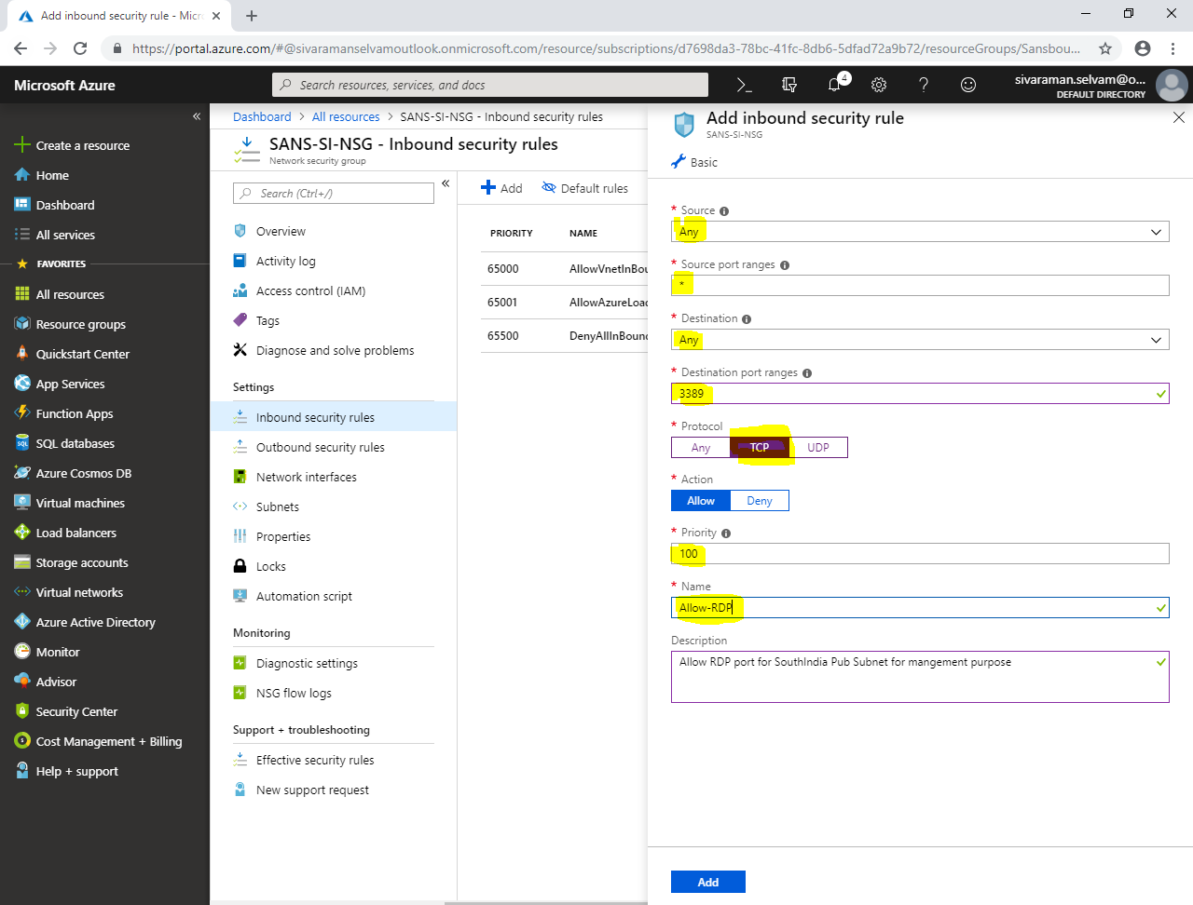

Click **“Add”**.

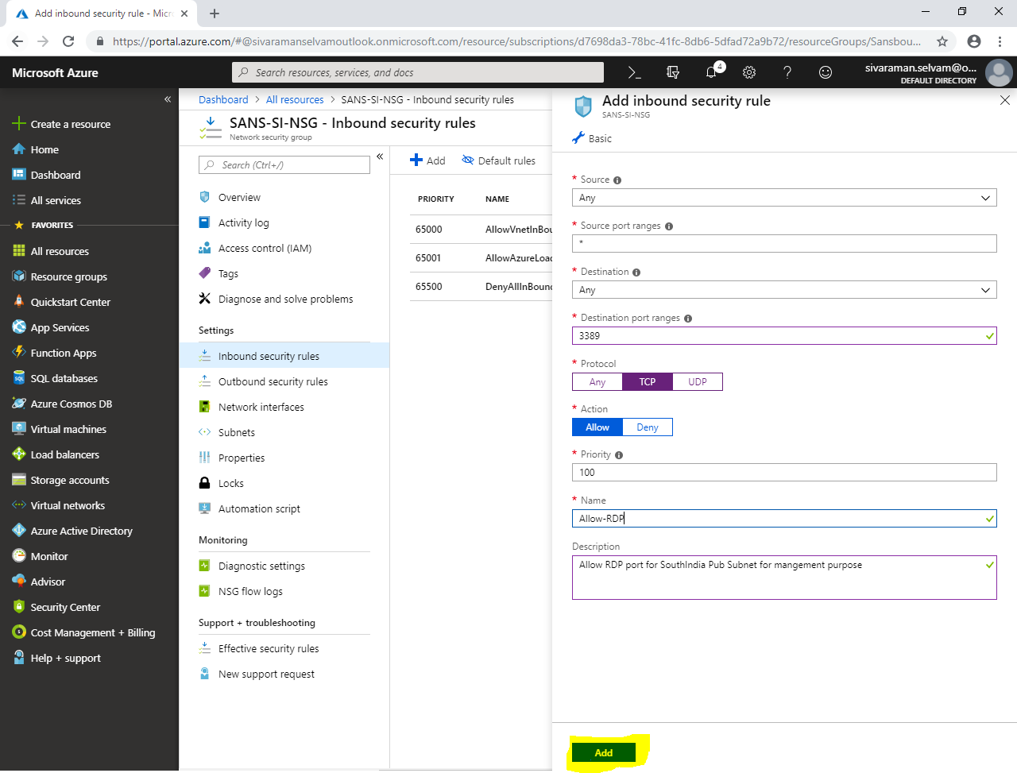

In **“SANS-SI-NSG”**,

Click **“Subnets”**.

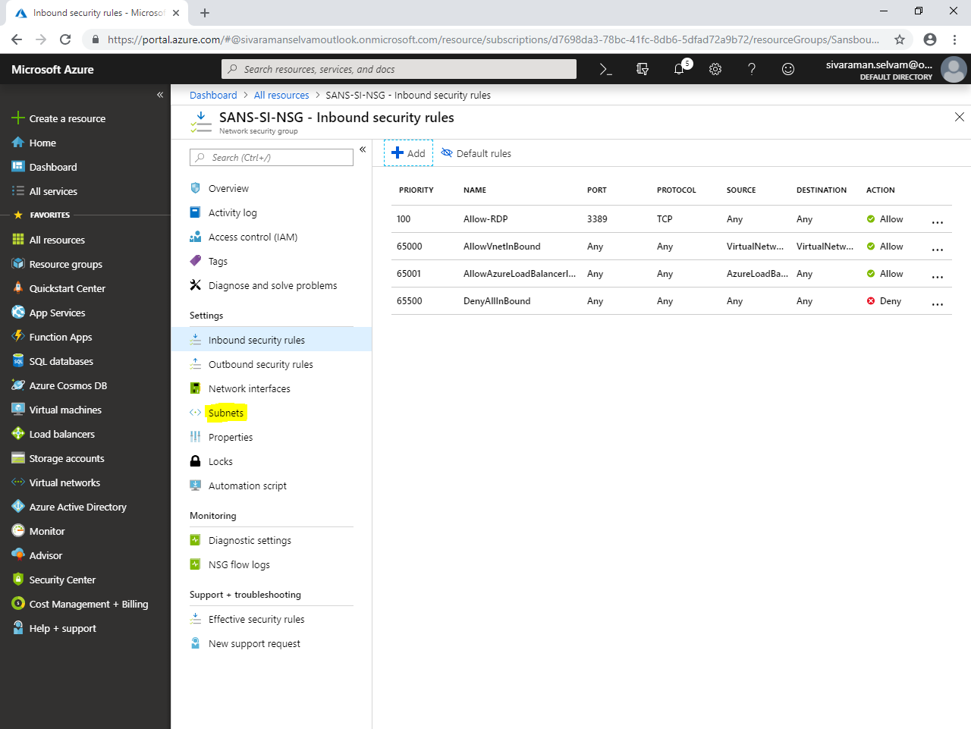

In **“Subnets”**,

Click **“Associate”**.

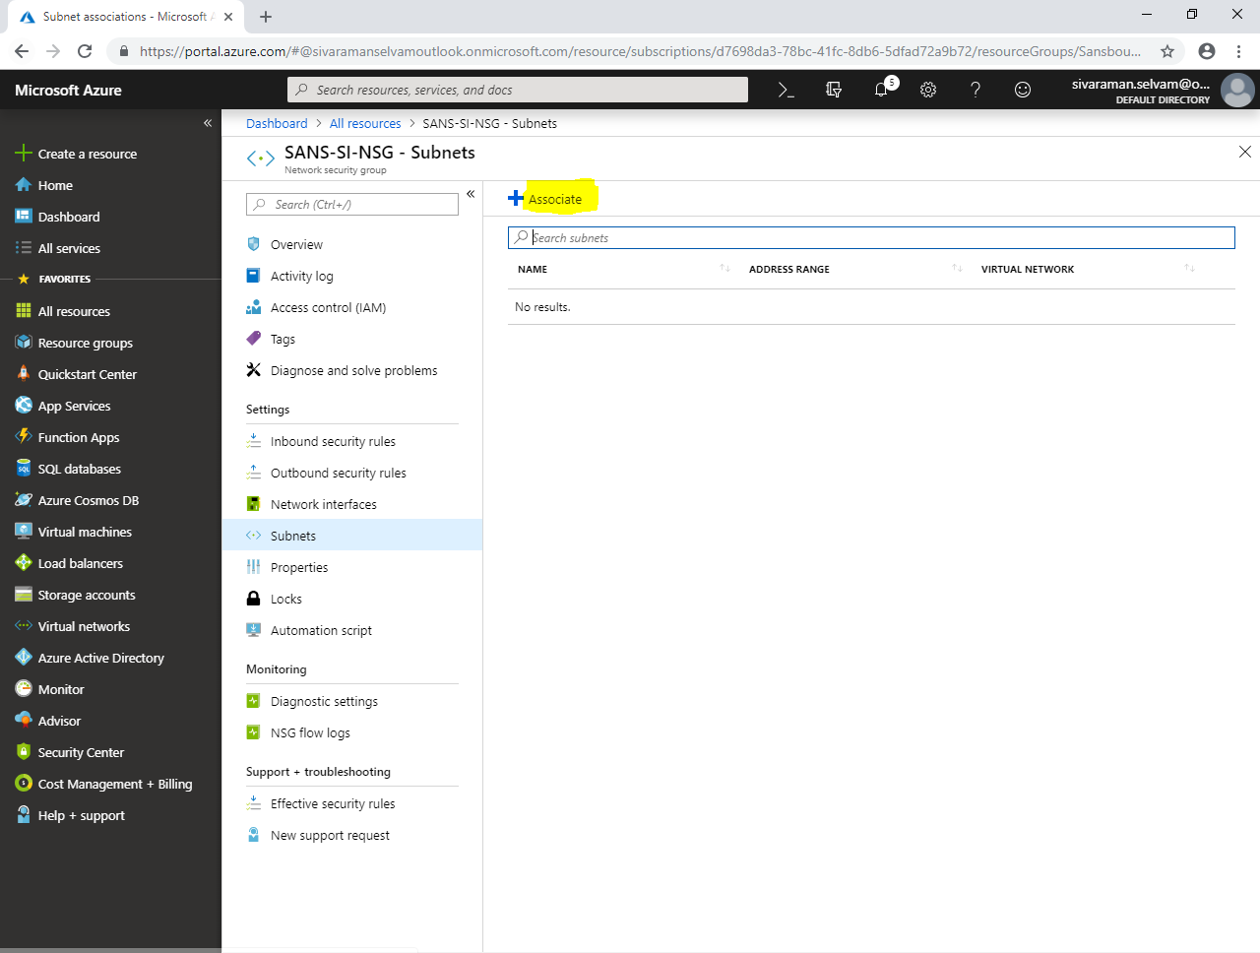

While **“Associate subnet”**,

Click **“Choose a virtual network”**.

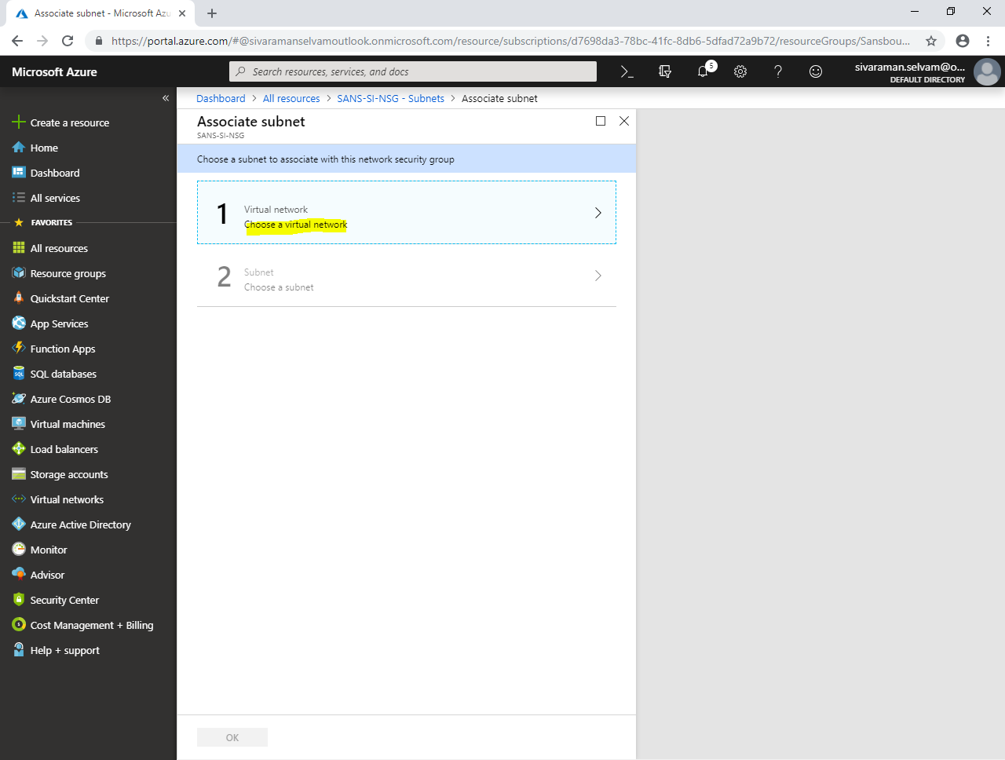

Click **“SANS-SOUTHINDIA”**.

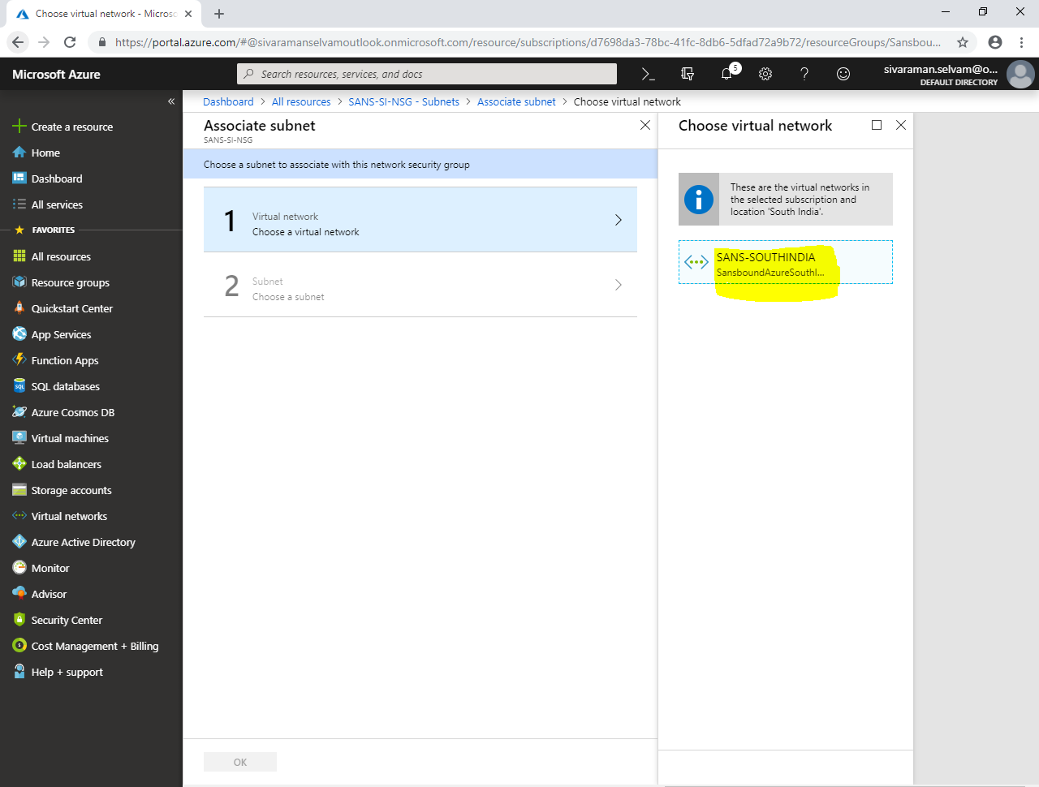

In **“Choose a subnet”**,

Click **“Sans-IndPubSubnet”**.

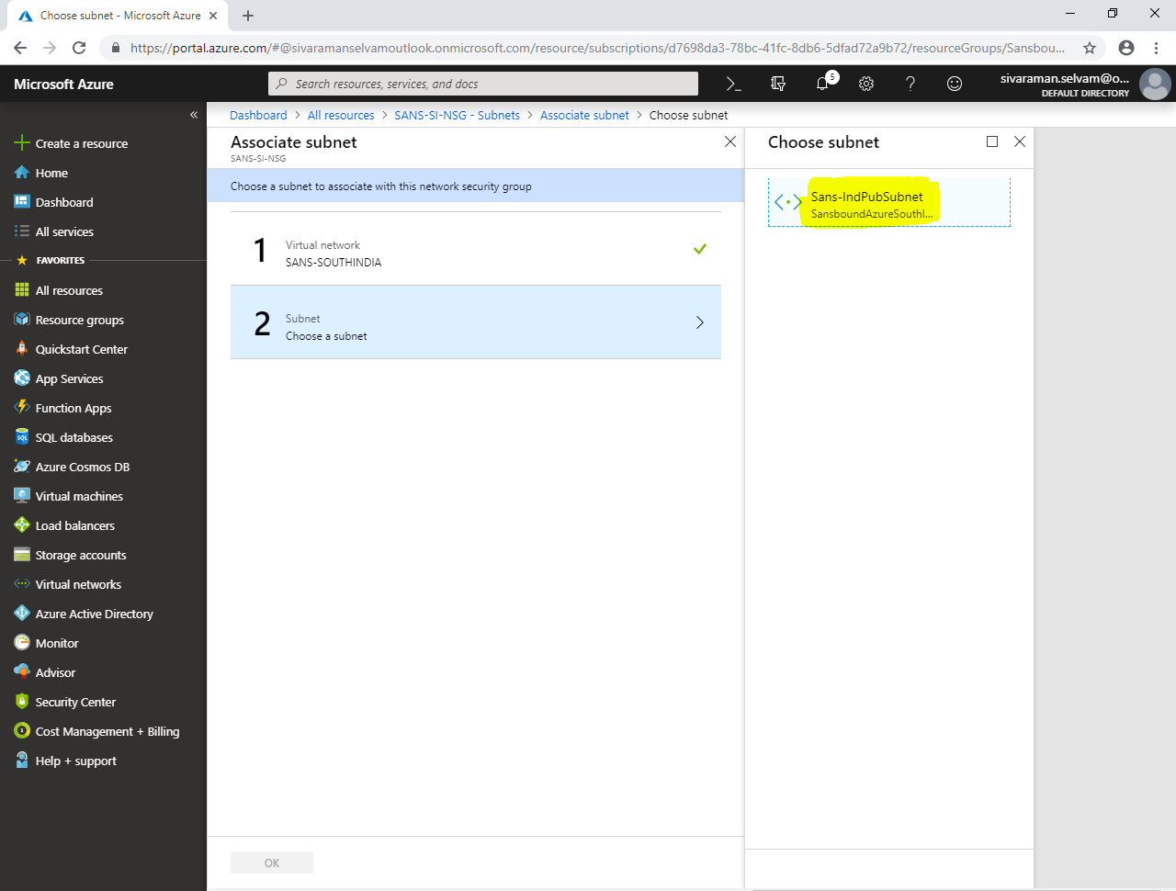

Click **“Ok”**.

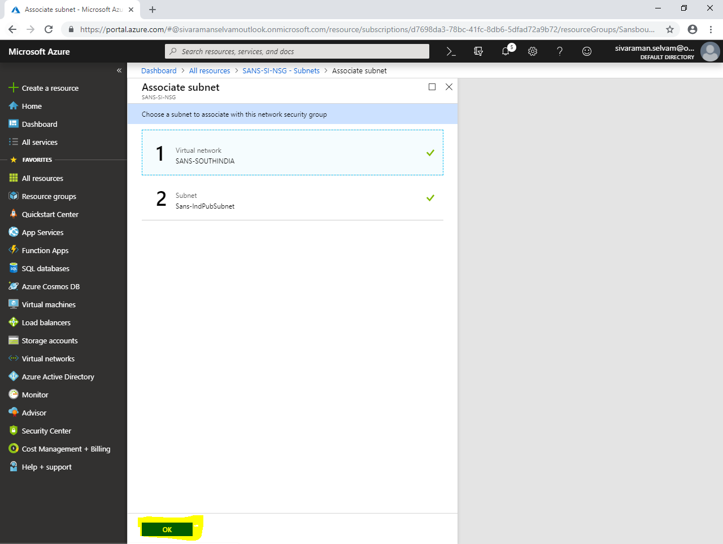

You are able to see that **“Sans-IndPubSubnet”** has been associated for **“SANS-SI-NSG”** network security Group.

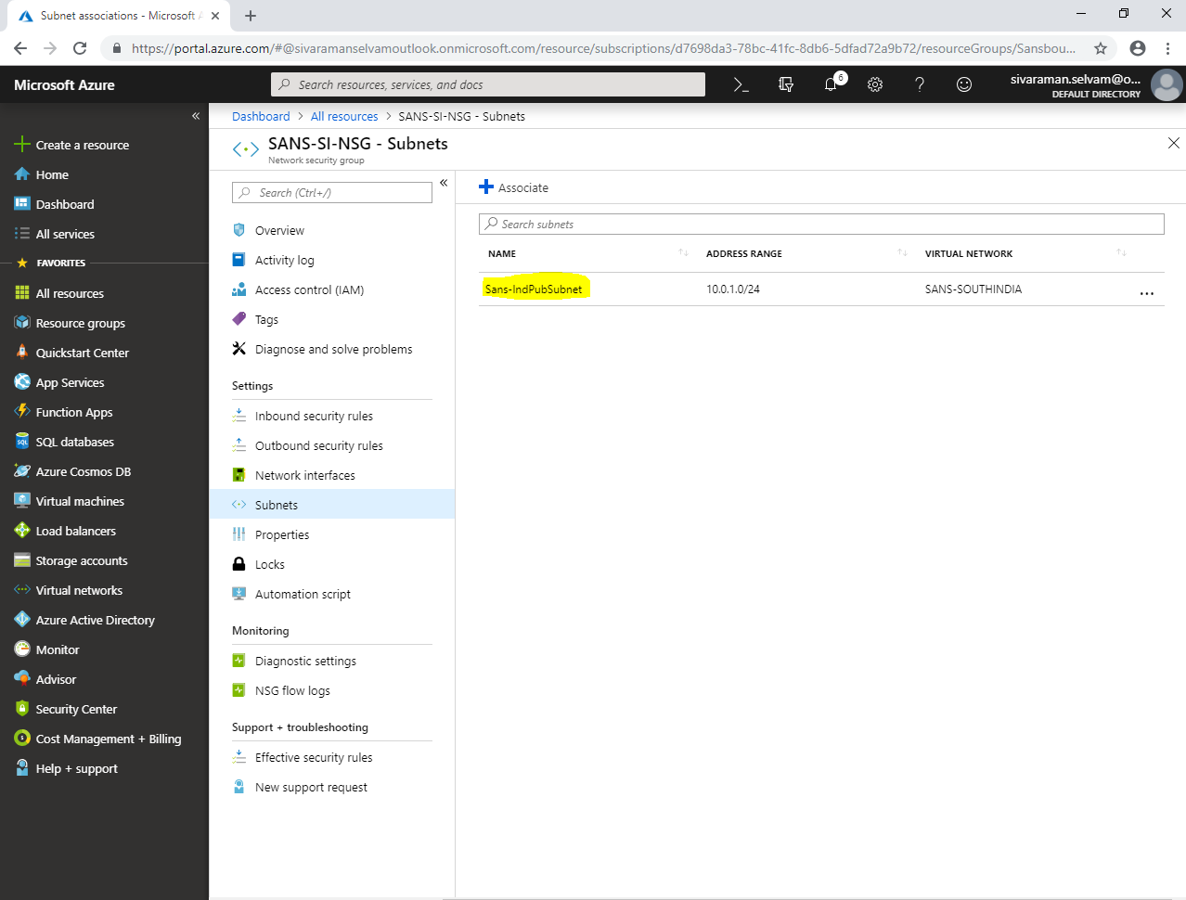

Click **“Virtual machines”** in left side panel.

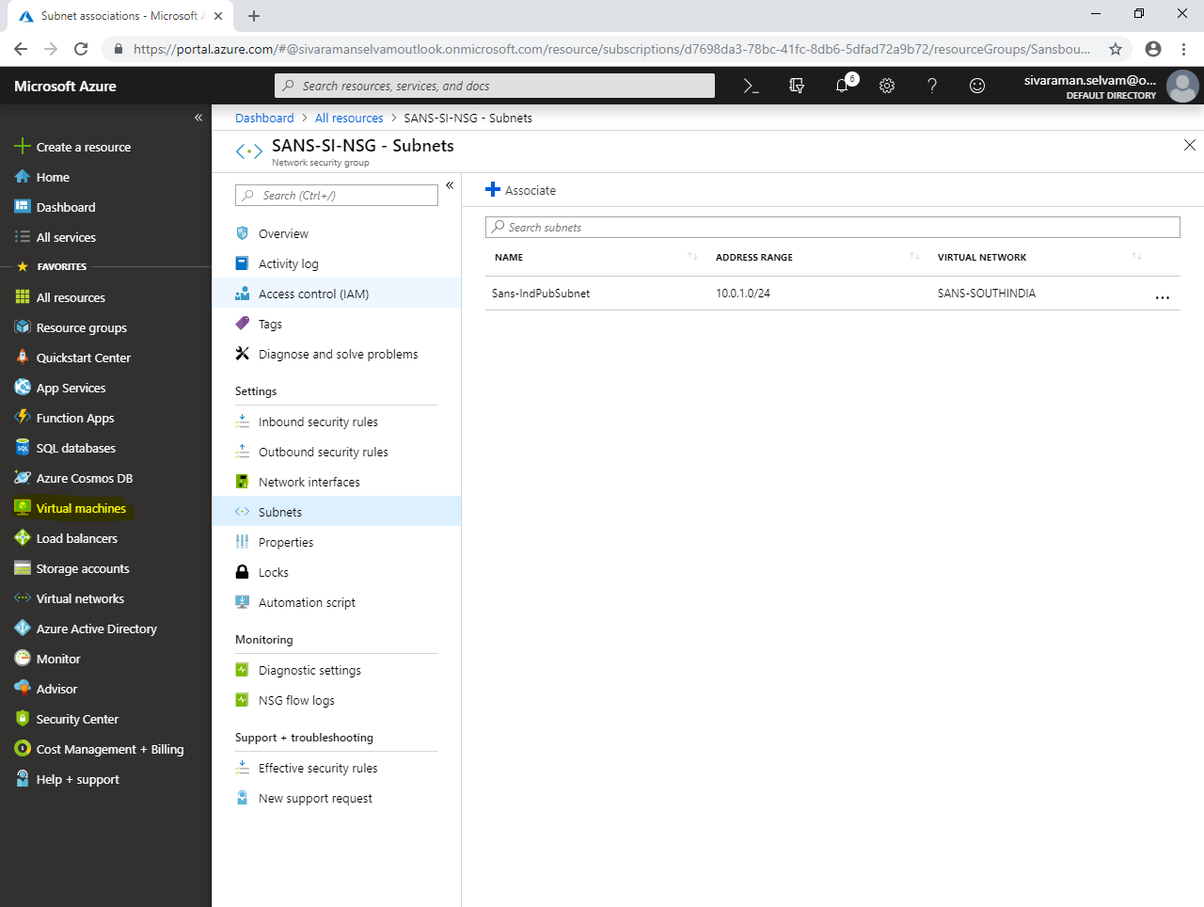

In **“Virtual machines”**,

Click **“Add”**.

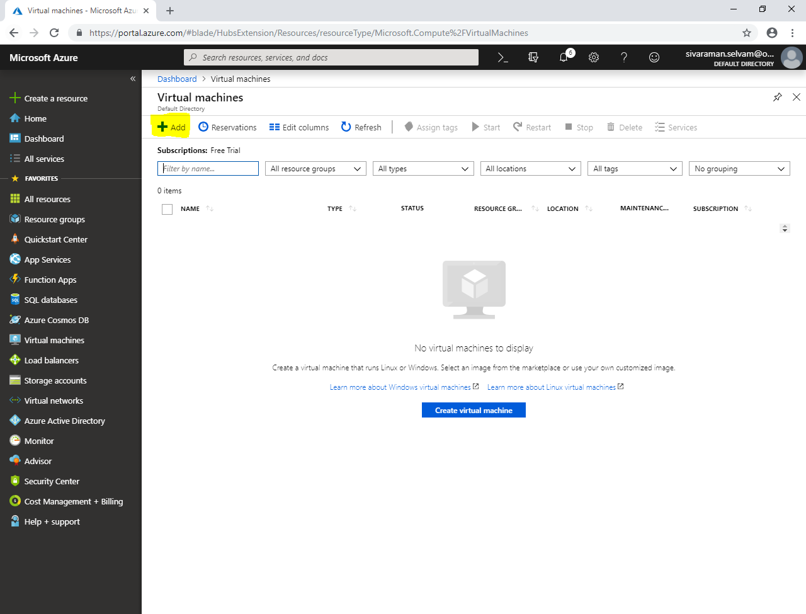

While create a virtual machine,

Select **“Subscription”** as **“Free Trial”**.

Select **“SansboundAzureSouthIndia”**.

Type **“Virtual machine name”** as **“SANSVM-WIN-SI”**.

Select **“Region”** as **“South India”**.

Select **“Image”** as **“Windows 2008 R2 SP1”**.

Change **“VM Size”** as **“Standard B1s”**.

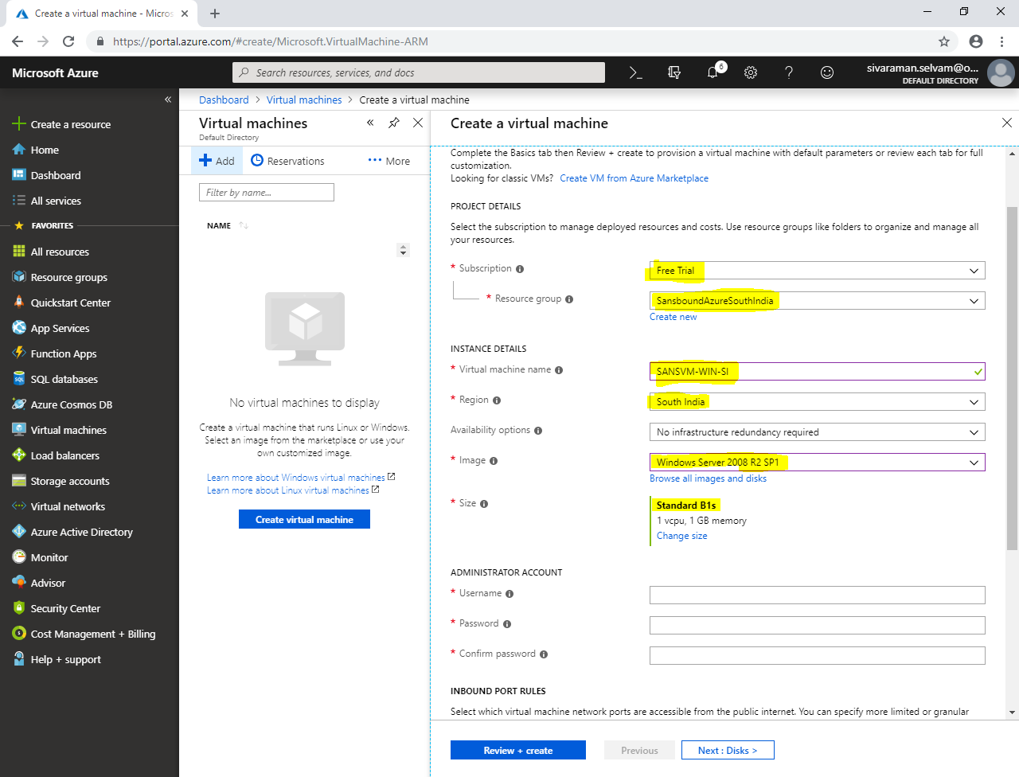

In **“Administrator Account”**,

Type **“Username”** as **“sansbound”**.

In **“Inbound port rules”** as **“None”**.

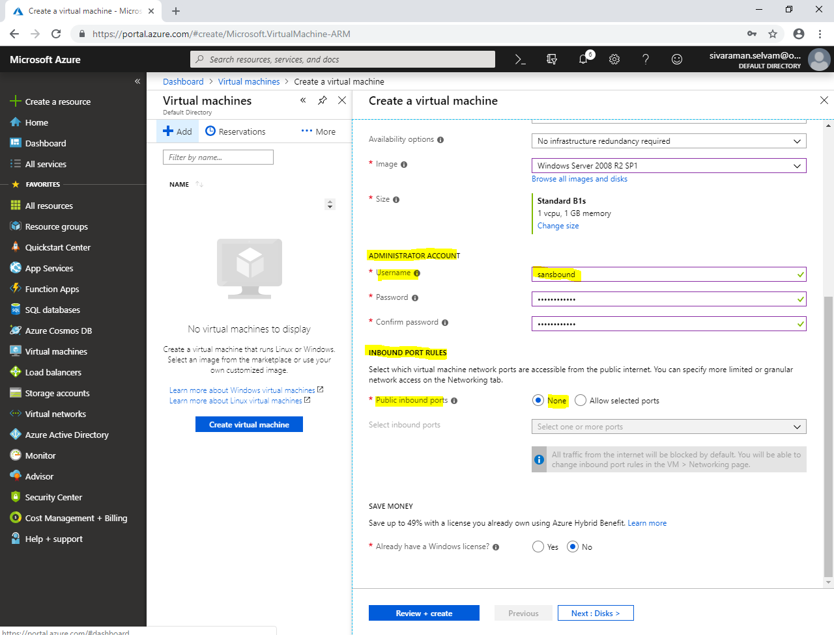

In **“Save Money”**,

Click **“Yes”** for Already have a Windows license.

Need to check **“Confirmation”** box.

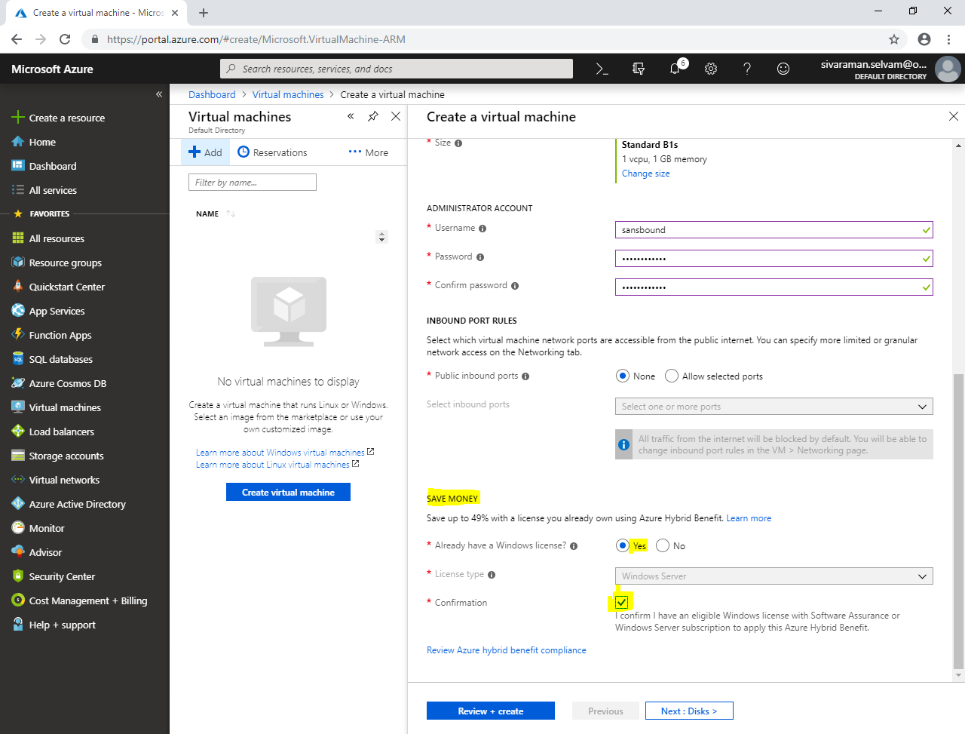

Click **“Next : Disks >”**.

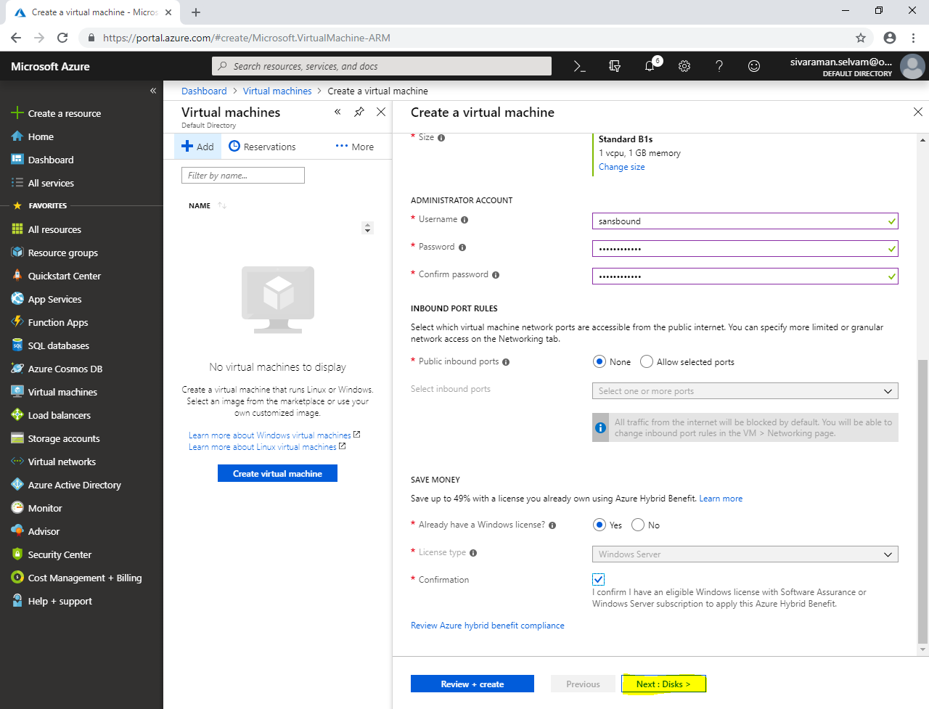

In **“Disks”**,

Click **“Next : Networking>”**.

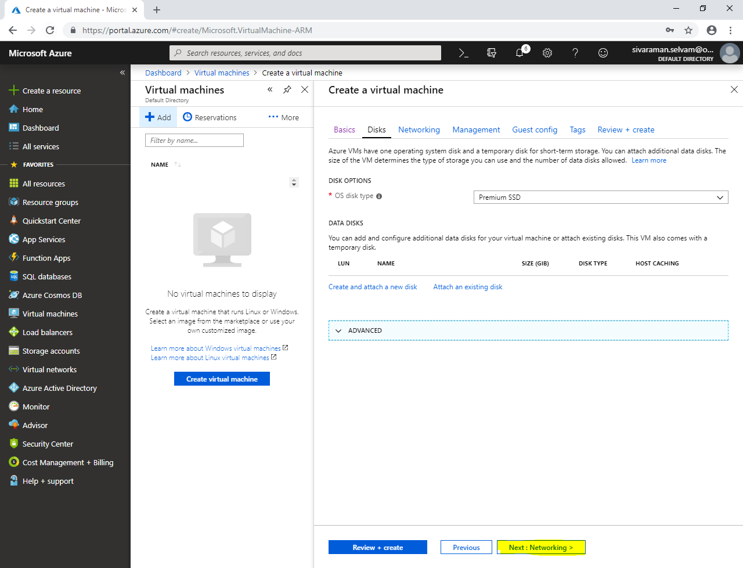

In **“Networking”**,

Ensure that **“Virtual network”** as **“SANS-SOUTHINDIA”**.

Ensure **“Subnet”** as **“Sans-IndPubSubnet”**.

Ensure Pubic IP is set.

Ensure **“NIC Network security group”** as **“None”**. (Because we have already created network security group named SANS-SI-NSG” and associated it to Sans-IndPubSubnet”.

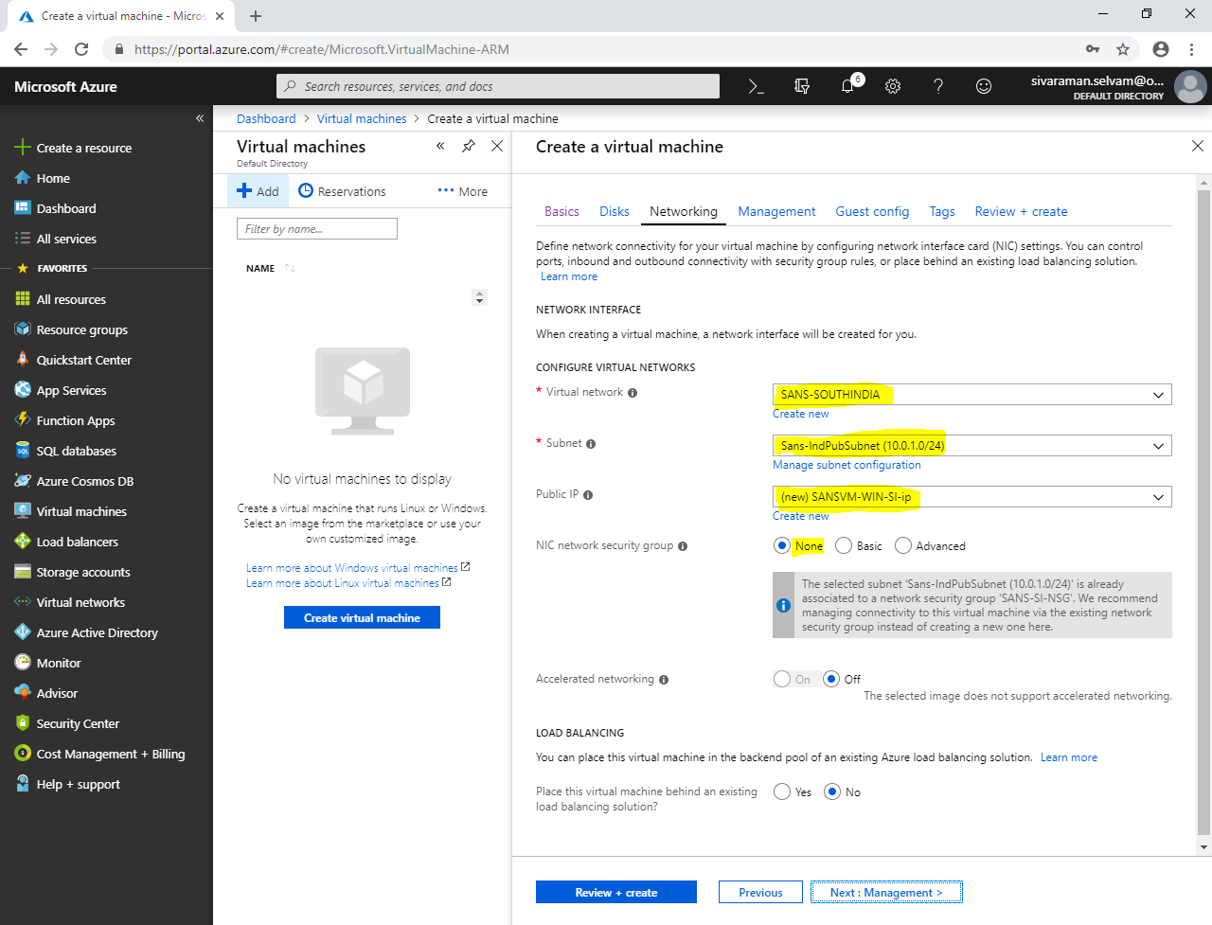

Click **“Next : Management> ”.**

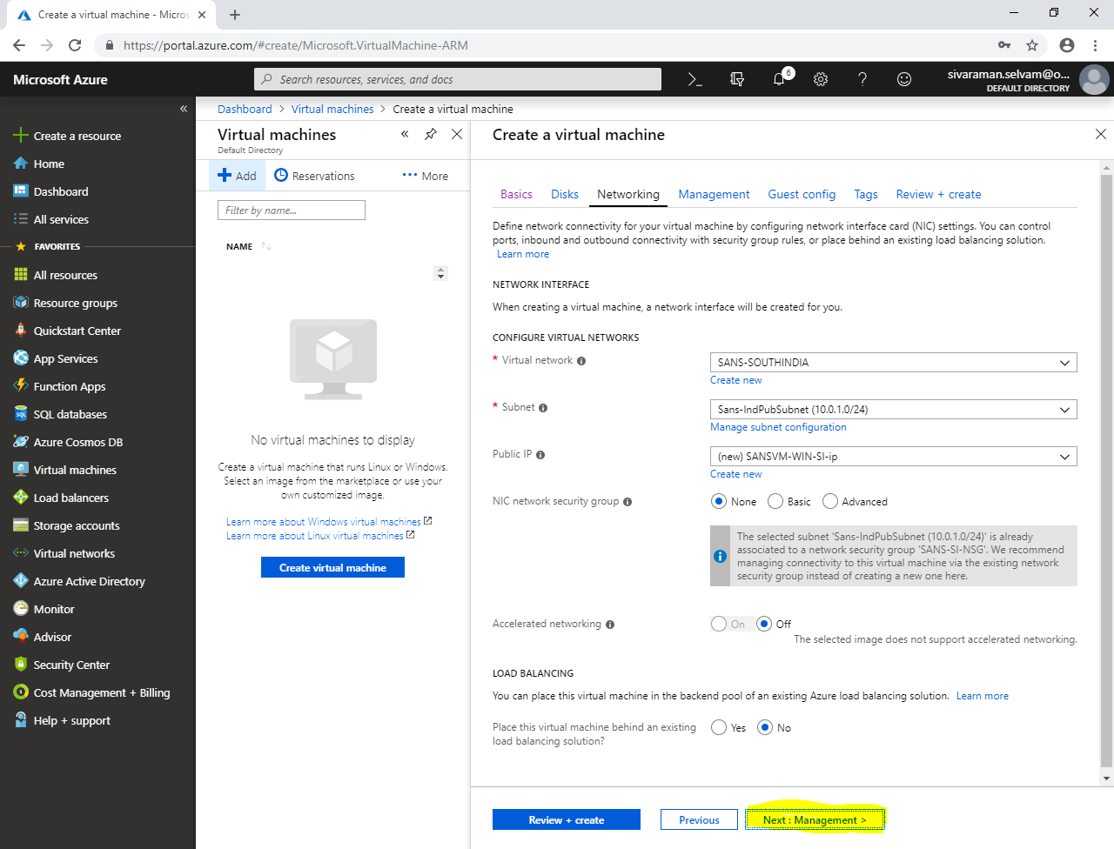

In **“Management”**,

Click **“Next : Guest config >”**.

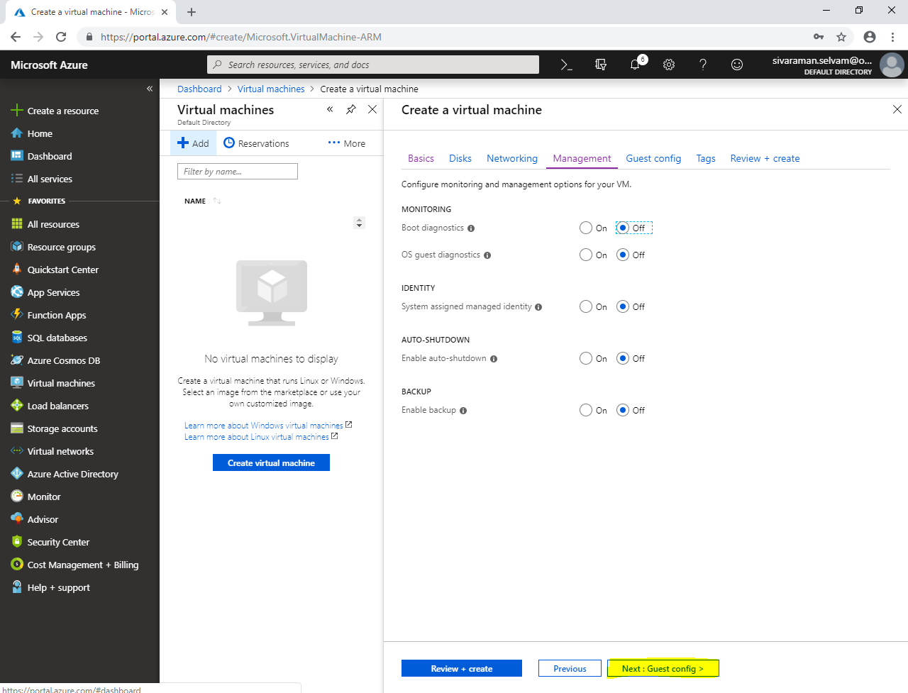

In **“Guest config”**,

Click **“Next : Tags >”**.

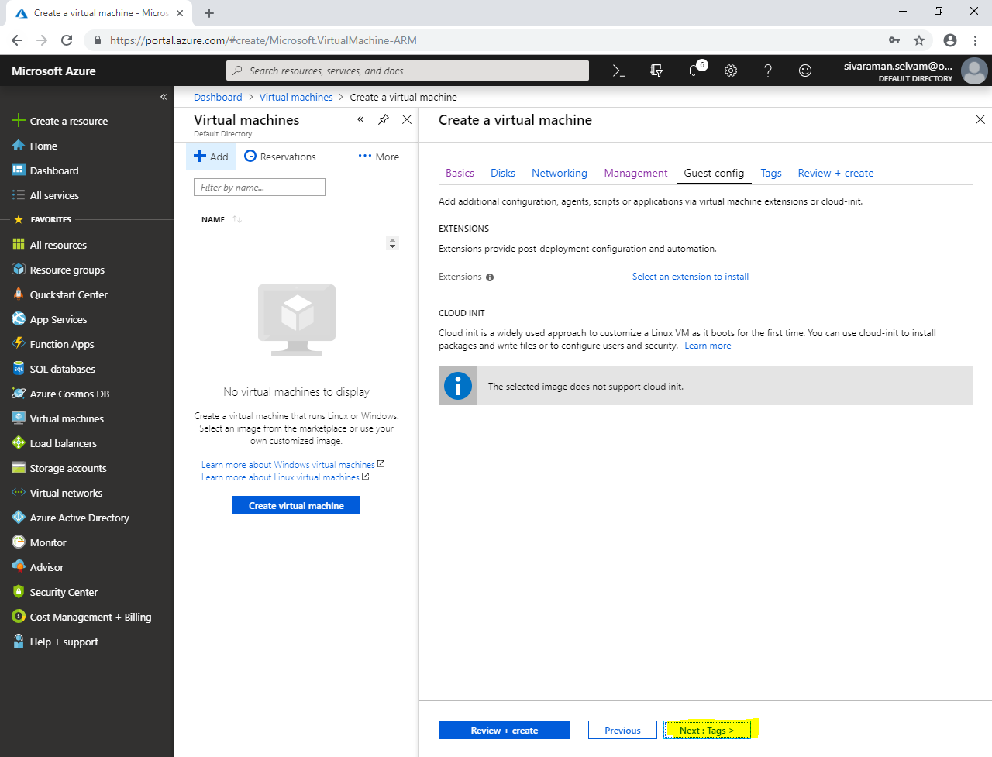

In **“Tags”**,

Click **“Next : Review + create”**.

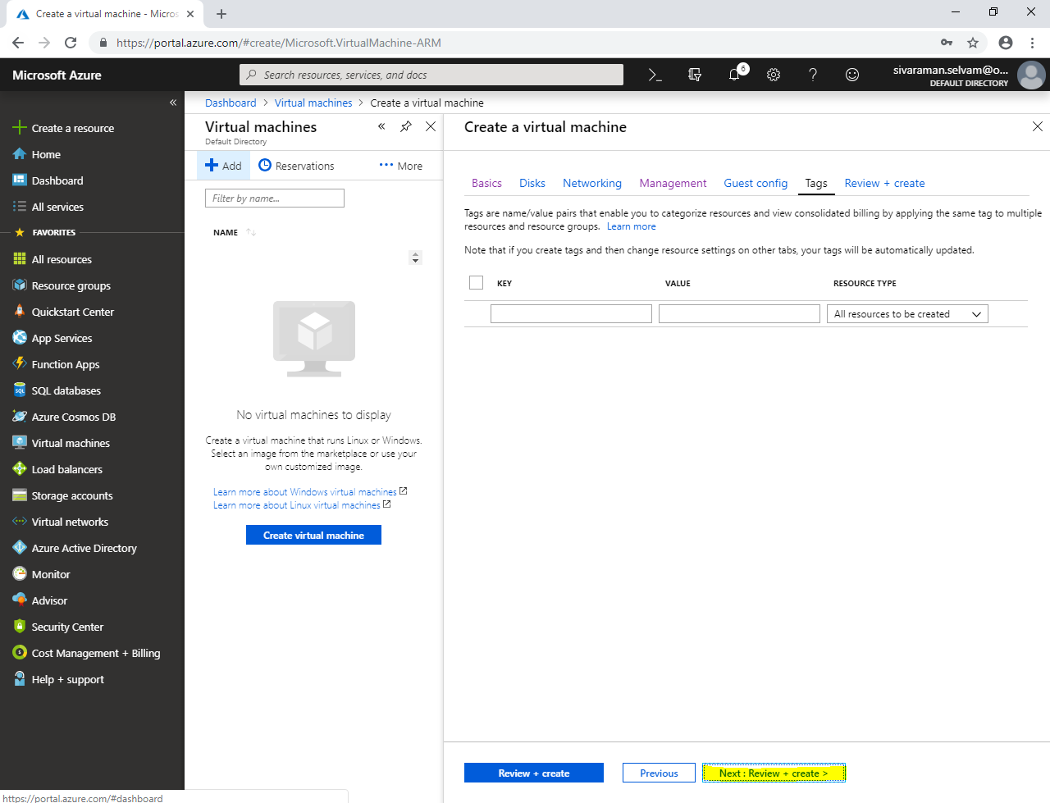

Click **“Create”**.

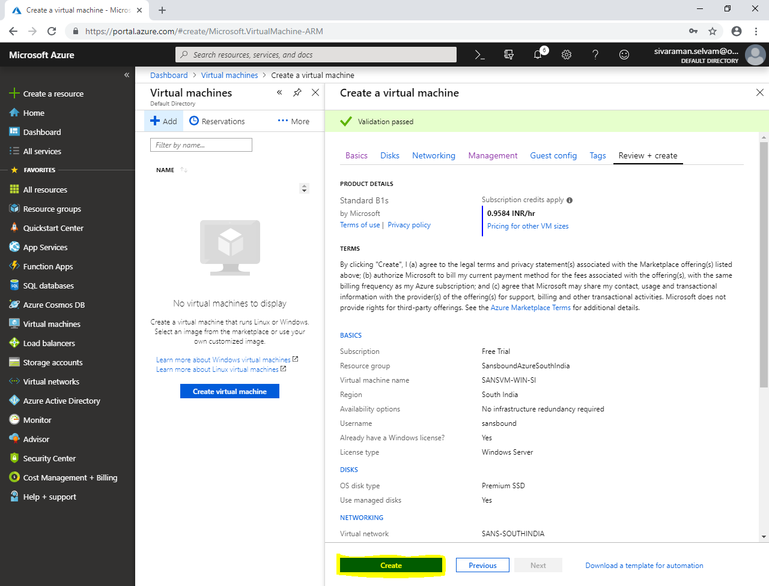

Click **“Resource groups”** in left side panel.

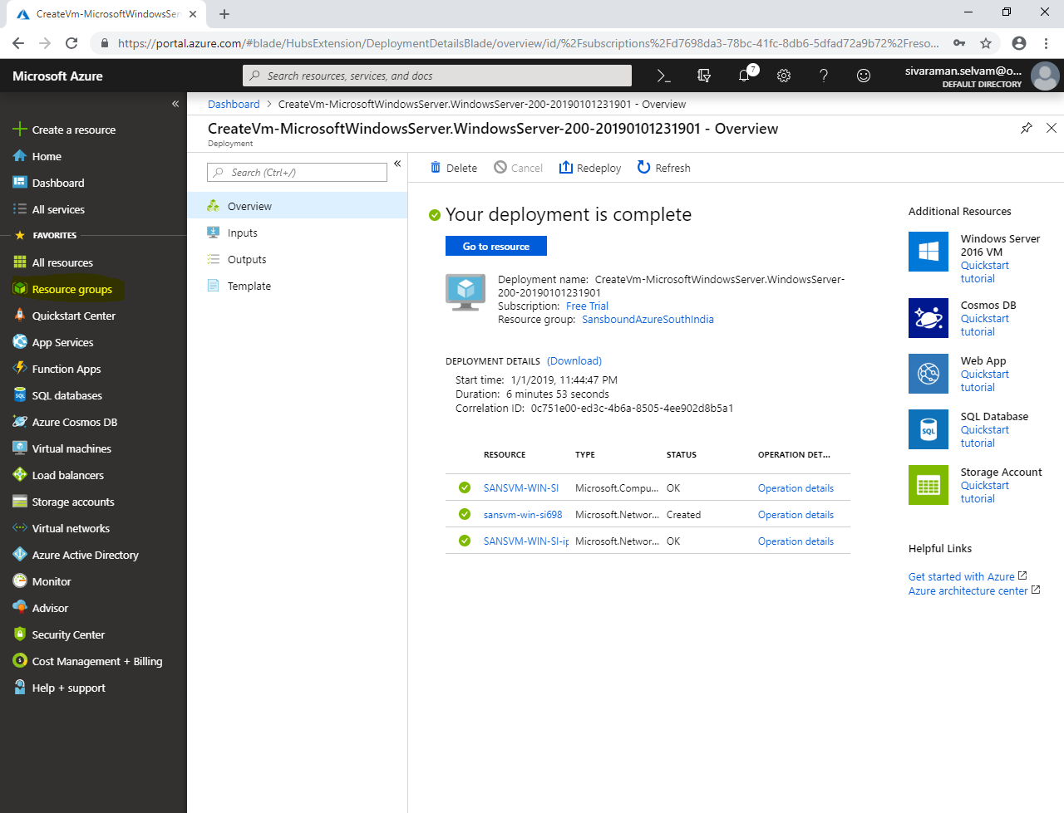

In **“Resource groups”**, click **“Add”**.

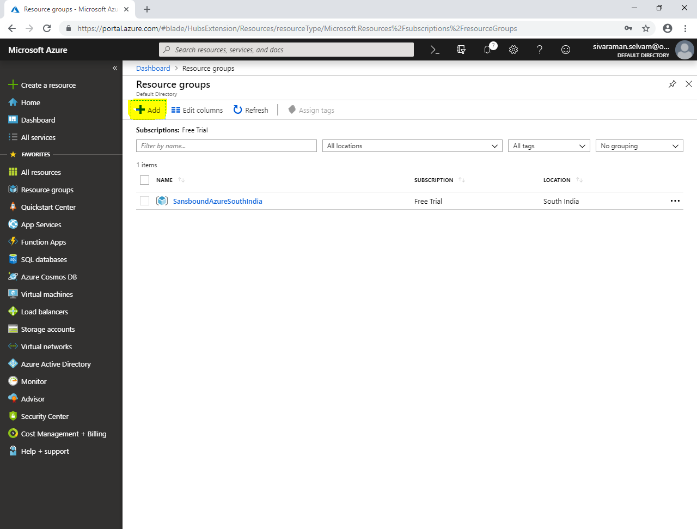

While create **“Resource group”,**

Type **“Resource group name”** as **“SansboundAzureUS”**.

Select **“Subscription”** as **“Free Trial”**.

Select **“Resource group location”** as **“Central US”**.

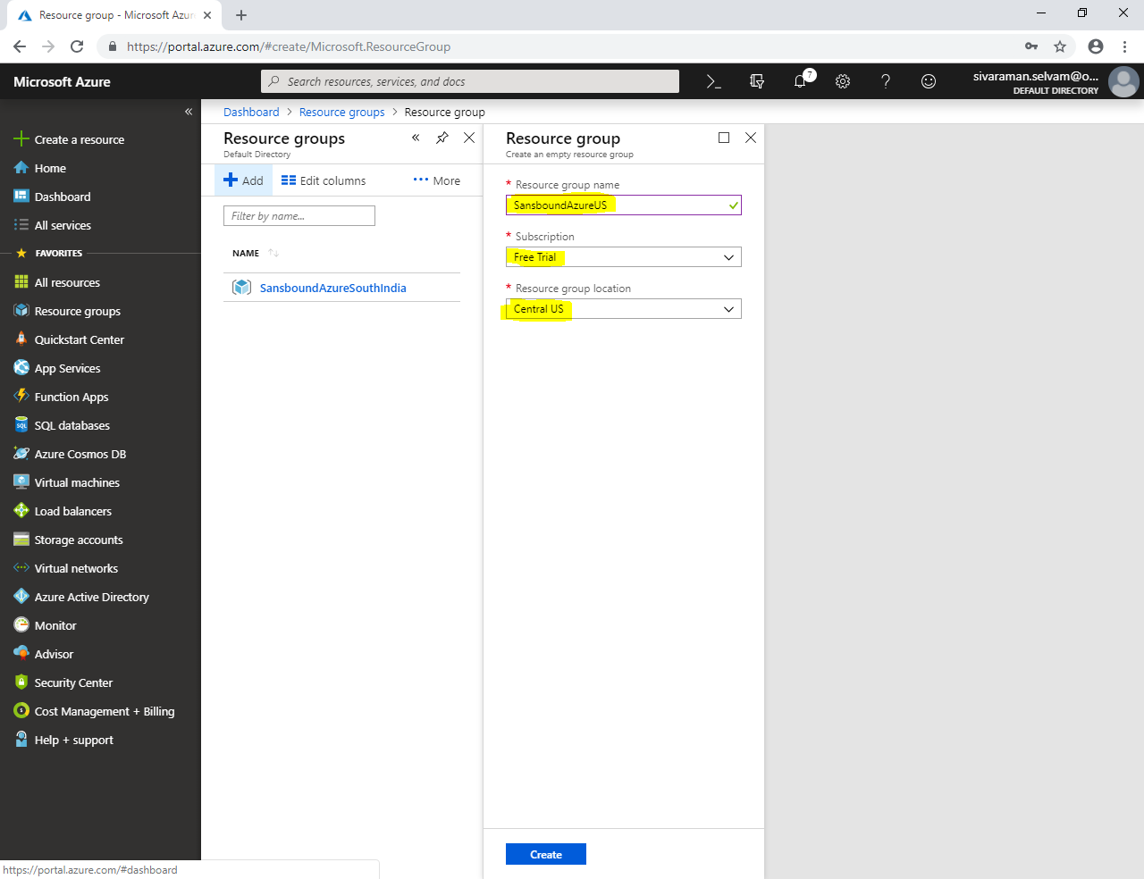

Click **“Create”**.

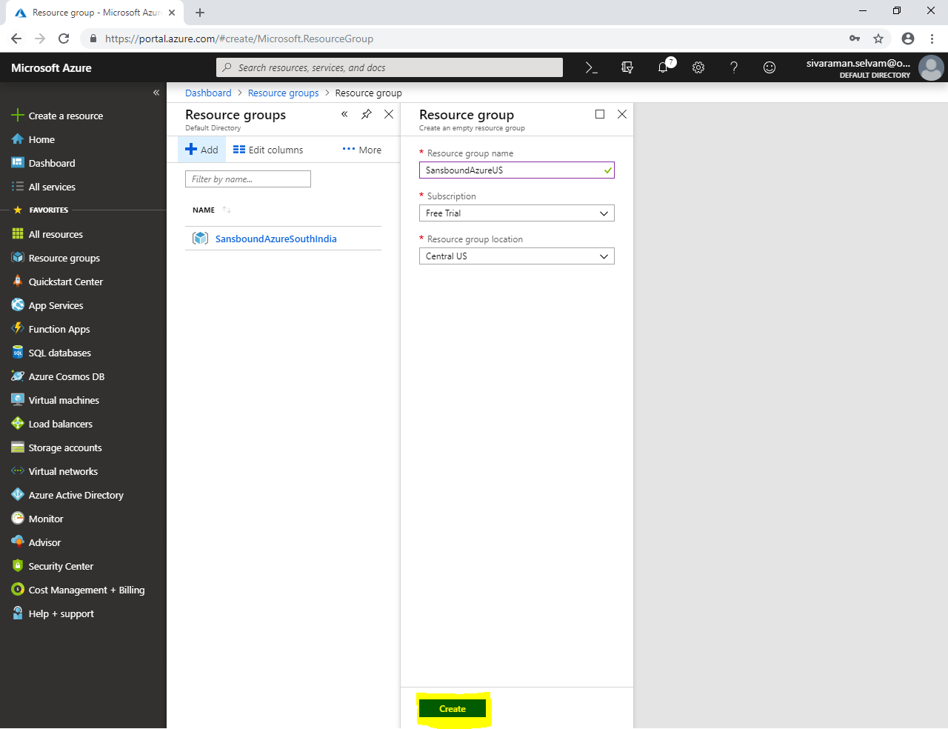

Click **“Virtual networks”** in left side panel.

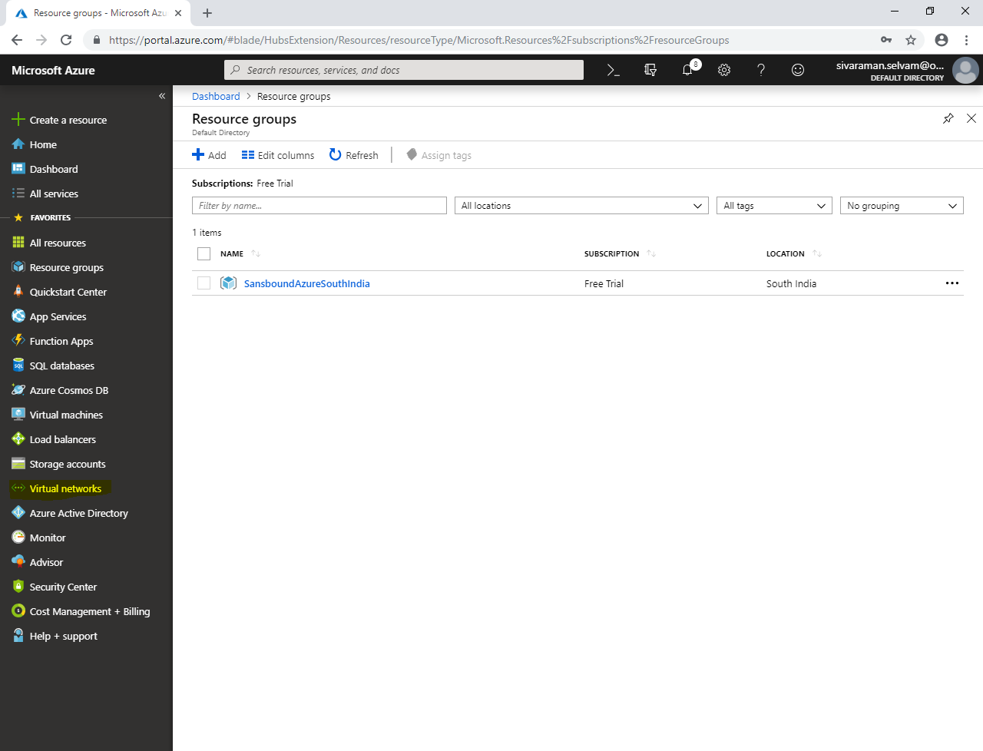

In **“Virtual networks”**,

Click **“Add”**.

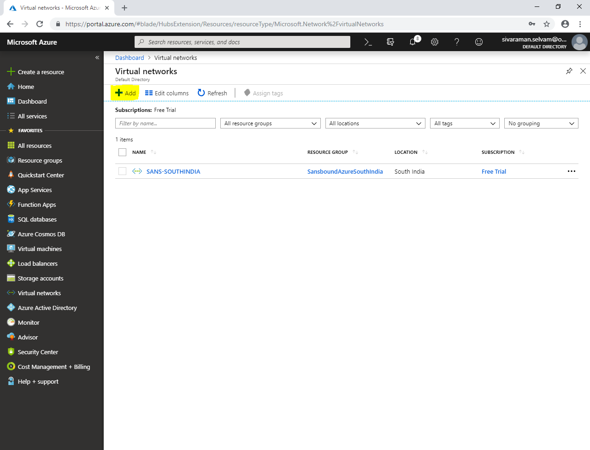

While create virtual network,

Type **“Name”** as **“SANS-CENTRALUS”**.

Type **“Address space”** as **172.16.0.0/16**.

Select **“Subscription”** as **“Free Trial”**.

Select **“Resource group”** as **“SansboundAzureUS”**.

Select **“Location”** as **“Central US”**.

In **“Subnet”** type name as **“SANS-CUS-PubSubnet”**.

Type **“Address range”** as **172.16.1.0/24.**

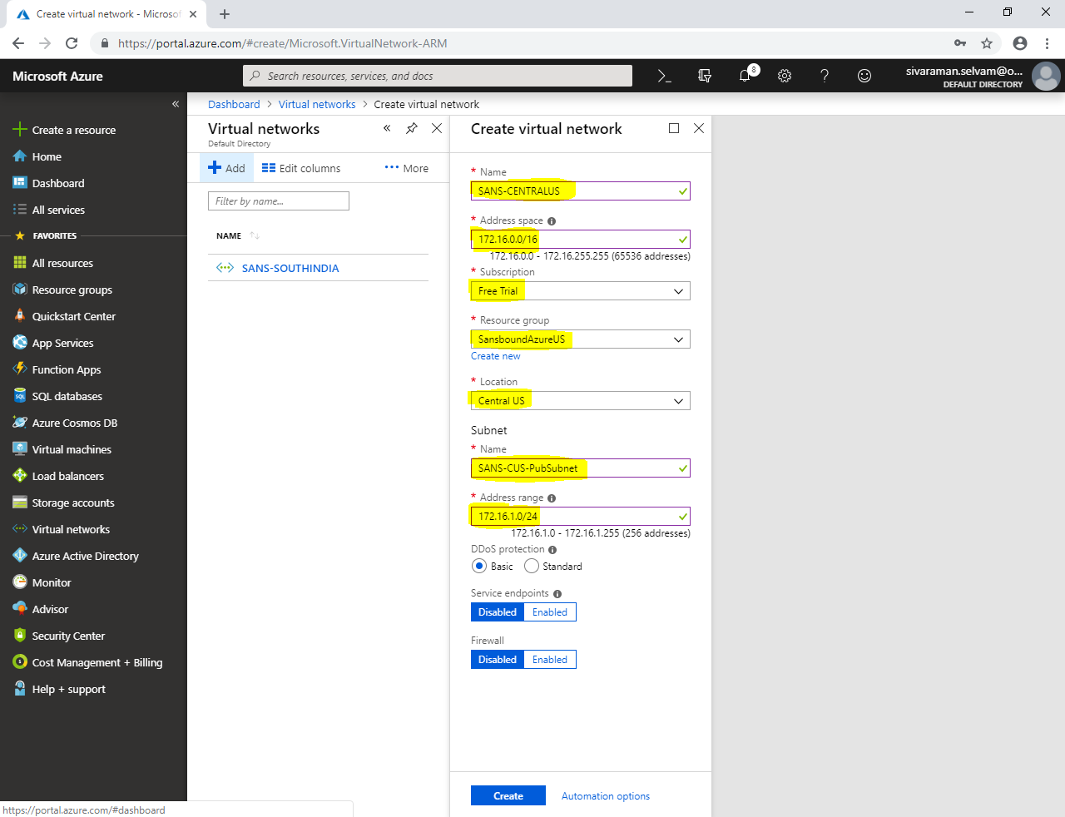

Click **“Create”**.

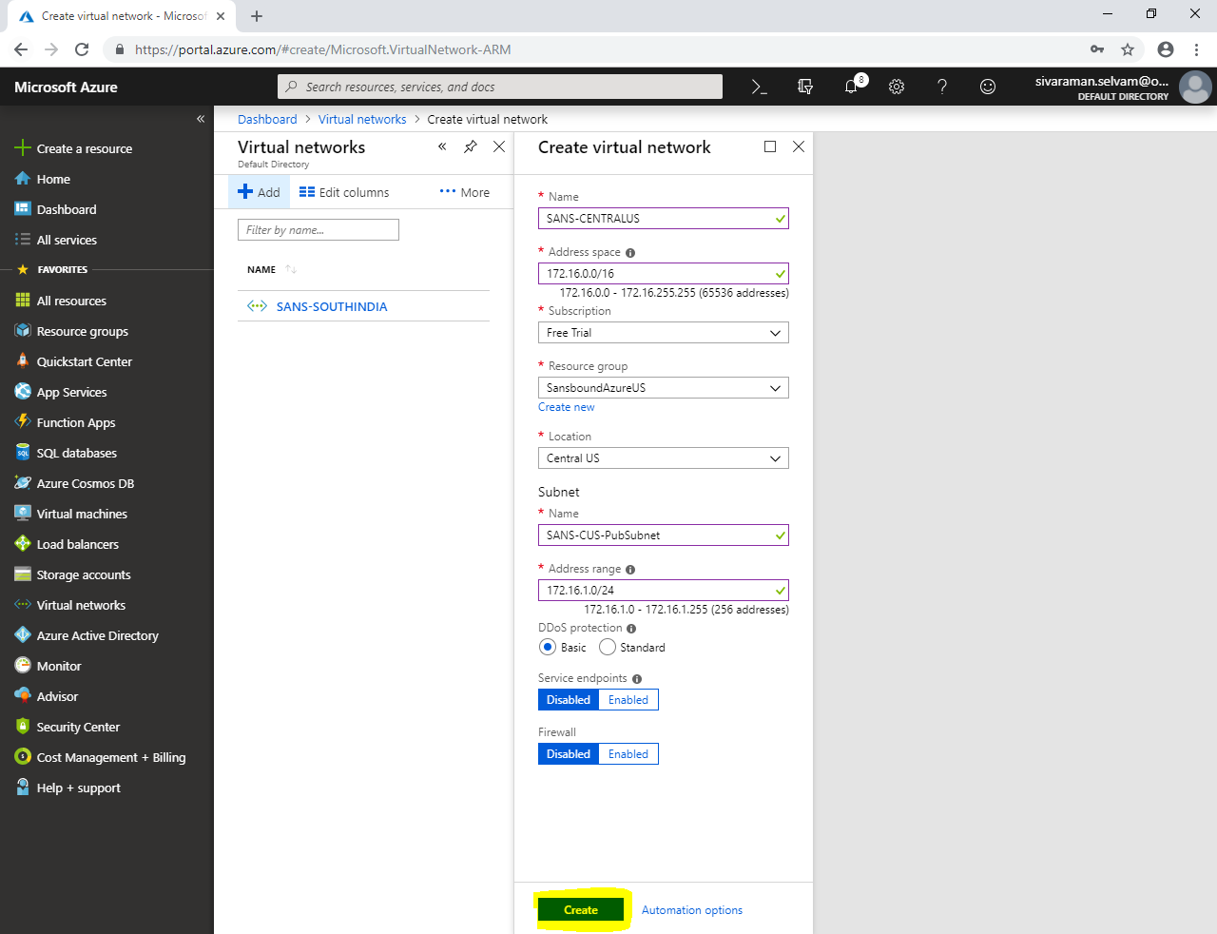

Click **“Virtual machines”** in left side panel.

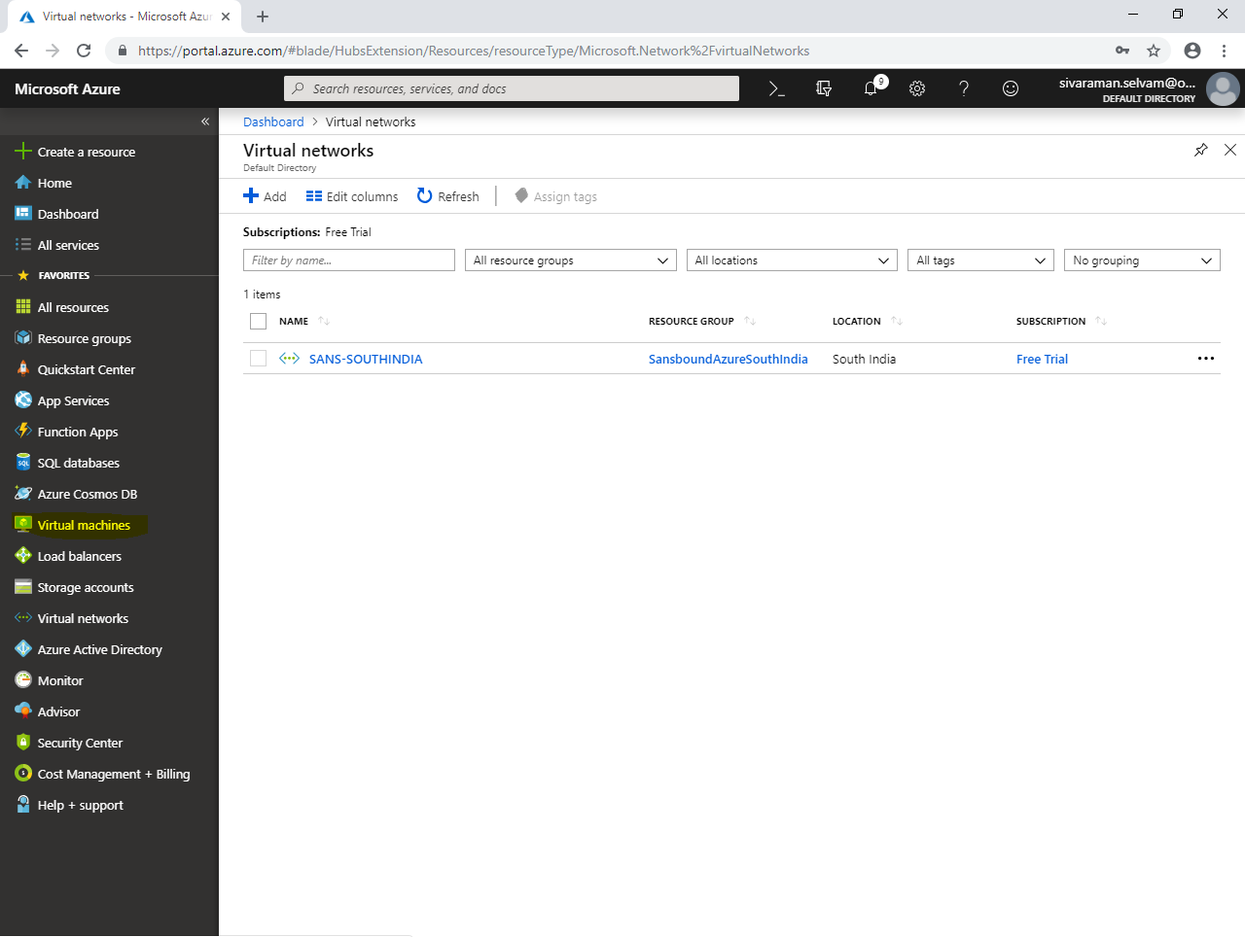

Click **“Add”**.

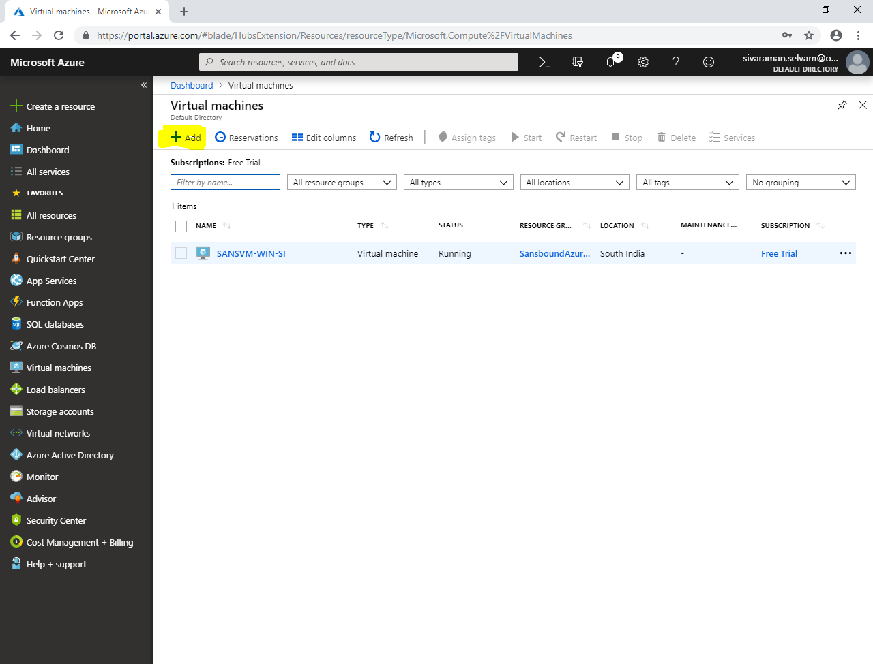

While create virtual machine,

Select **“Subscription”** as **“Free Trial”**.

Select **“Resource group”** as **“SansboundAzureUS”**.

Type **“Virtual machine name”** as **“SANS-CUS-Ubuntu”**.

Select **“Region”** as **“Central US”**.

Select **“Image”** as **“Ubuntu server 18.04 LTS”**.

Change **“VM Size”** as **“Standard B1s”**.

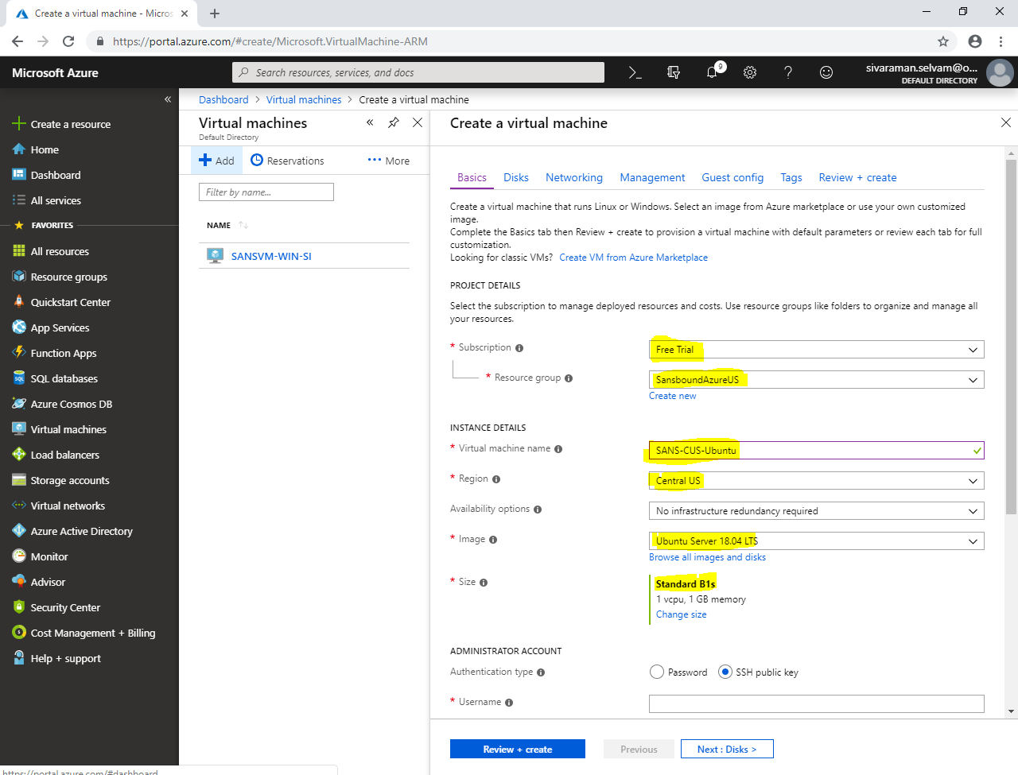

In **“Administrator account”**,

Select **“Authentication type”** as **“Password”**.

Type **“username”** as **“sansbound”**

Type **“Password”** for Ubuntu as per your wish.

In **“Inbound Port Rules”**,

**Public Inbound rules as “None”.**

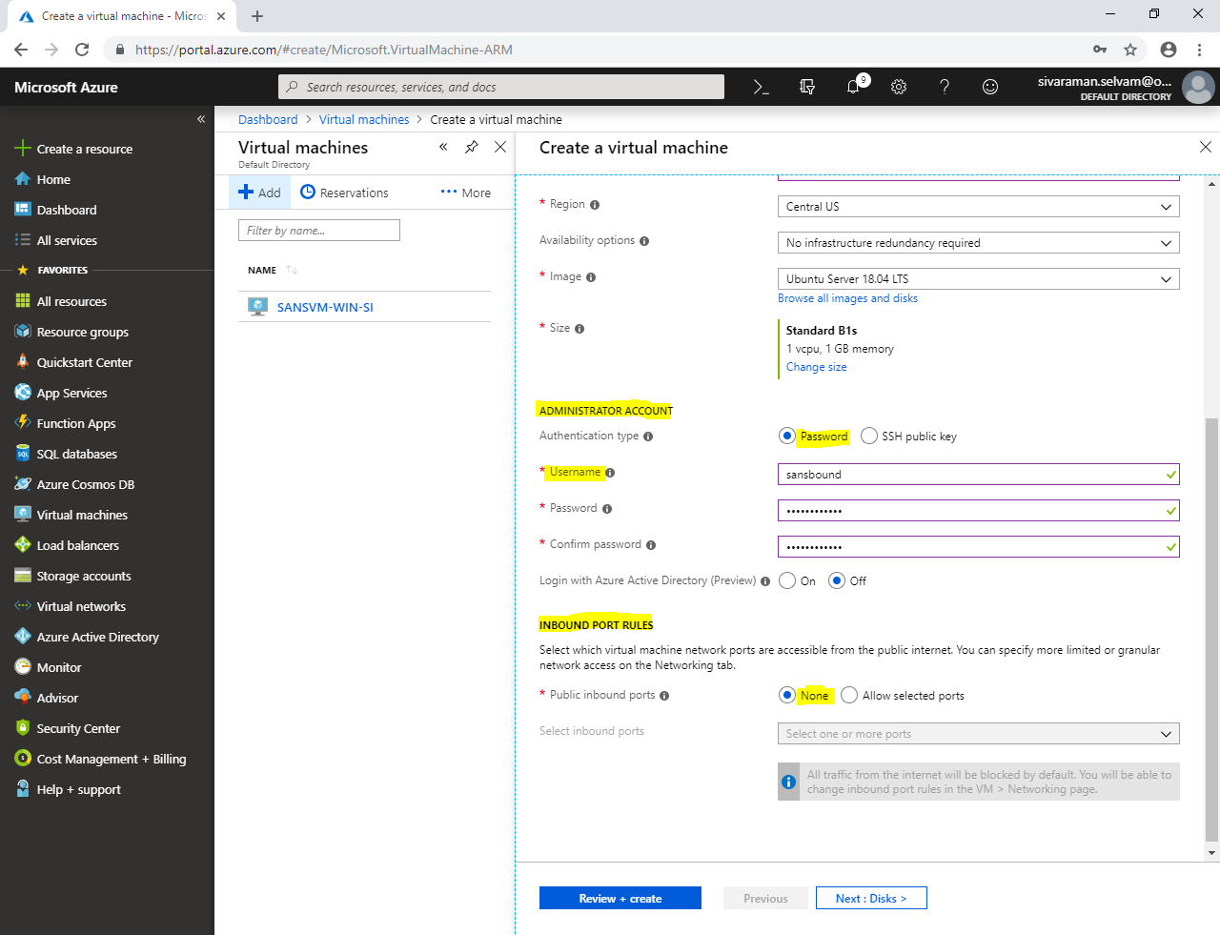

Click **“Next : Disks >”**.

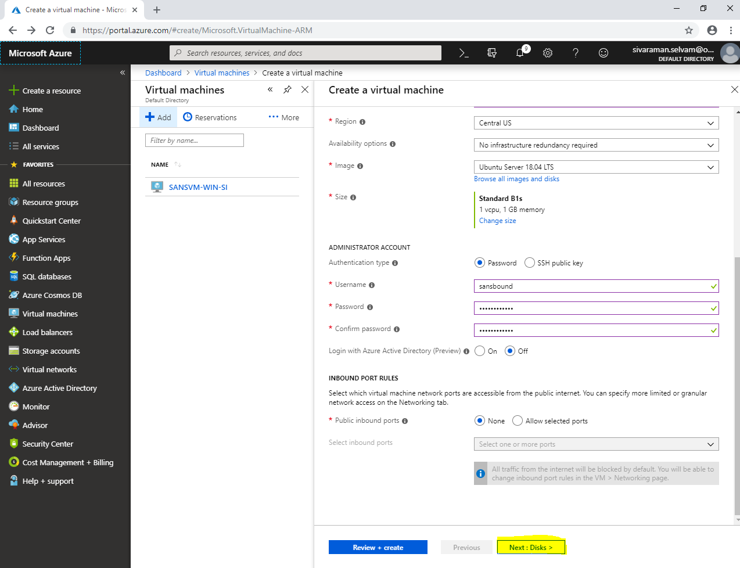

Click **“Next : Networking >”**.

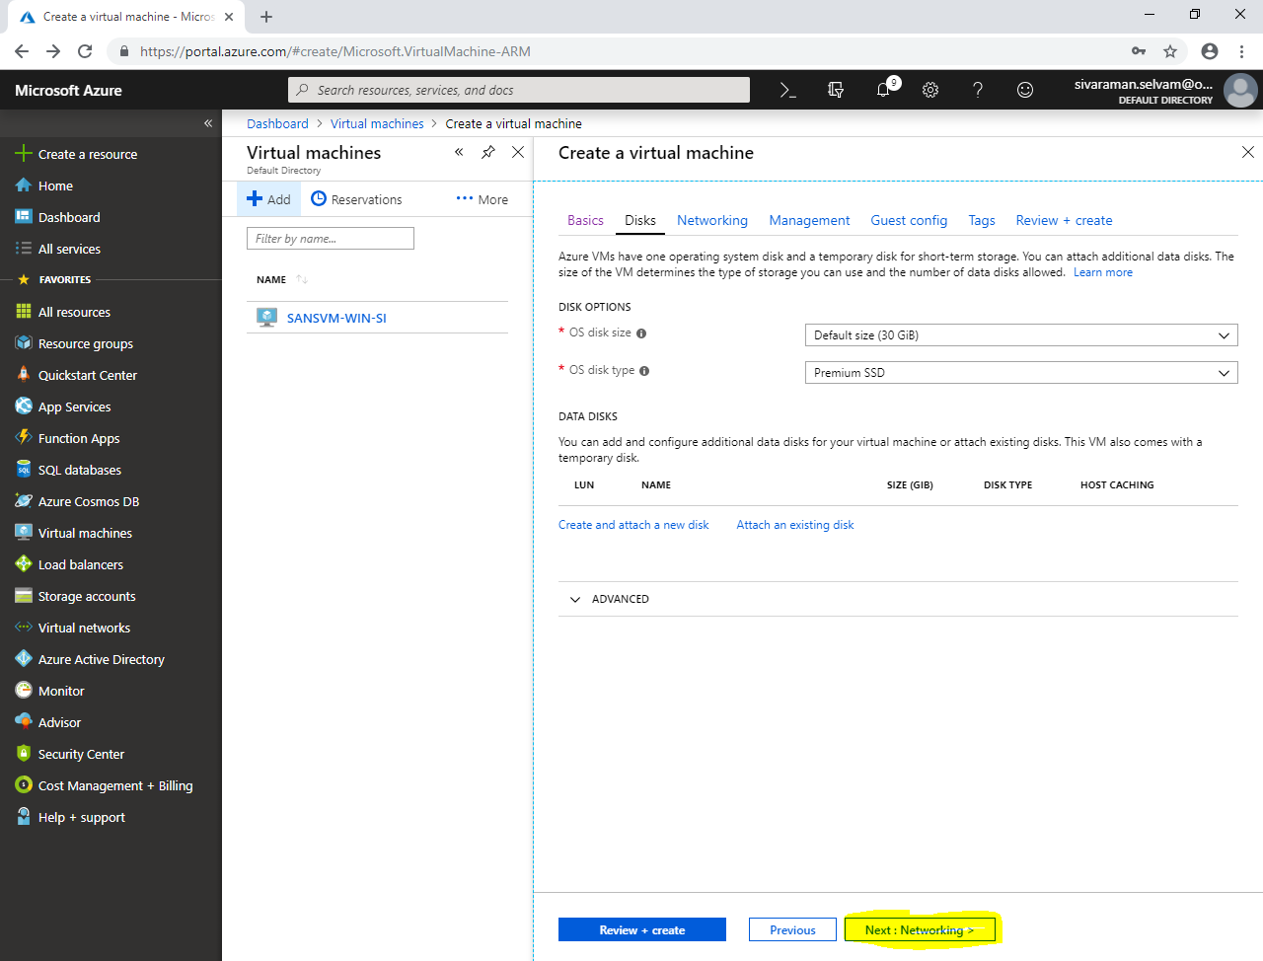

In **“Networking”**,

Ensure that **“Virtual network”** as **“SANS-CENTRALUS”**.

Ensure **“Subnet”** as **“SANS-CUB-PubSubnet”**.

Public IP provision to be set.

You need click **“NIC network security group”** as **“None”**. 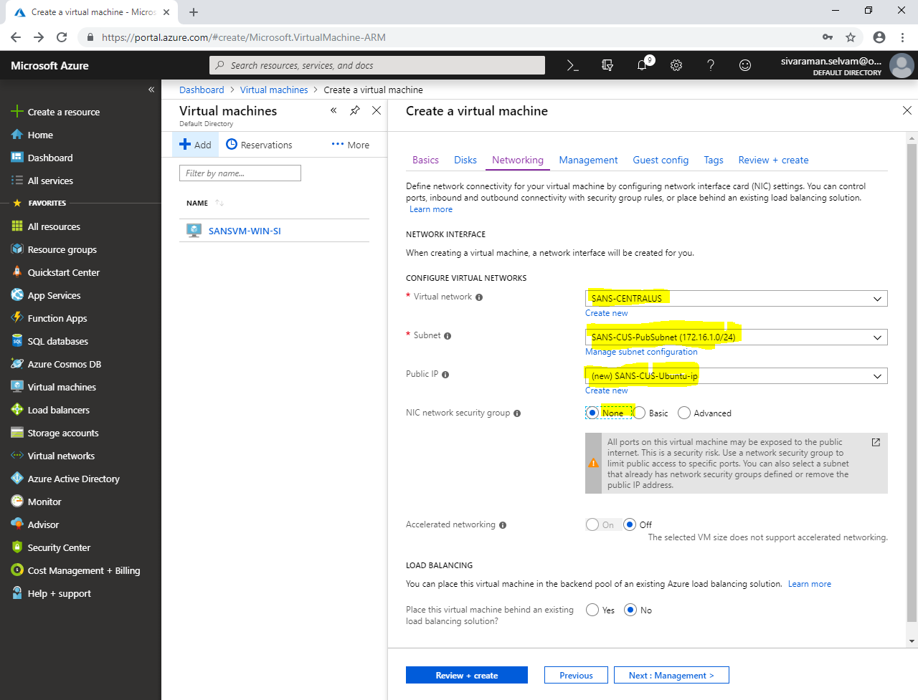

Click **“Next : Management”**.

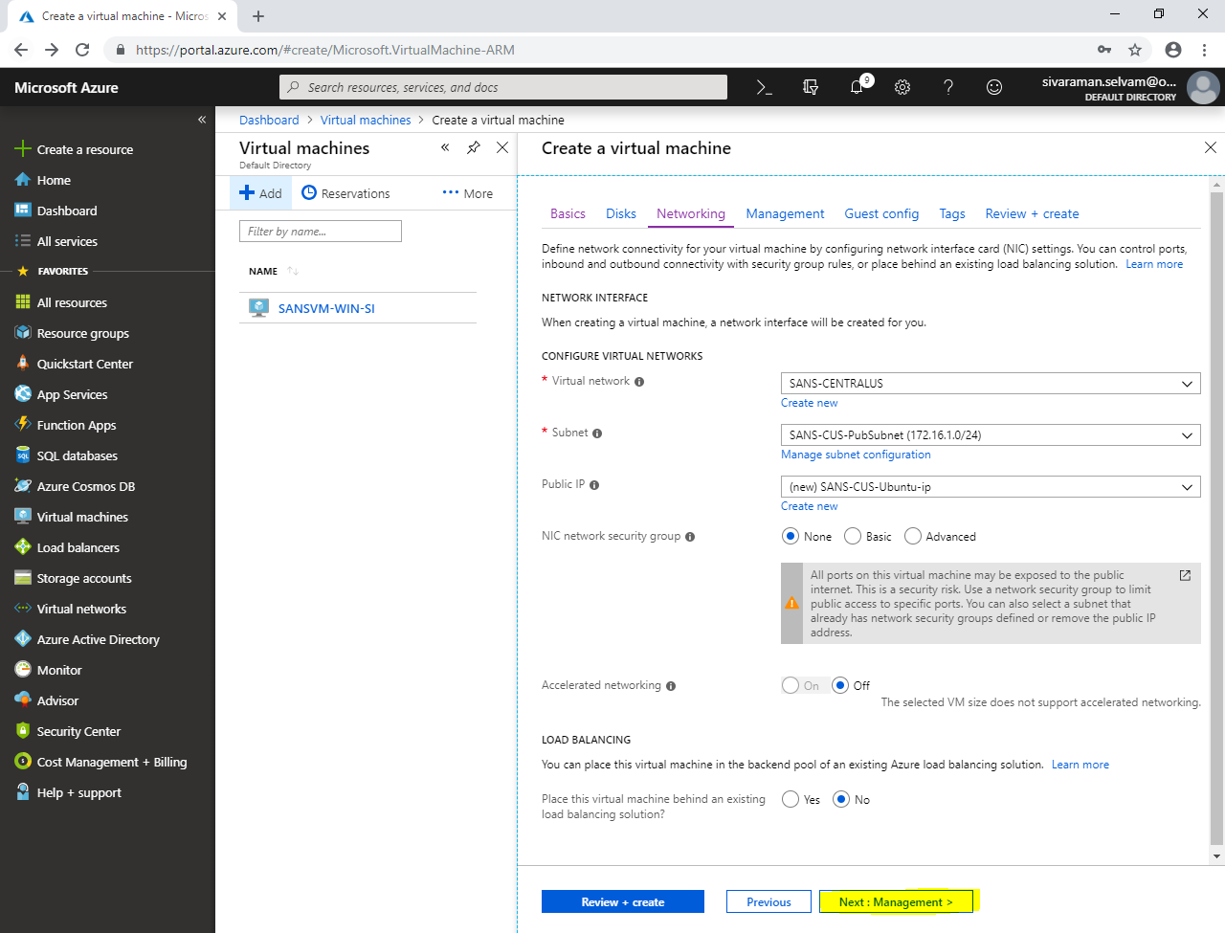

Click **“Next : Guest config >”**.

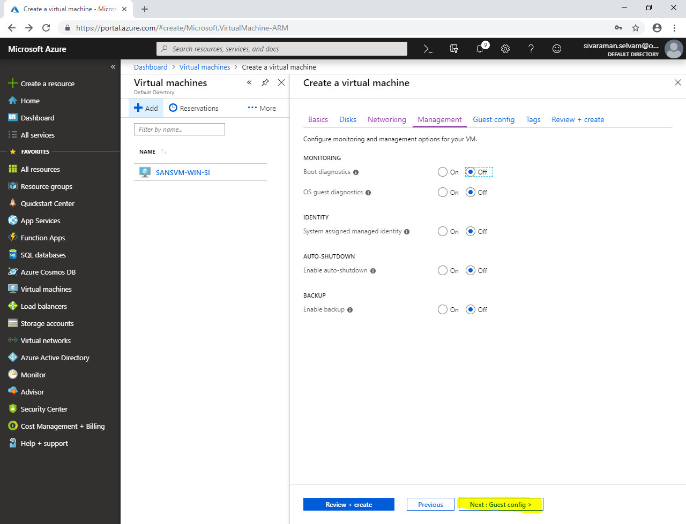

In **“Guest config”**,

Click **“Next : Tags >”**.

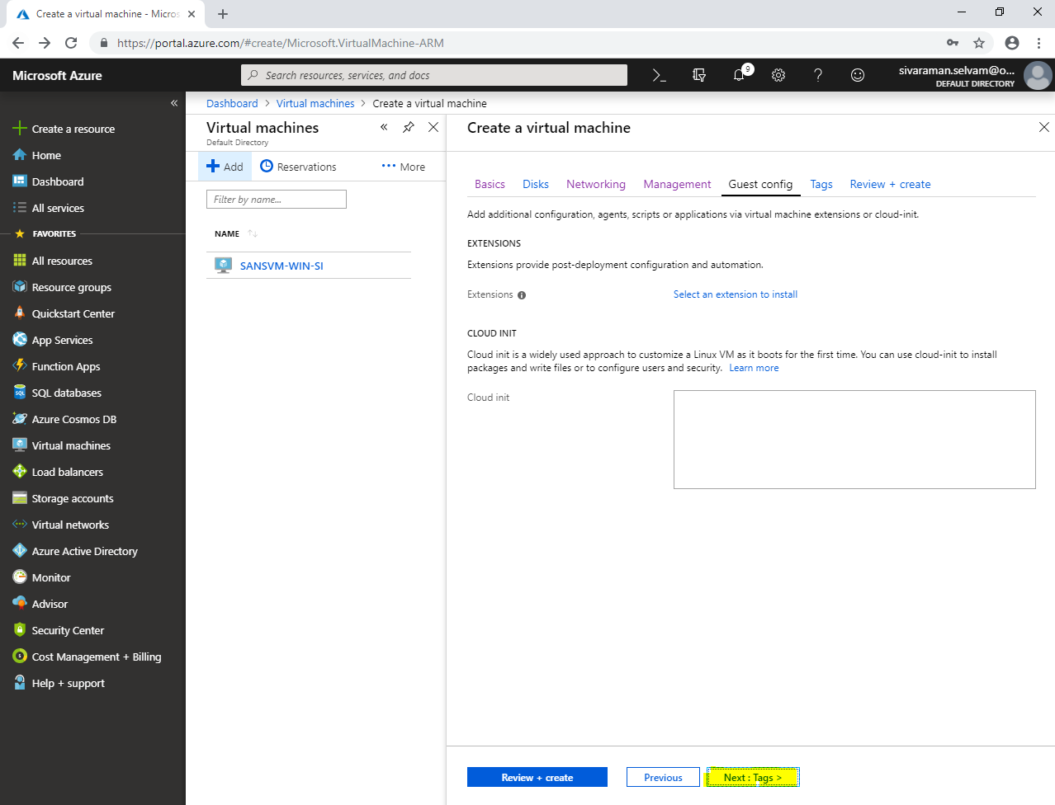

In **“Tags”**,

Click **“Review + create”**.

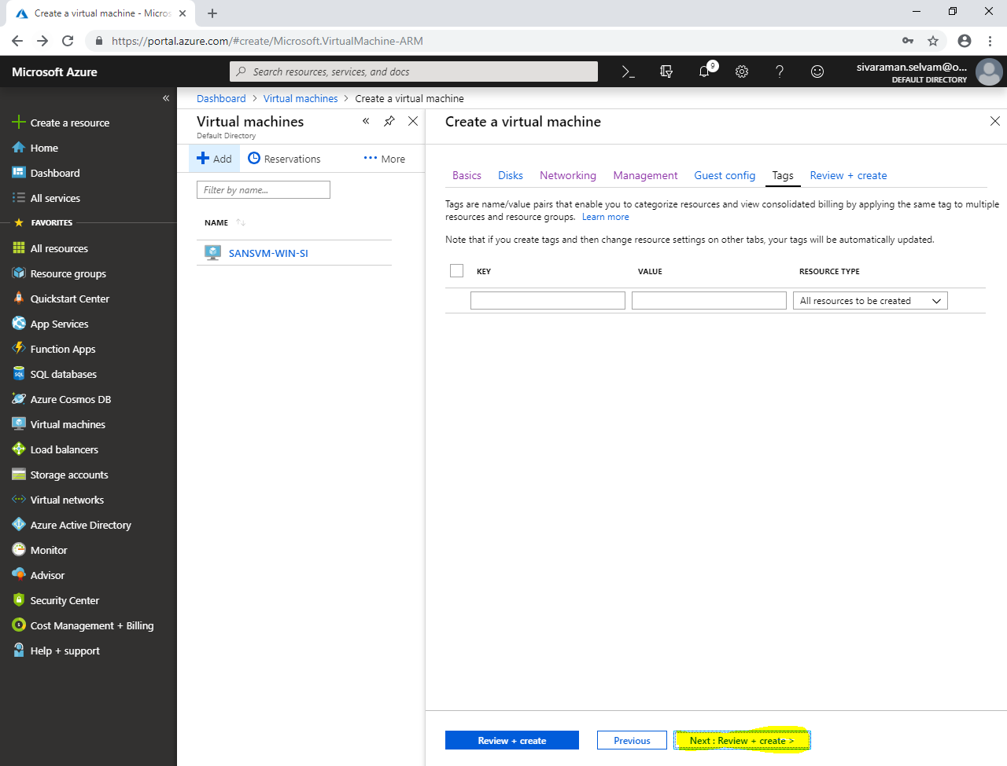

Click **“Create”**.

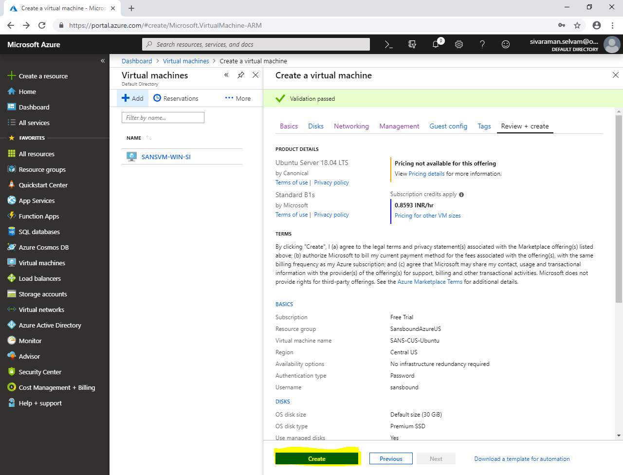

In **“All resources”**,

Click **“Add”**.

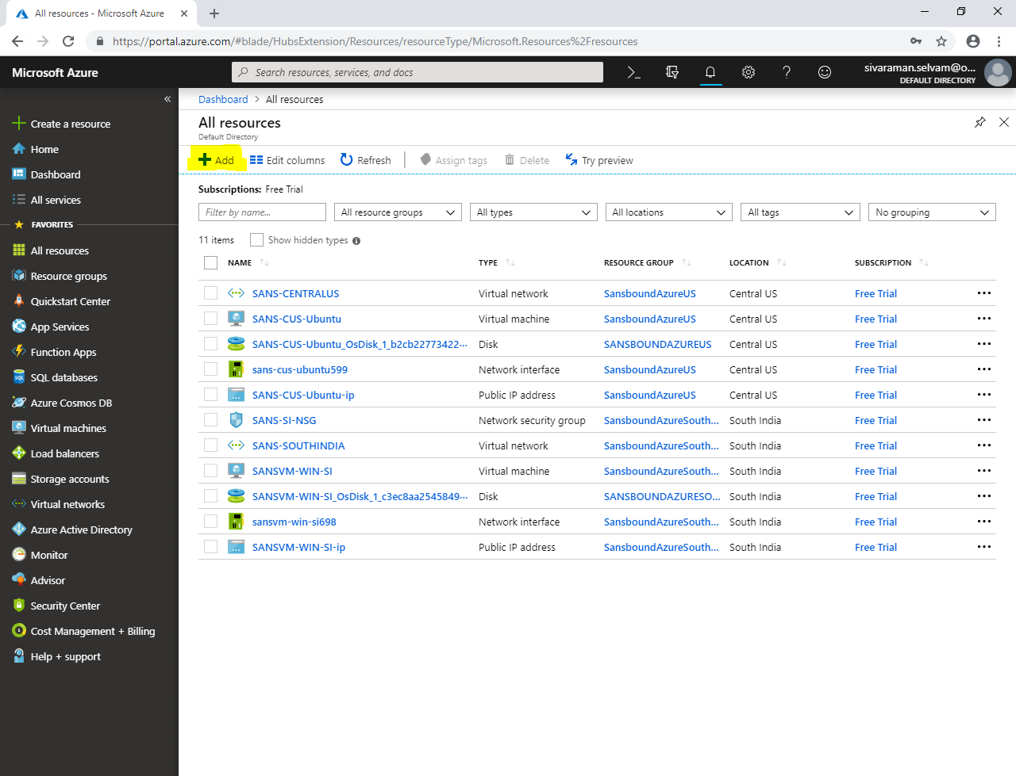

Click on **“Networking”**,

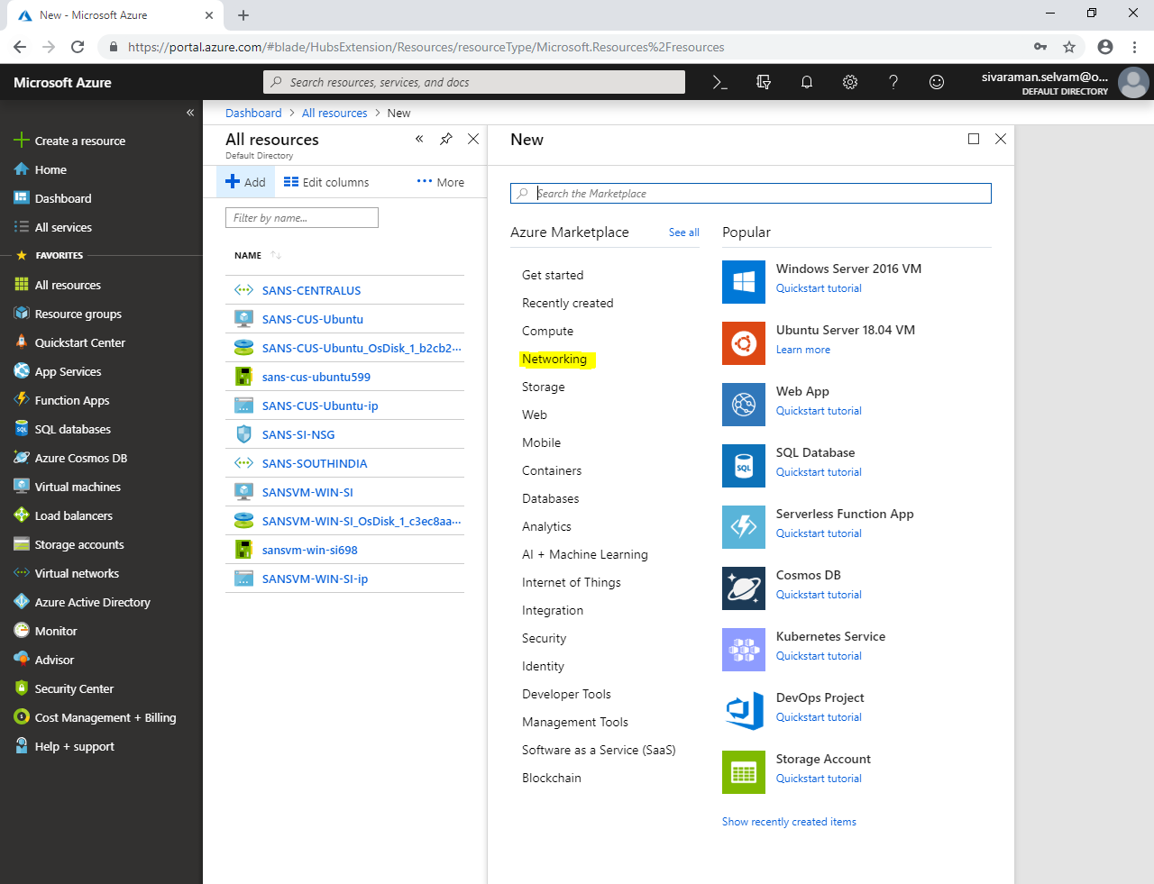

Click **“Network security group”**.

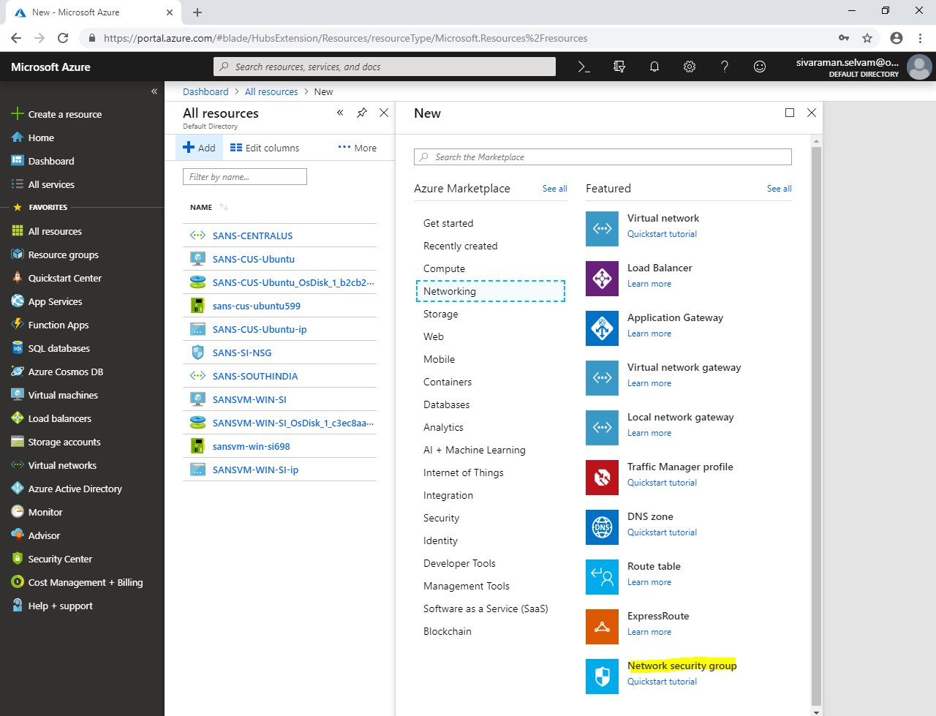

While create network security group,

Type **“Name”** as **“SANS-CUS-NSG”**.

Select **“Subscription”** as **“Free Trial”**.

Select **“Resource group”** as **“SansbundAzureUS”**.

Select **“Location”** as **“Central US”**.

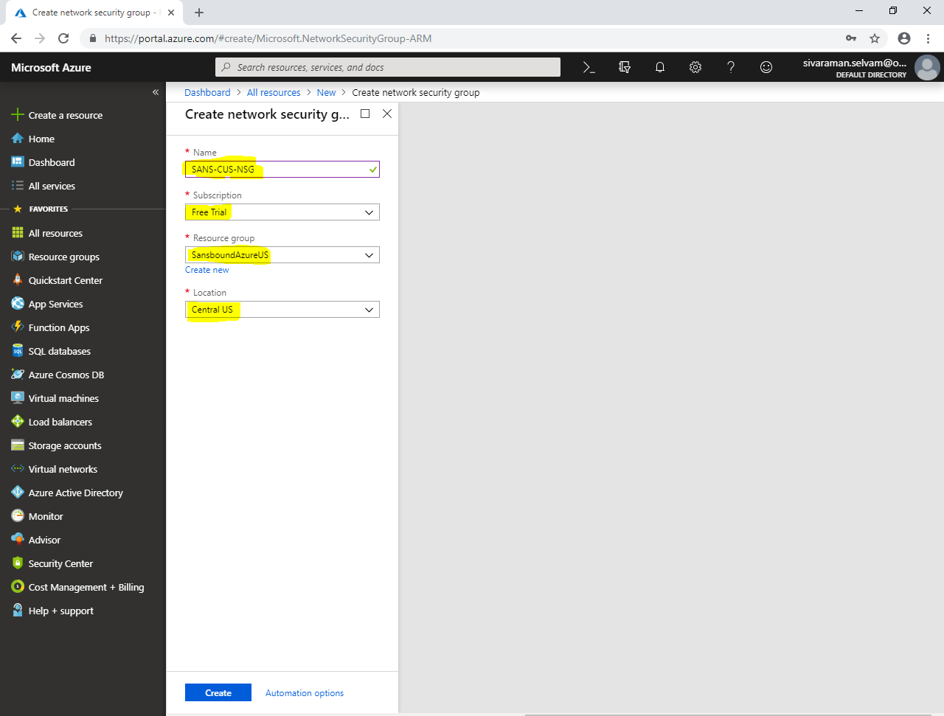

Click **“Create”**.

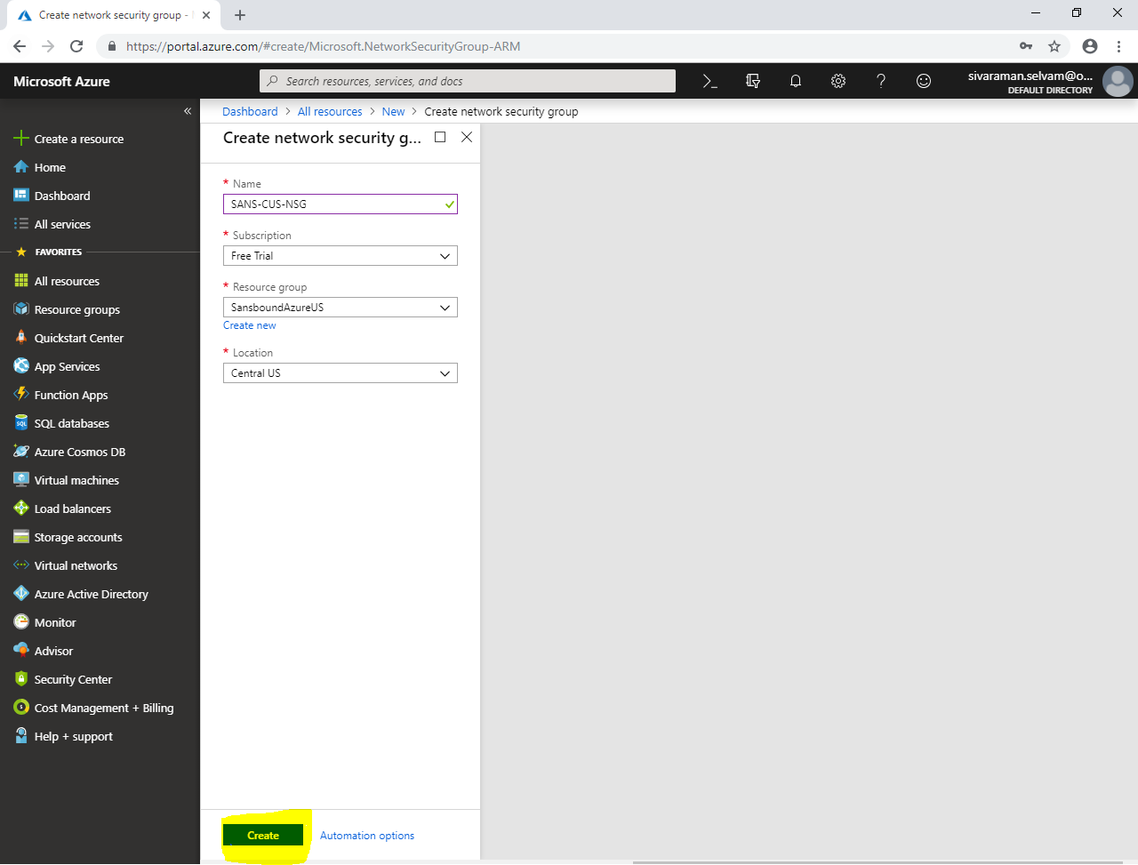

Click **“All resources”** in left side panel.

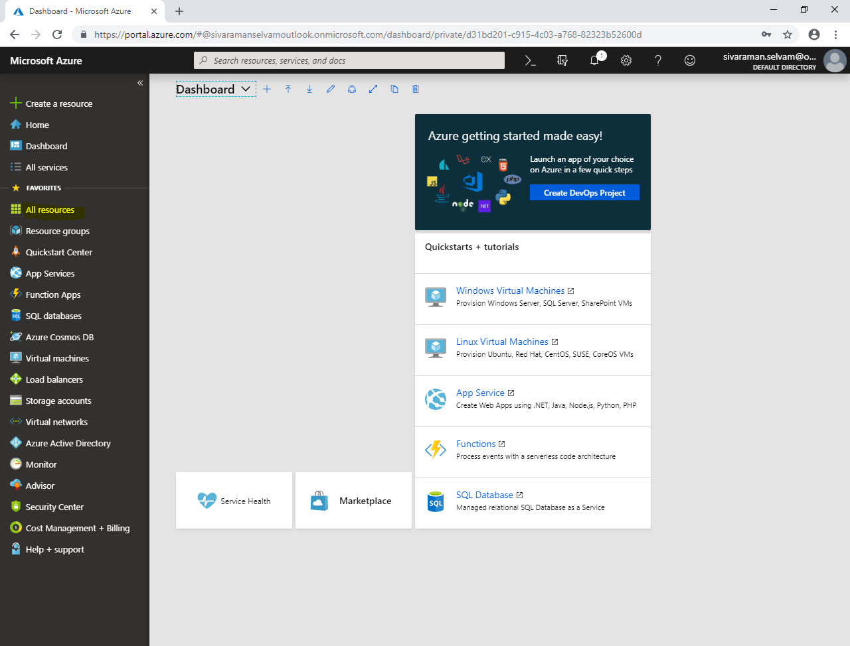

Click **“SANS-CUS-NSG”** network security group.

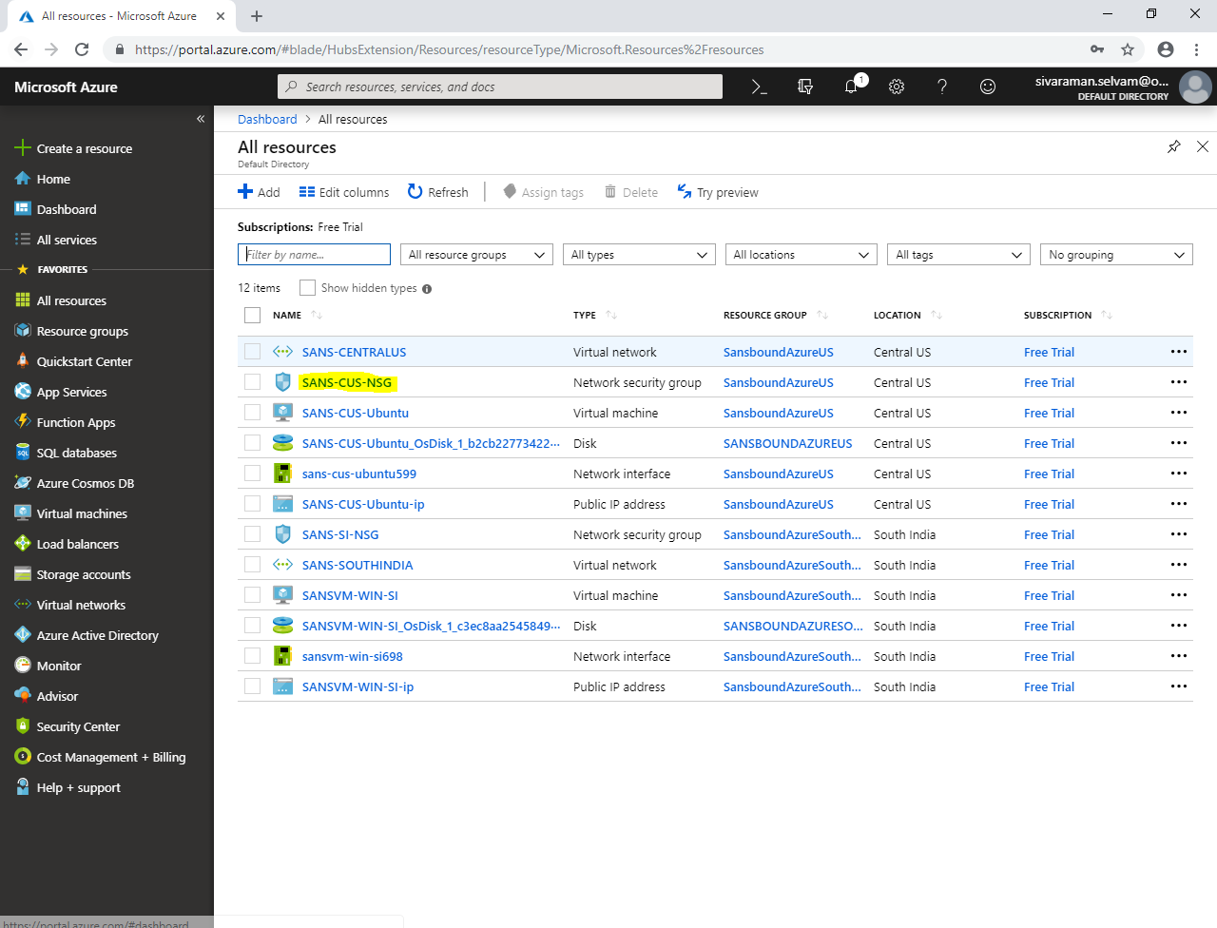

In **“SANS-CUS-NSG”** network security group,

Click **“Inbound security rules”**.

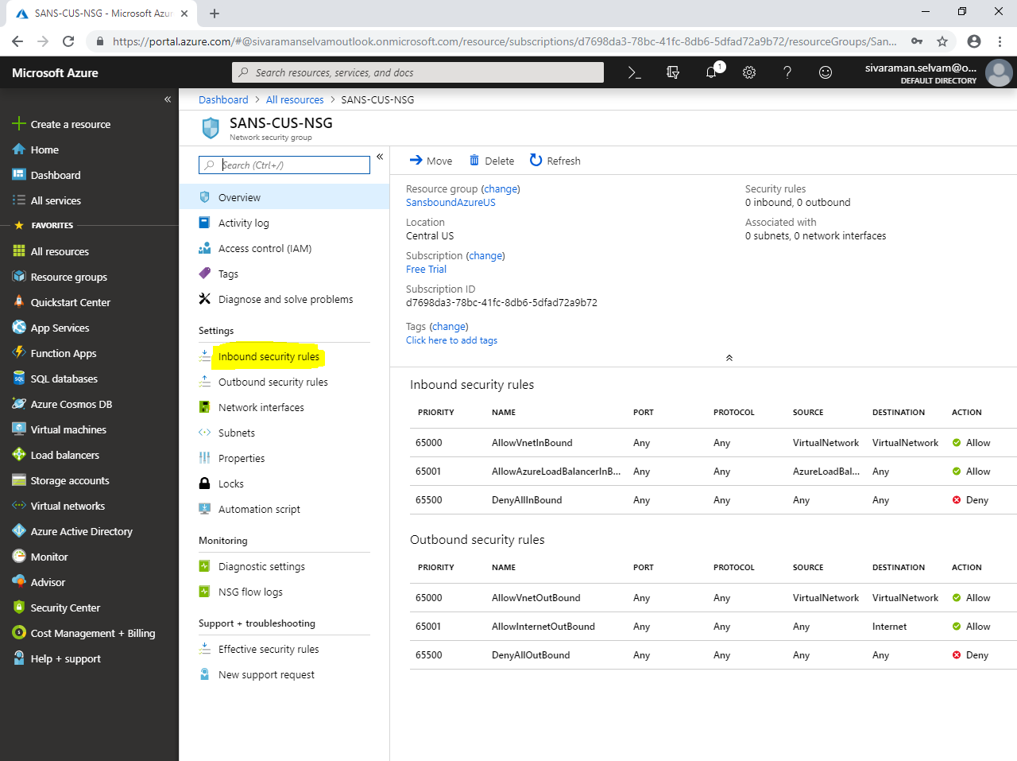

Click **“Add”**.

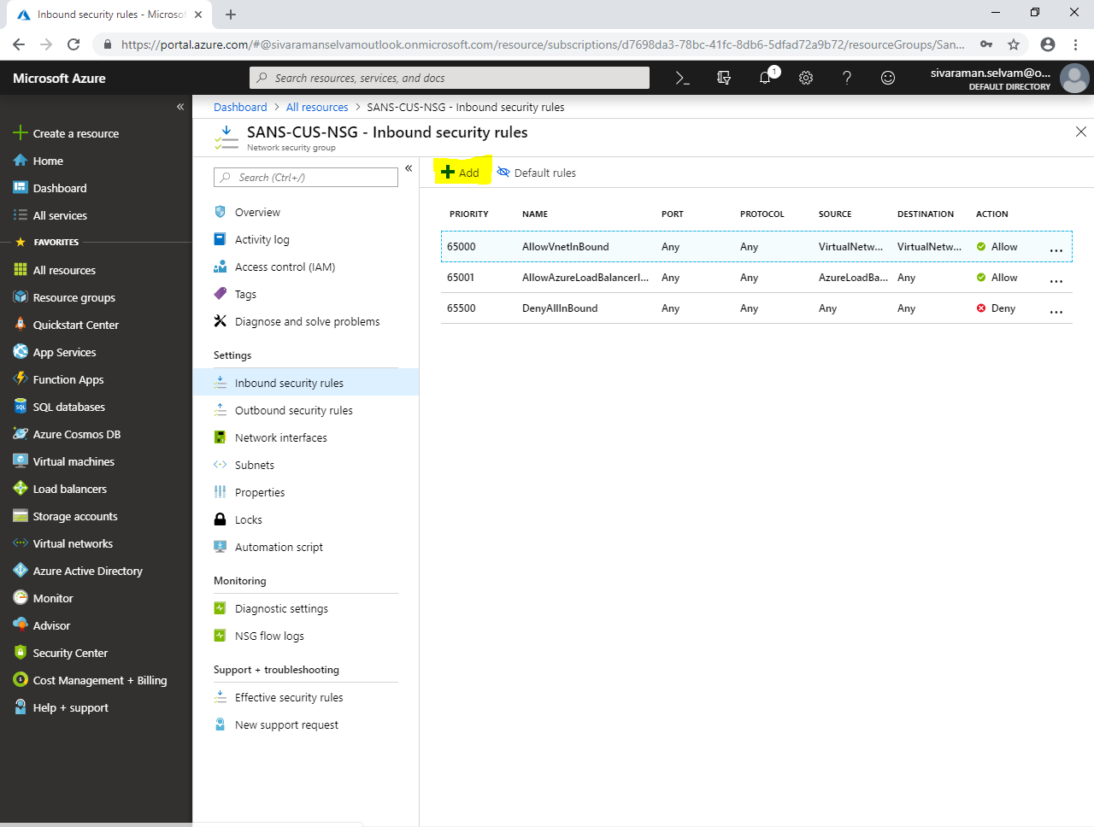

While **“Add inbound security rule”**,

Select **“Source”** as **“Any”**.

Select **“Source port ranges”** as **“*”**.

Select **“Destination”** as **“Any”**.

Specify **“Destination port ranges”** as **“22”**.

In Protocol, click **“TCP”**.

Ensure **“Priority”** as **“100”**.

Type **“Name”** as **“AllowSSH”**.

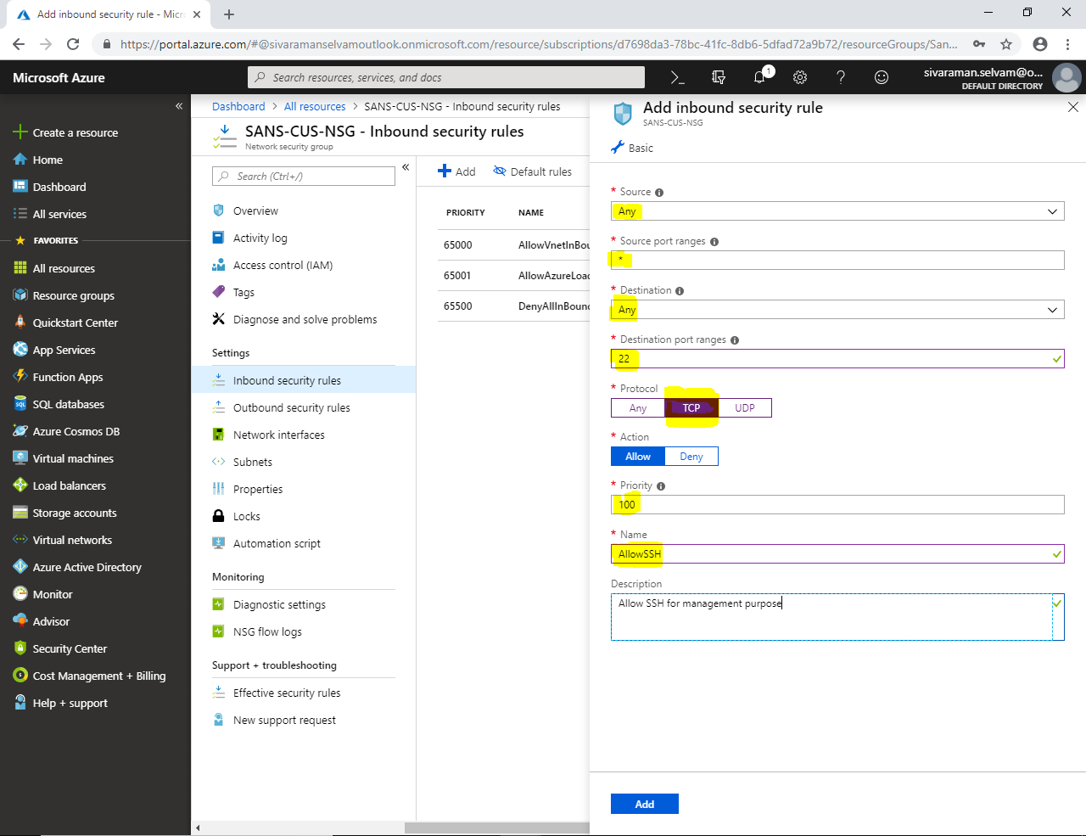

Click **“Add”**.

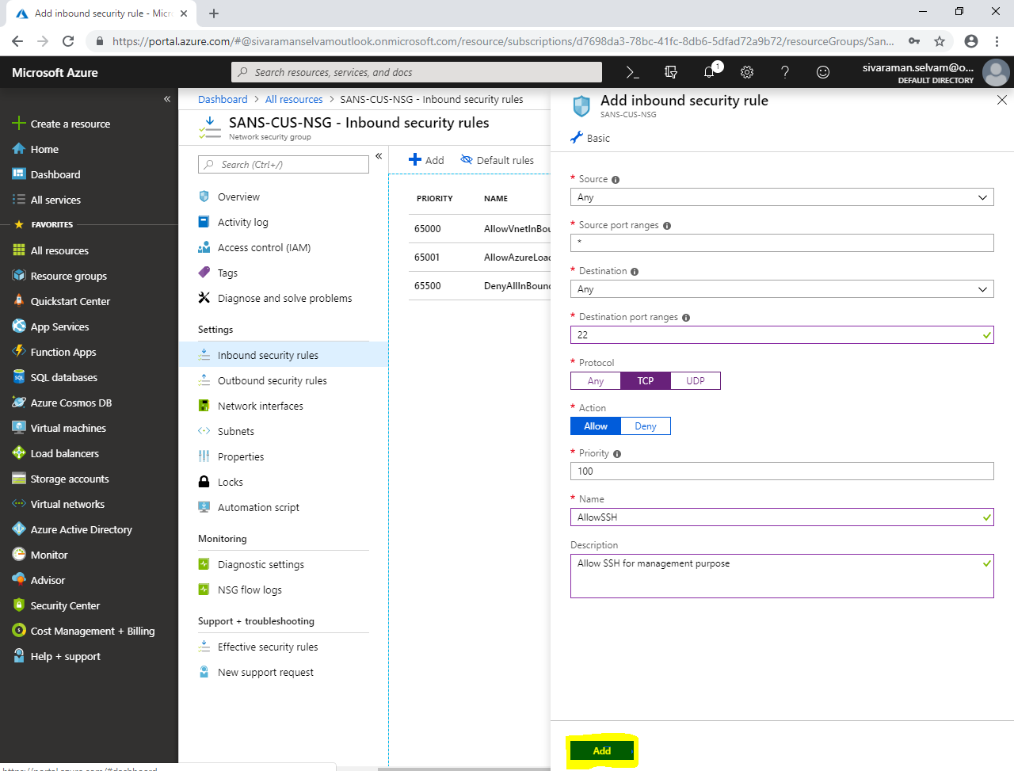

In **“SANS-CUS-NSG”**,

Click **“Subnets”**.

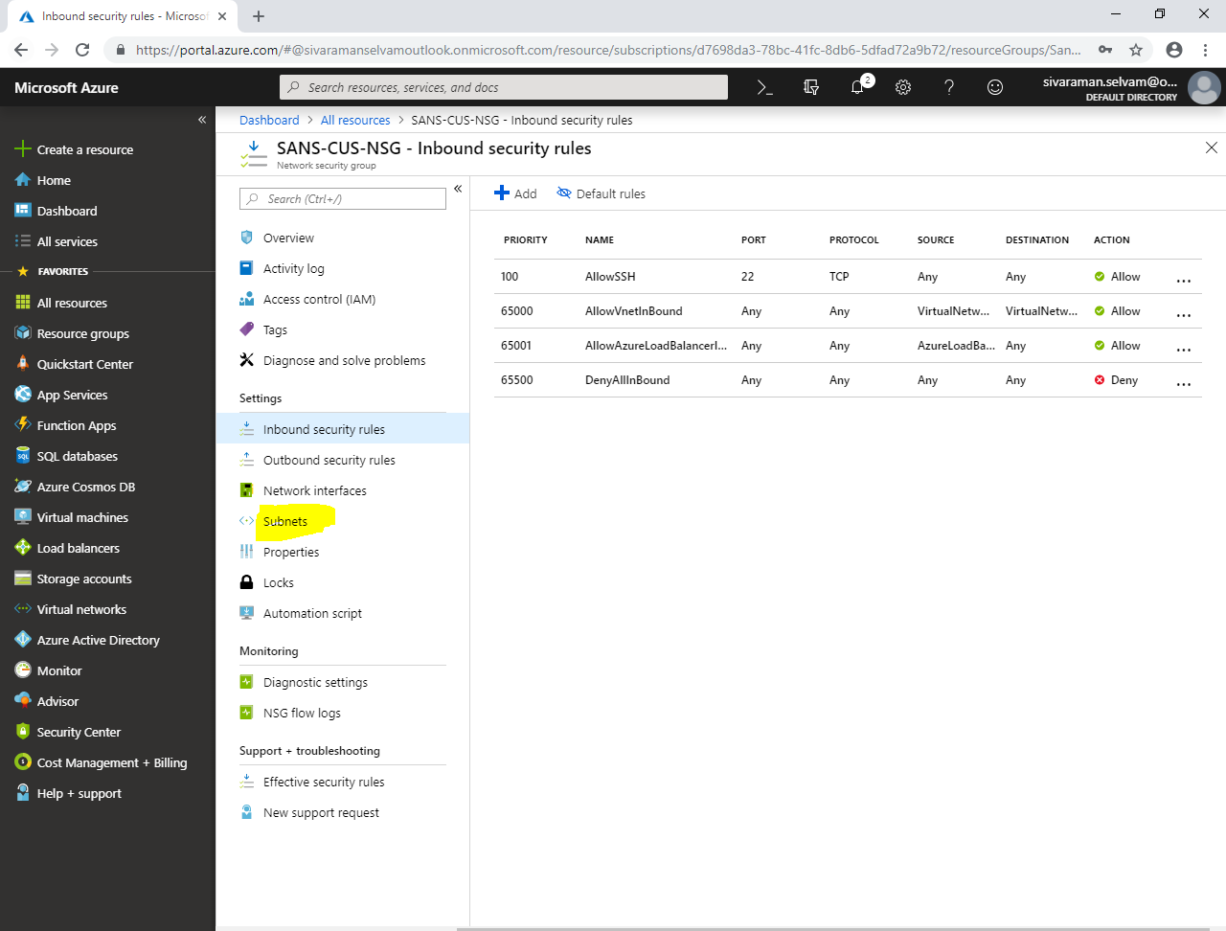

Click **“Associate”** to associate the subnet to network security group named **“SANS-CUS-NSG”**.

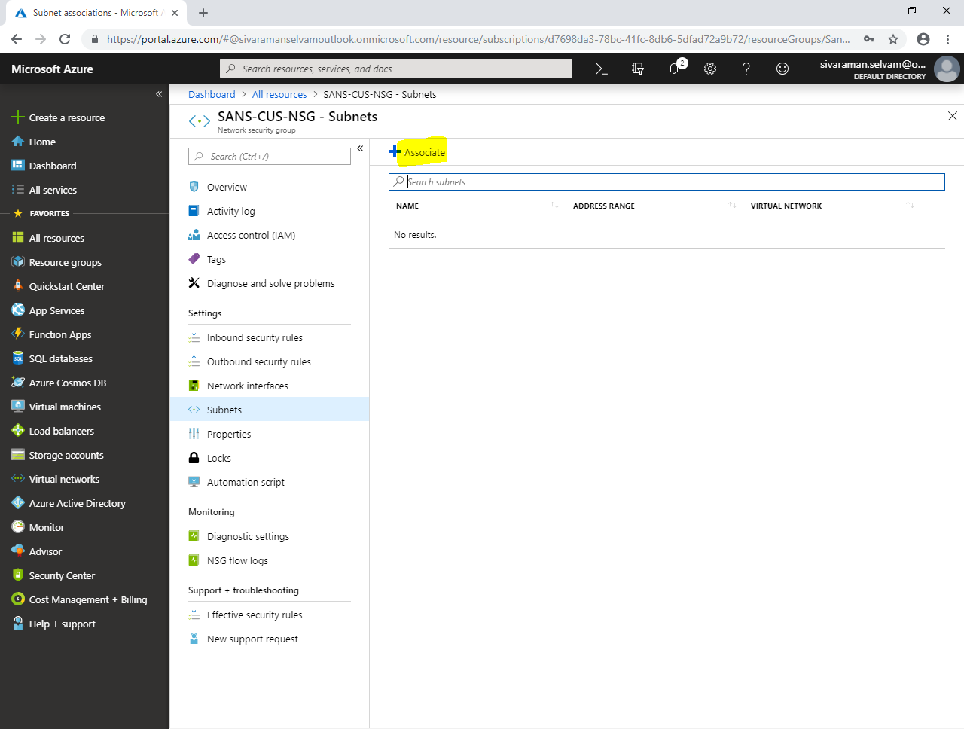

While **“Associate subnet”**,

Click **“Choose a virtual network”**.

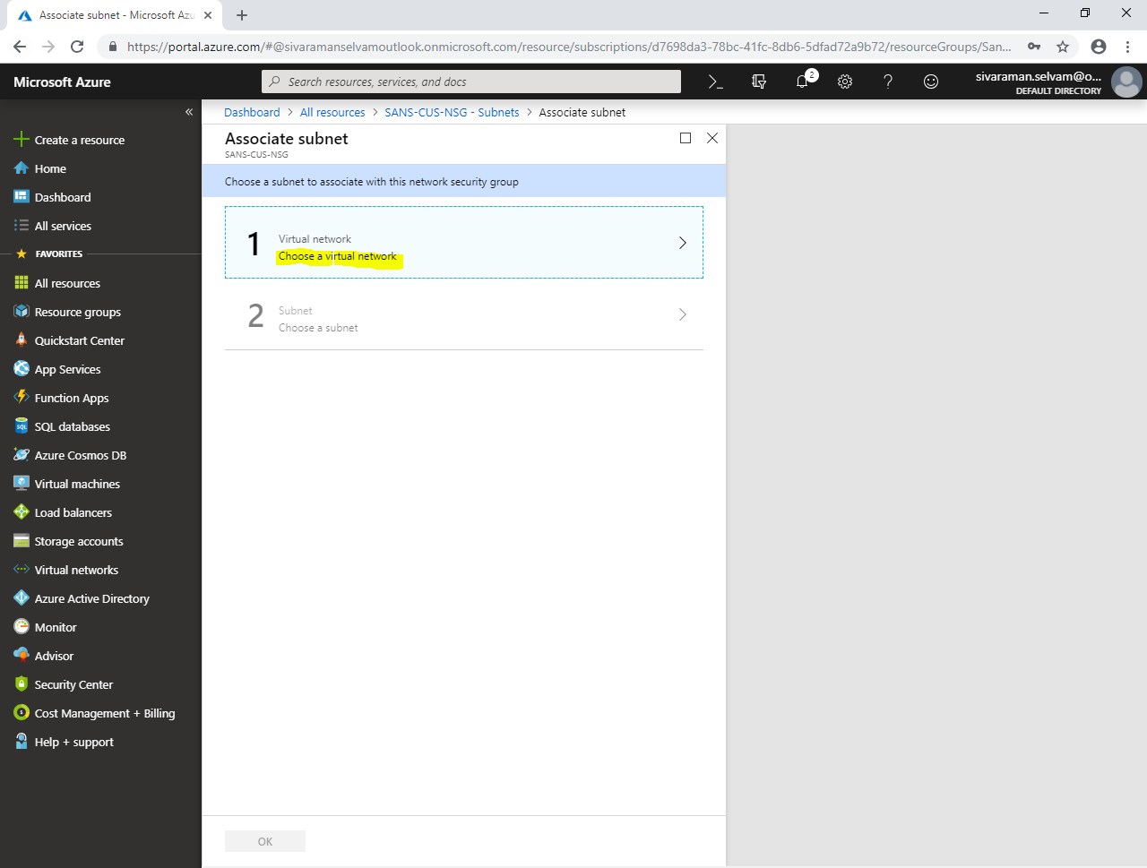

Click on **“SANS-CENTRALUS”** virtual network to select.

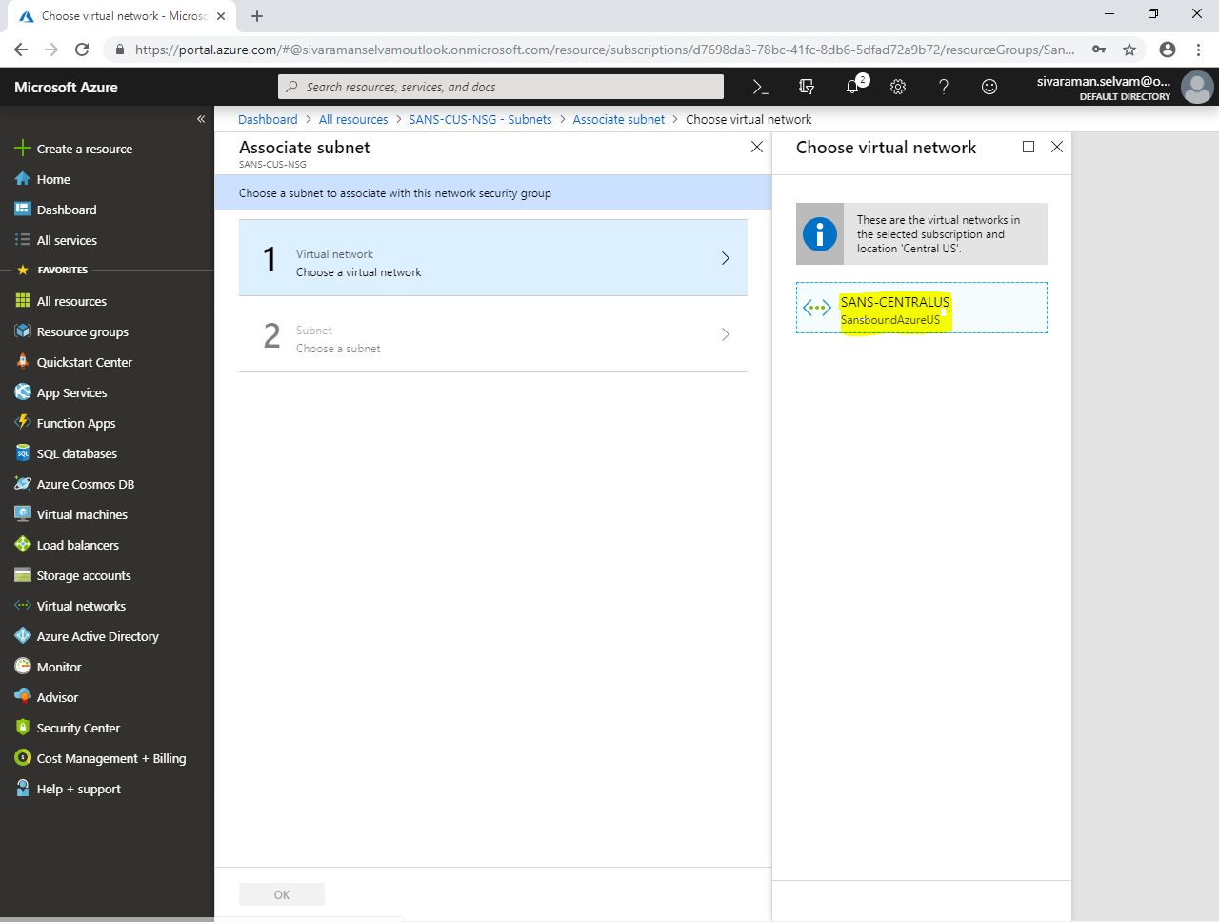

To **“Choose a subnet”** click on **“SANS-CUS-PubSubnet”**.

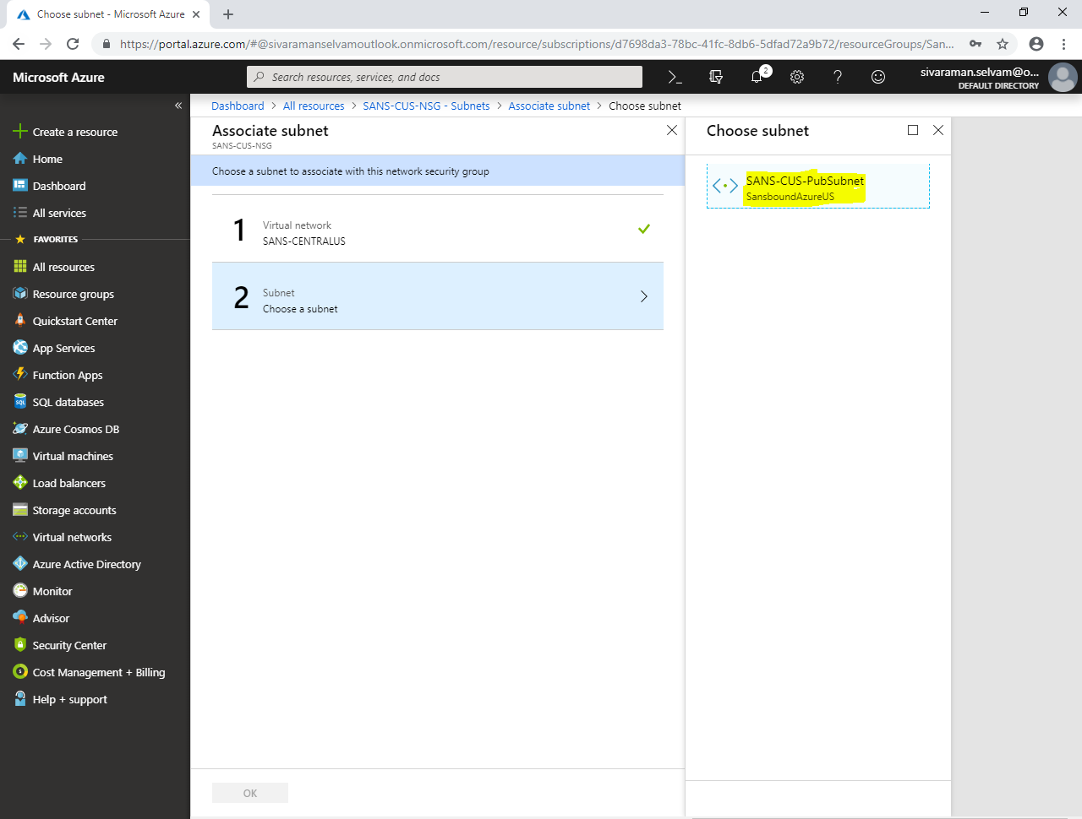

Click **“Ok”**.

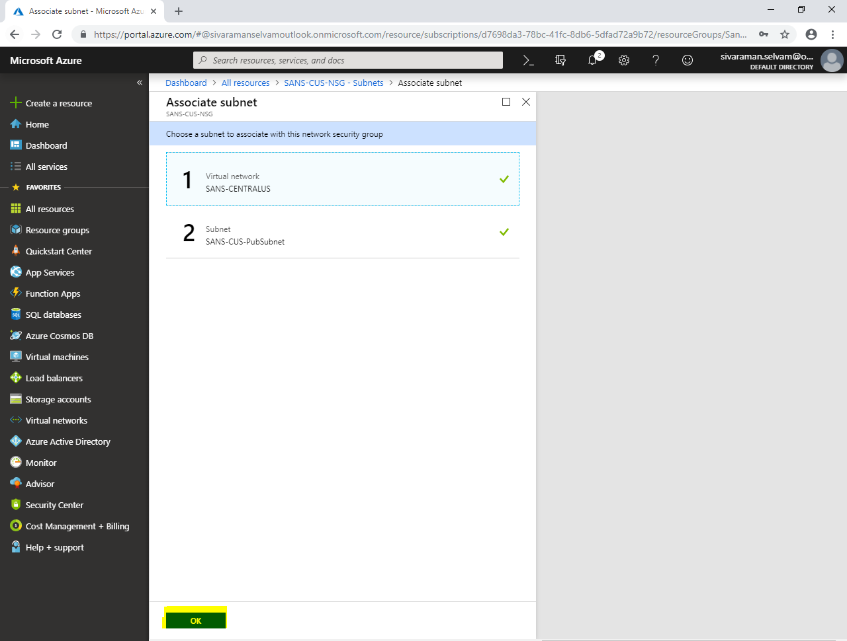

You have successfully associated **“SANS-CUS-PubSubnet”** with **“SANS-CUS-NSG”** network security group.

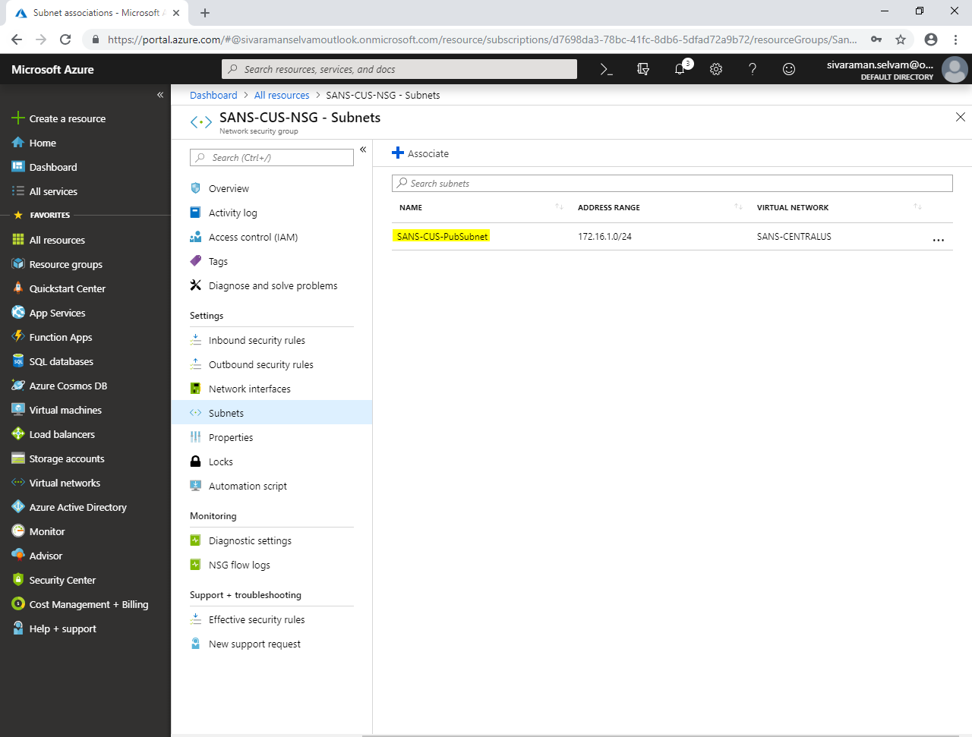

Click **“All resources”**.

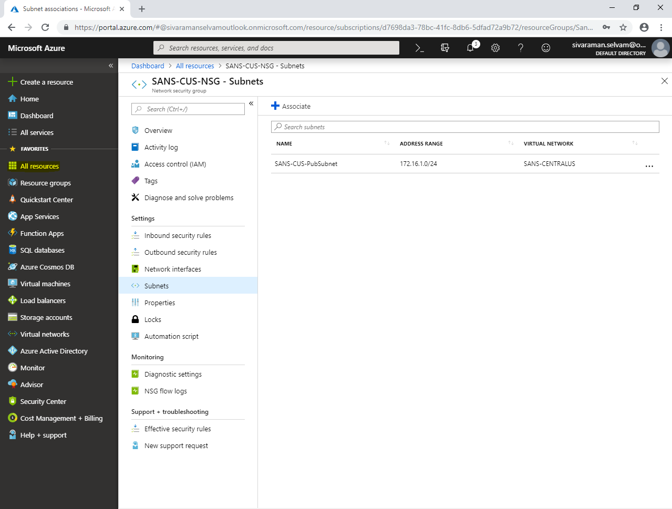

In **“All resources”**,

Click **“SANSVM-WIN-SI”**.

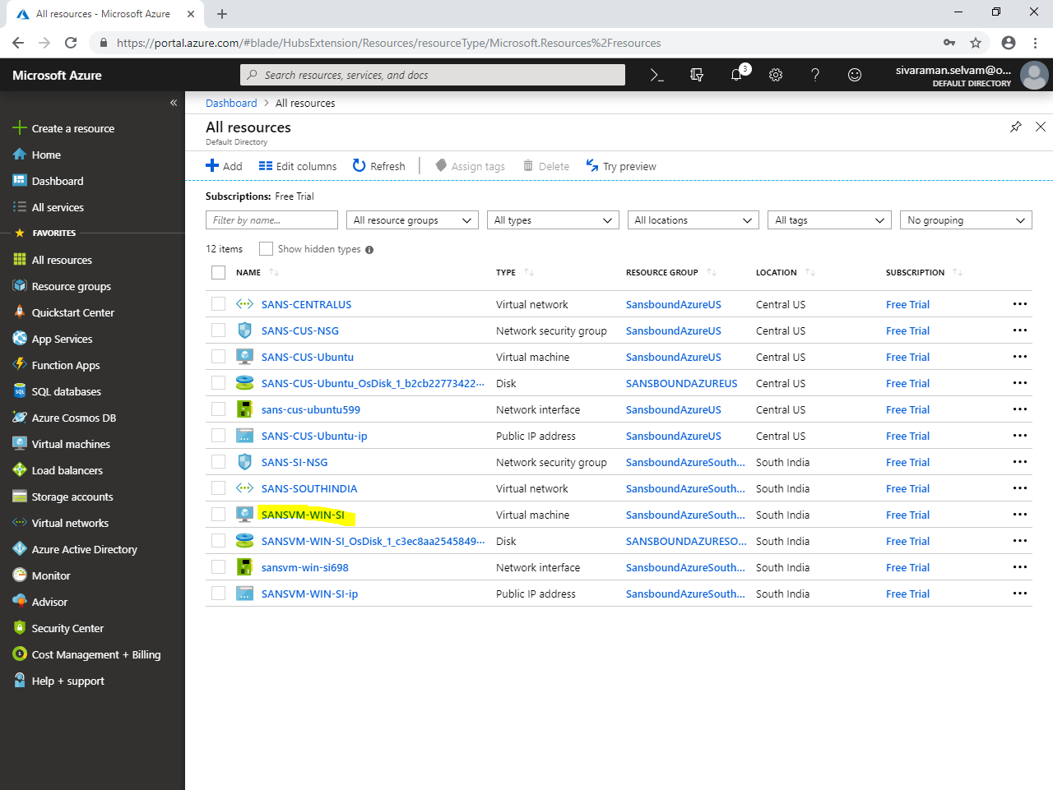

Kindly note the Public IP address of **SANSVM-WIN-SI** virtual machine.

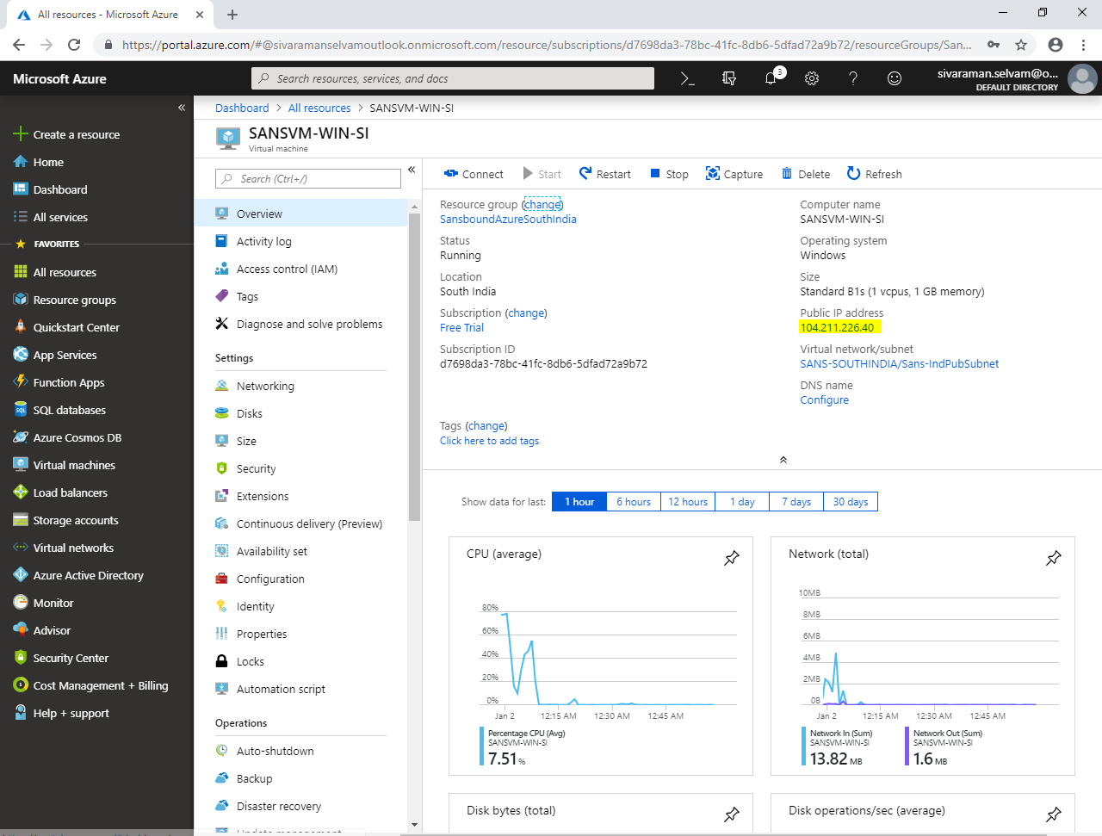

In your local machine, type **“mstsc”** in Run box and press **“Enter”.**

Type the Public IP address of Windows server 2008 R2 which you have got from Azure portal.

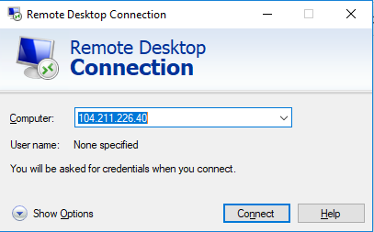

Click **“Connect”**.

Type username and password of the windows server 2008 R2 server.

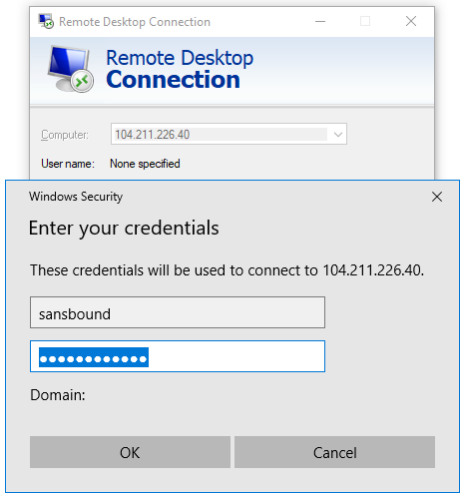

Click **“Ok”**.

Click **“Yes”**.

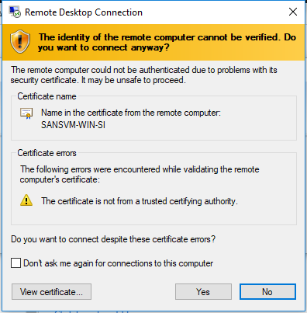

You have successfully logged into Windows 2008 R2 server.

In command prompt, type **“ipconfig”** and press **“Enter”**.

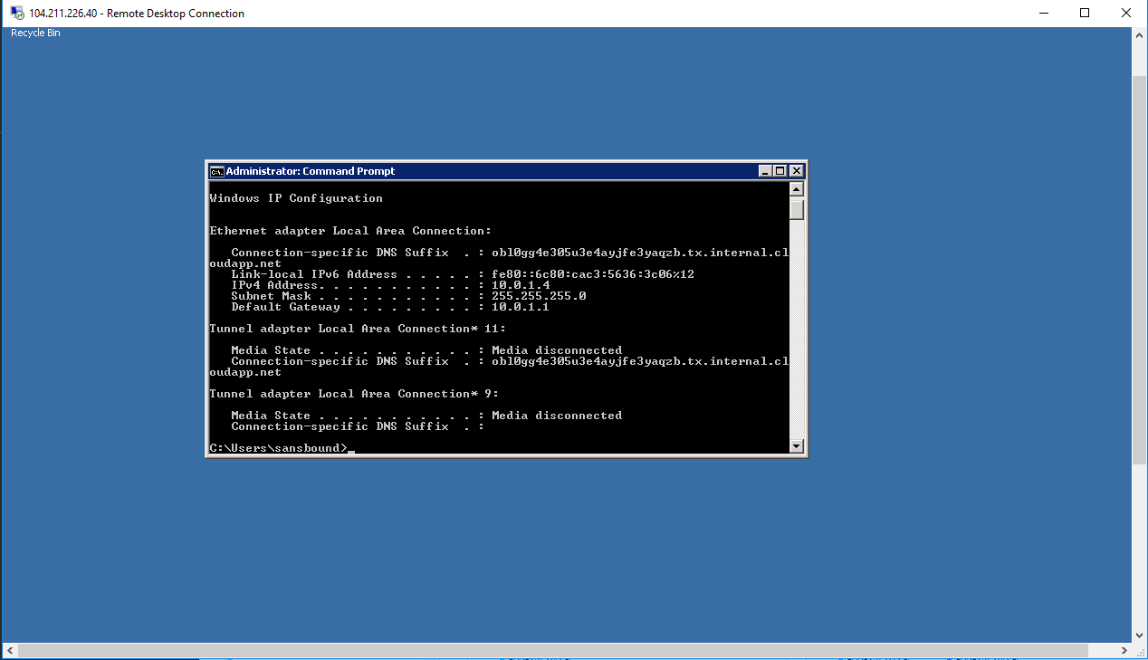

Click **“Virtual machines”** in left side panel.

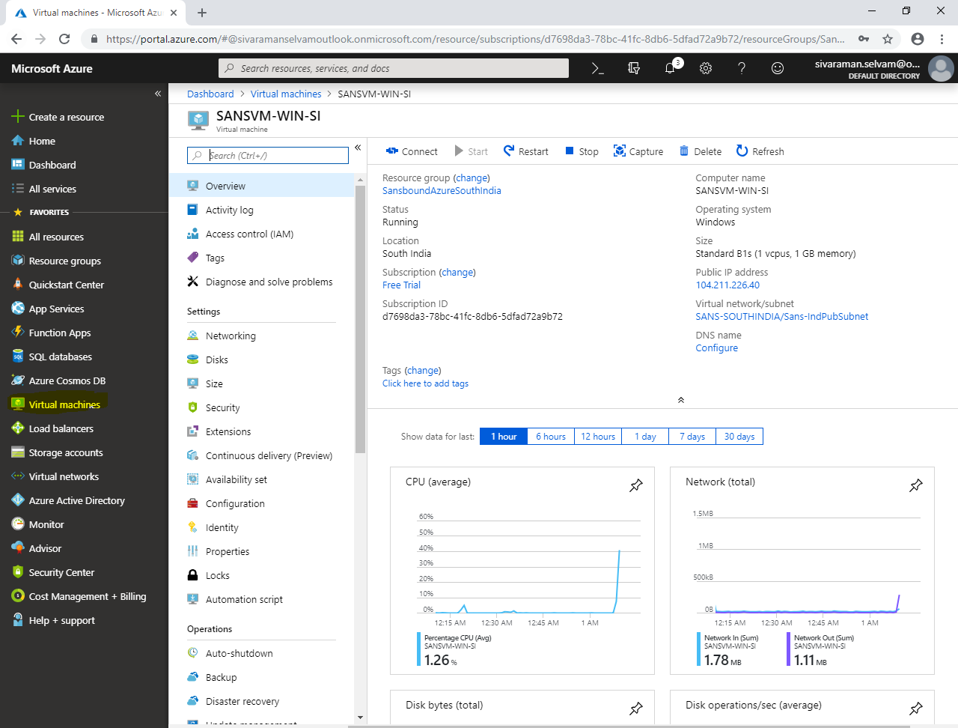

Click virtual machine named **“SANS-CUS-Ubuntu”**.

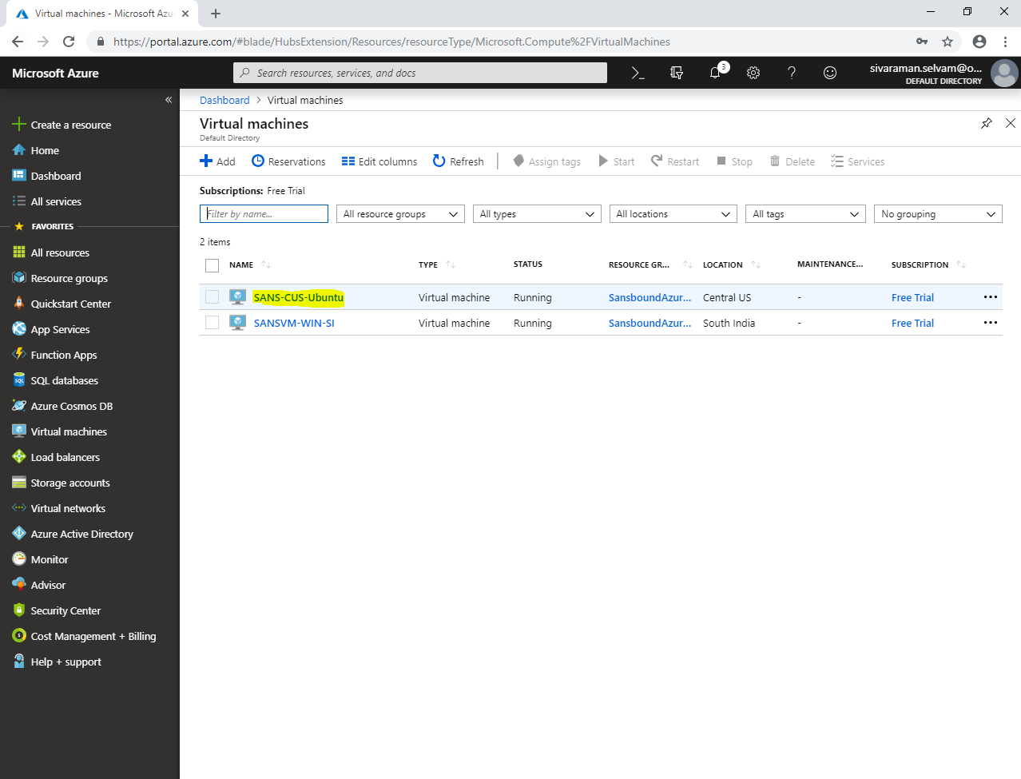

In **“SANS-CUS-Ubuntu”** virtual machine,

Click **“Networking”**.

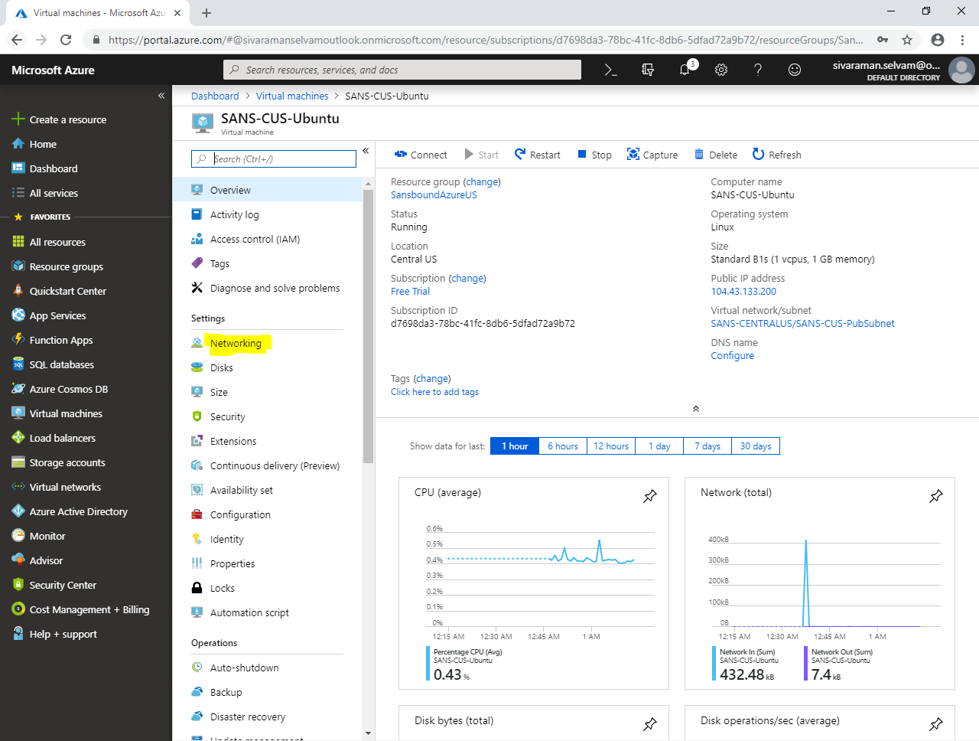

In **“Networking”**,

Kindly note the pubic IP address and private IP address of **SANS-CUS-Ubuntu** virtual machine.

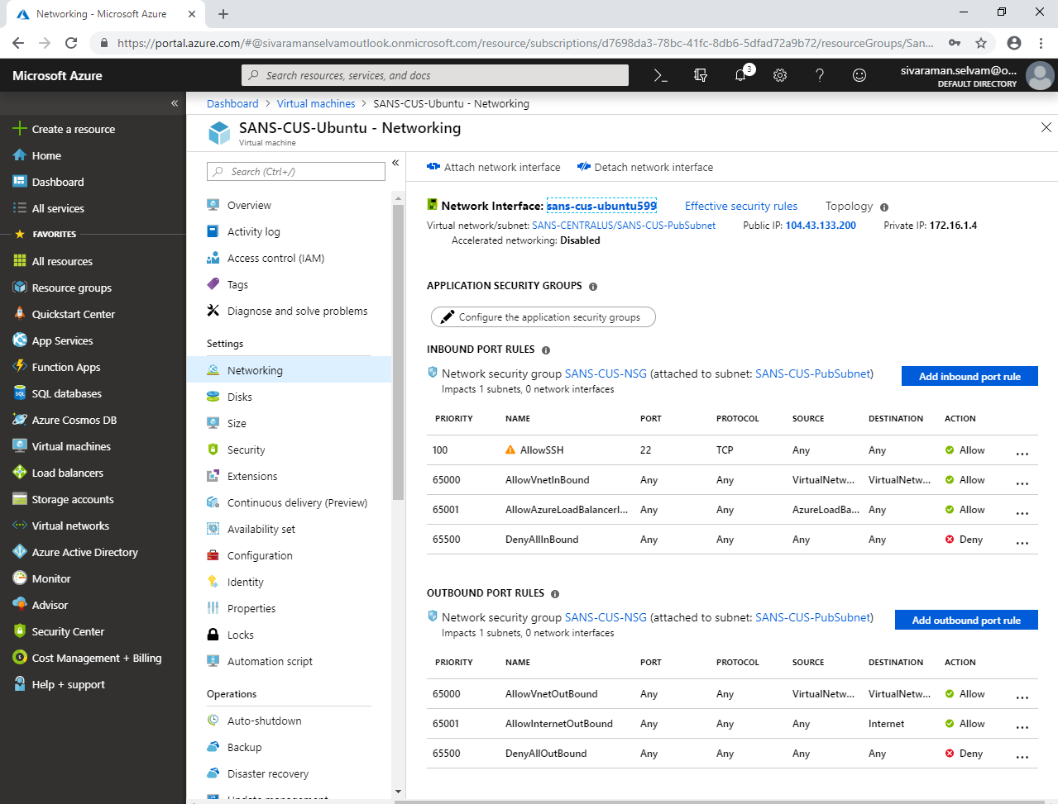

In your local machine, launch putty.exe

Type Public IP address of the Ubuntu and click **“Open”**.

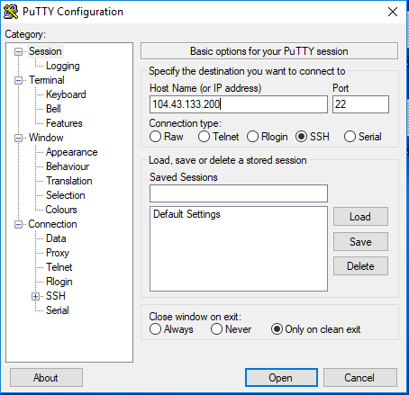

Click **“Yes”**.

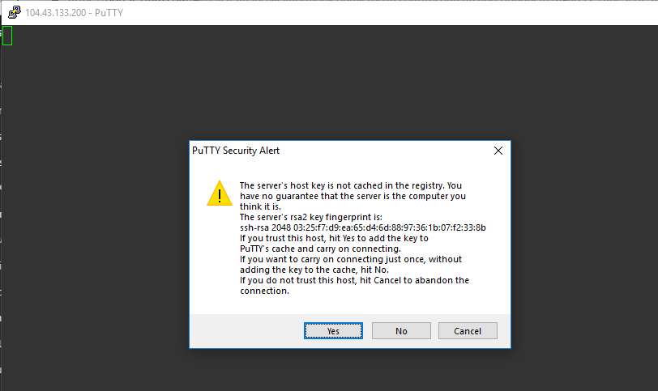

Type **“username”** and press **“Enter”**.

Type **“Password”** and press **“Enter”**.

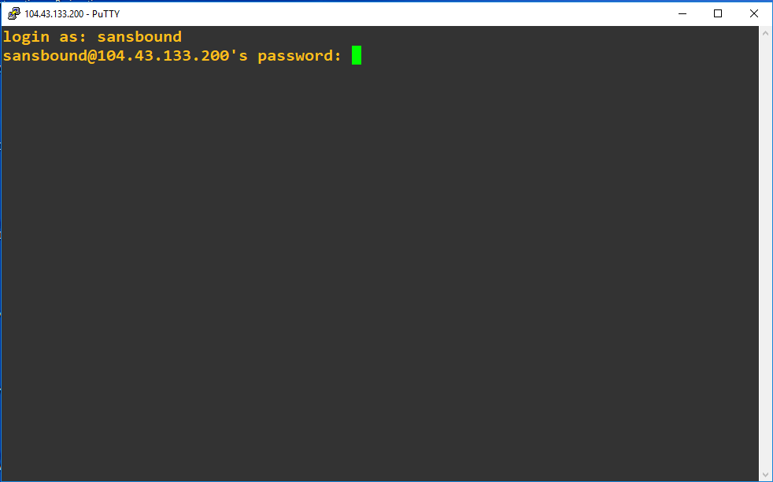

You have logged into Ubuntu successfully.

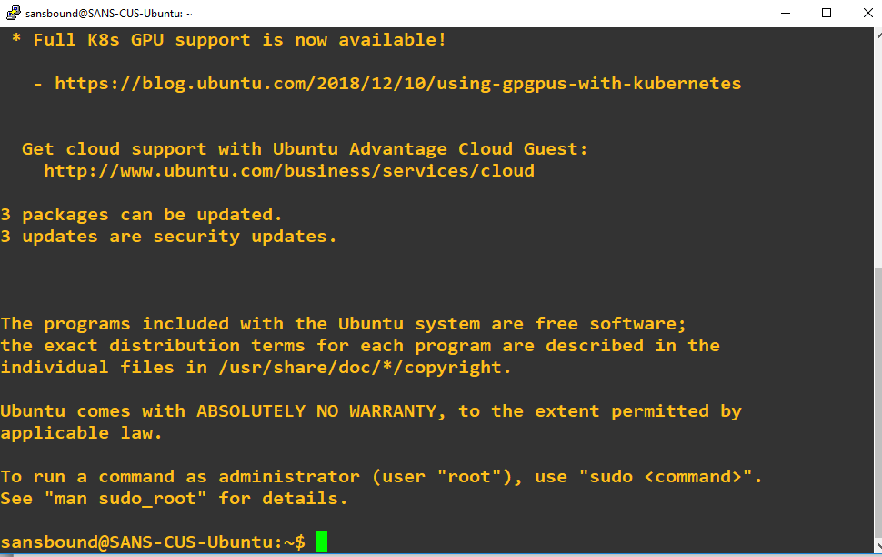

Type **“ifconfig”** and press **“Enter”**.

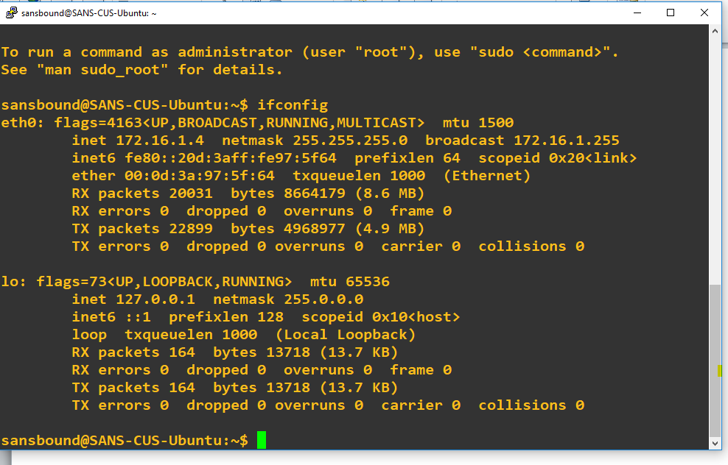

In Ubuntu, type **ping 10.0.1.4** (Windows 2008 R2 server) of **“SANS-SOUTHINDIA”** virtual network in South India region.

But, your Ubuntu virtual machine is running on “Central US” region with **“SANS-CENTRALUS”** virtual network.

**That’s the reason both Virtual networks not communicated with each other. We have required configuring VNET peering on both virtual networks.**

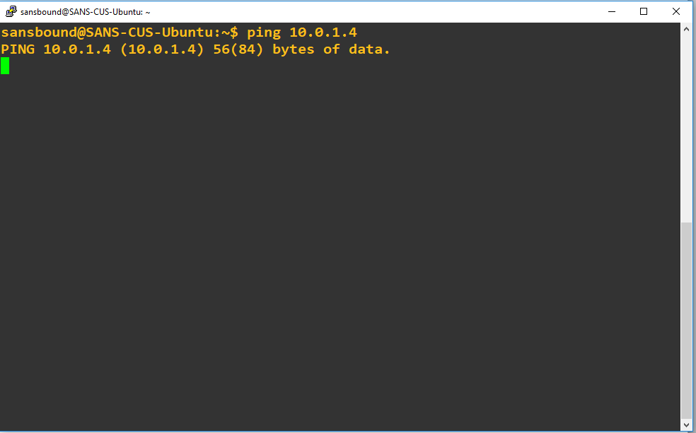

In **“All resources”**,

Click **“SANS-SOUTHINDIA”** virtual network.

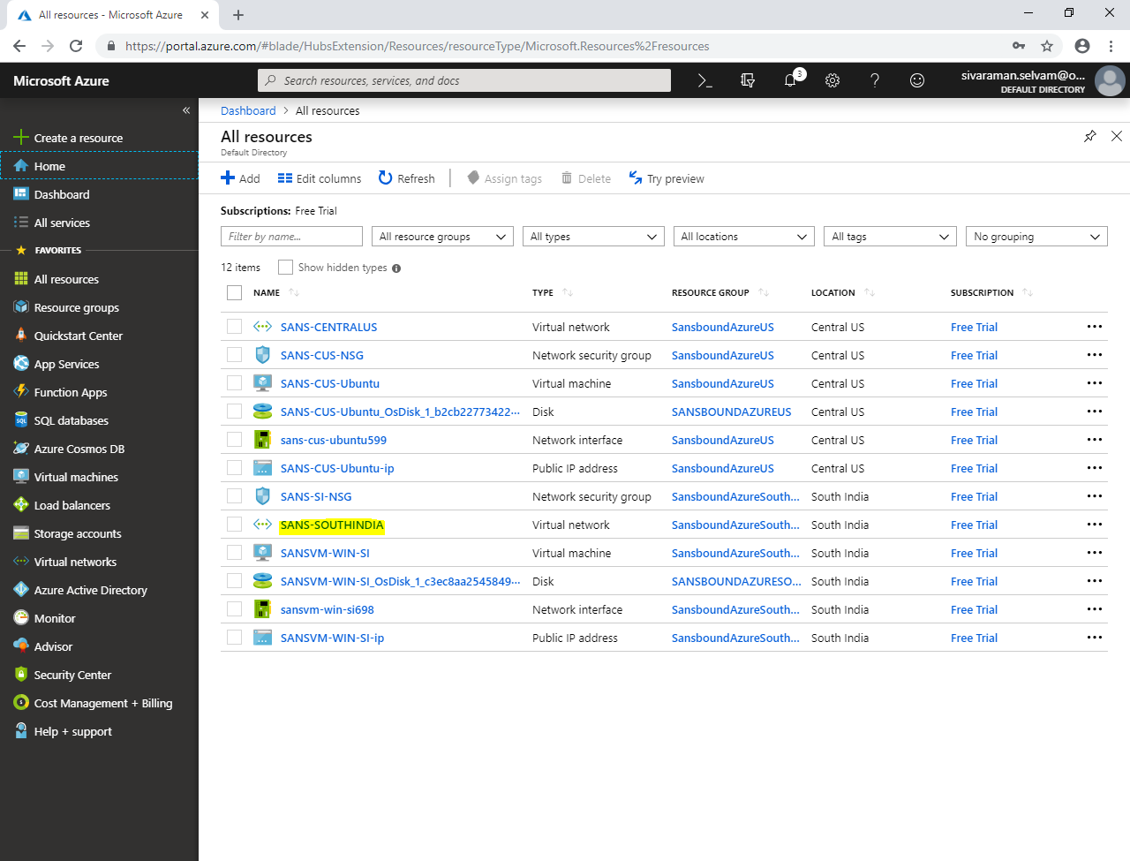

In **“SANS-SOUTHINDIA”** virtual network,

Click **“Peerings”**.

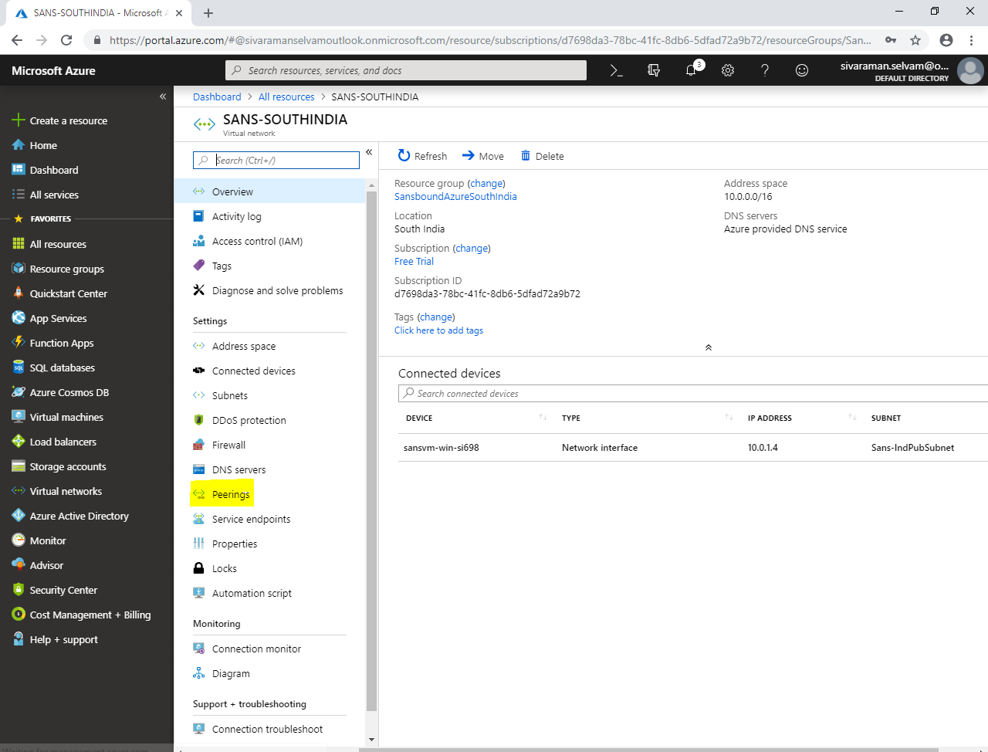

Click **“Add”**.

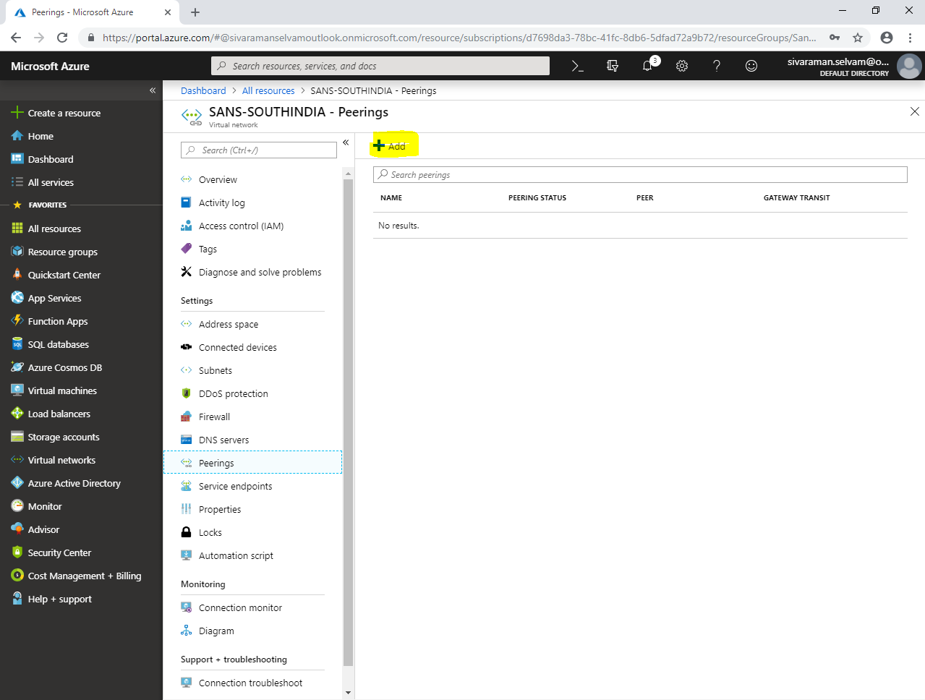

While **“Add peering”**,

Type **“Name”** as **“SANS-IND-US”**.

Click Peer details as **“Resource manager”**.

Select **“Subscription**” as **“Free Trial”**.

Select **“Virtual network”** as **“SANS-CENTRALUS”** (Remote virtual network)

Need to check **“Allow forwarded traffic”**.

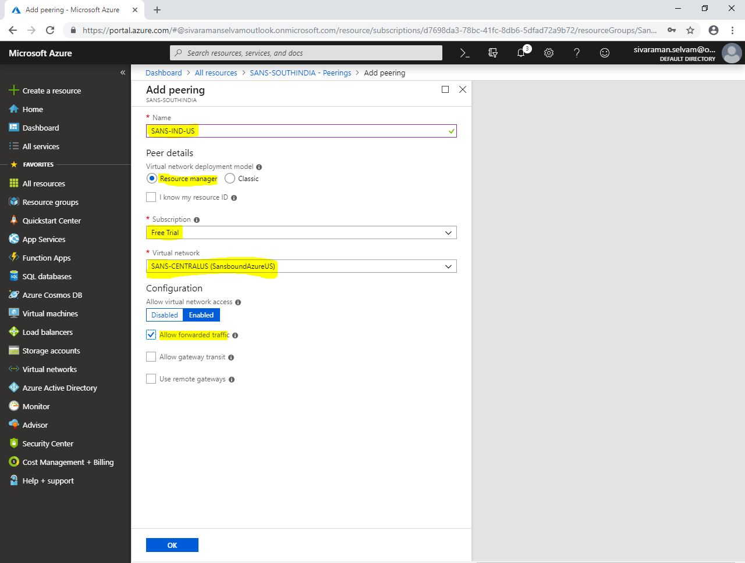

Click **“Ok”**.

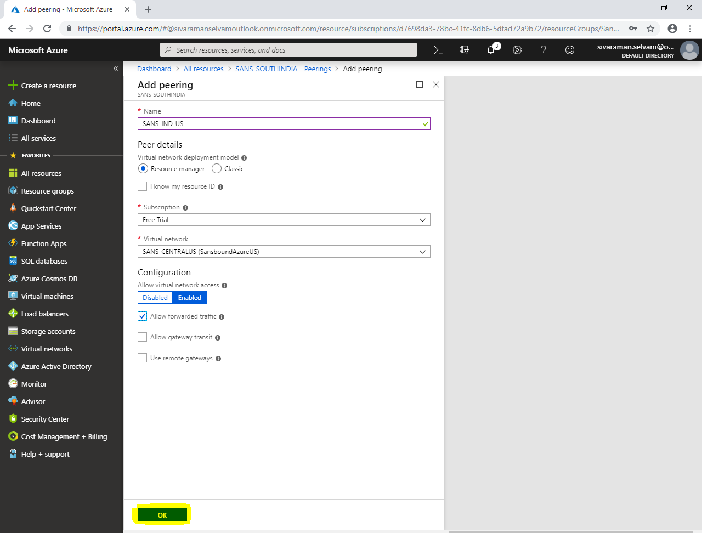

By default you are not able to view the Peering Virtual network details. So click on “Oveview” and click again in “Peerings”.

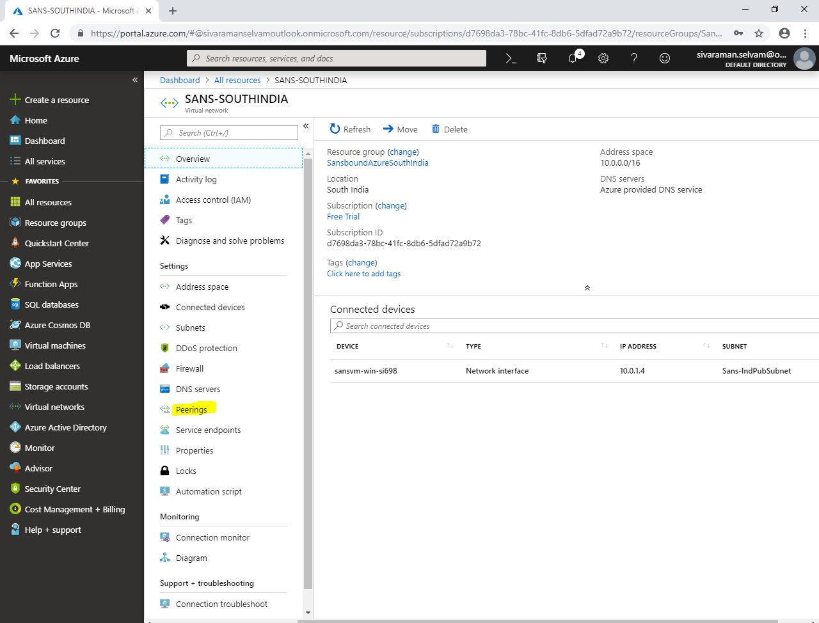

Now you are able to view the Peering details of SANS-SOUTHINDIA virtual network.

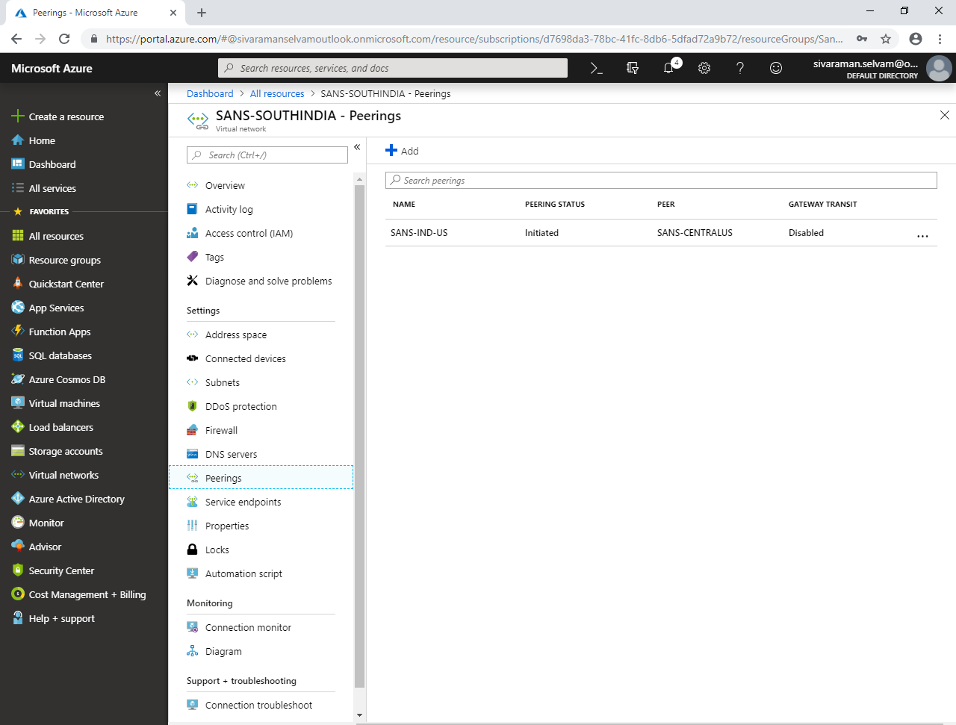

Now, we have required configuring VNET peering in “SANS-CENTRALUS” virtual network.

In **“Virtual networks”**,

Click **“SANS-CENTRALUS”**.

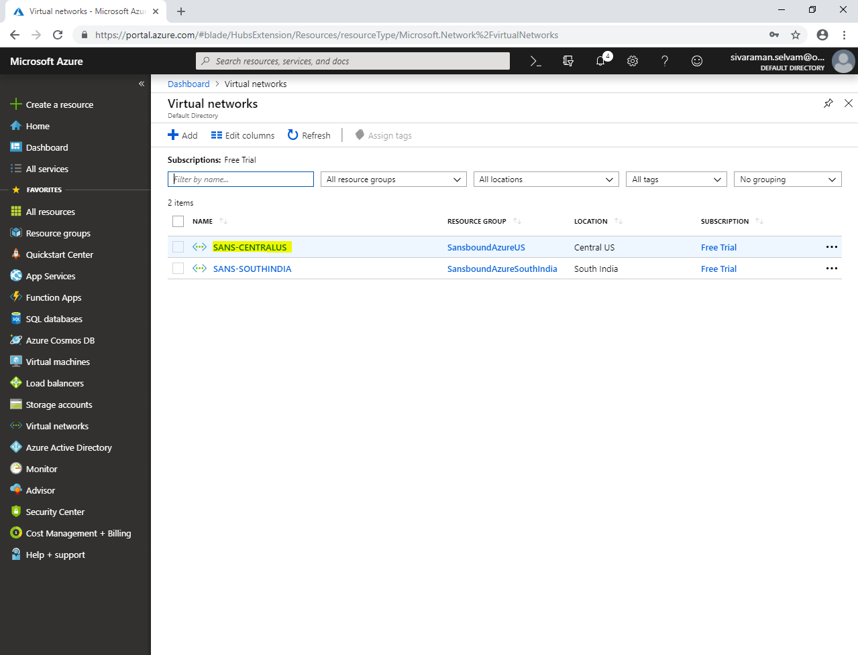

In **“SANS-CENTRALUS”** virtual network,

Click **“Peerings”**.

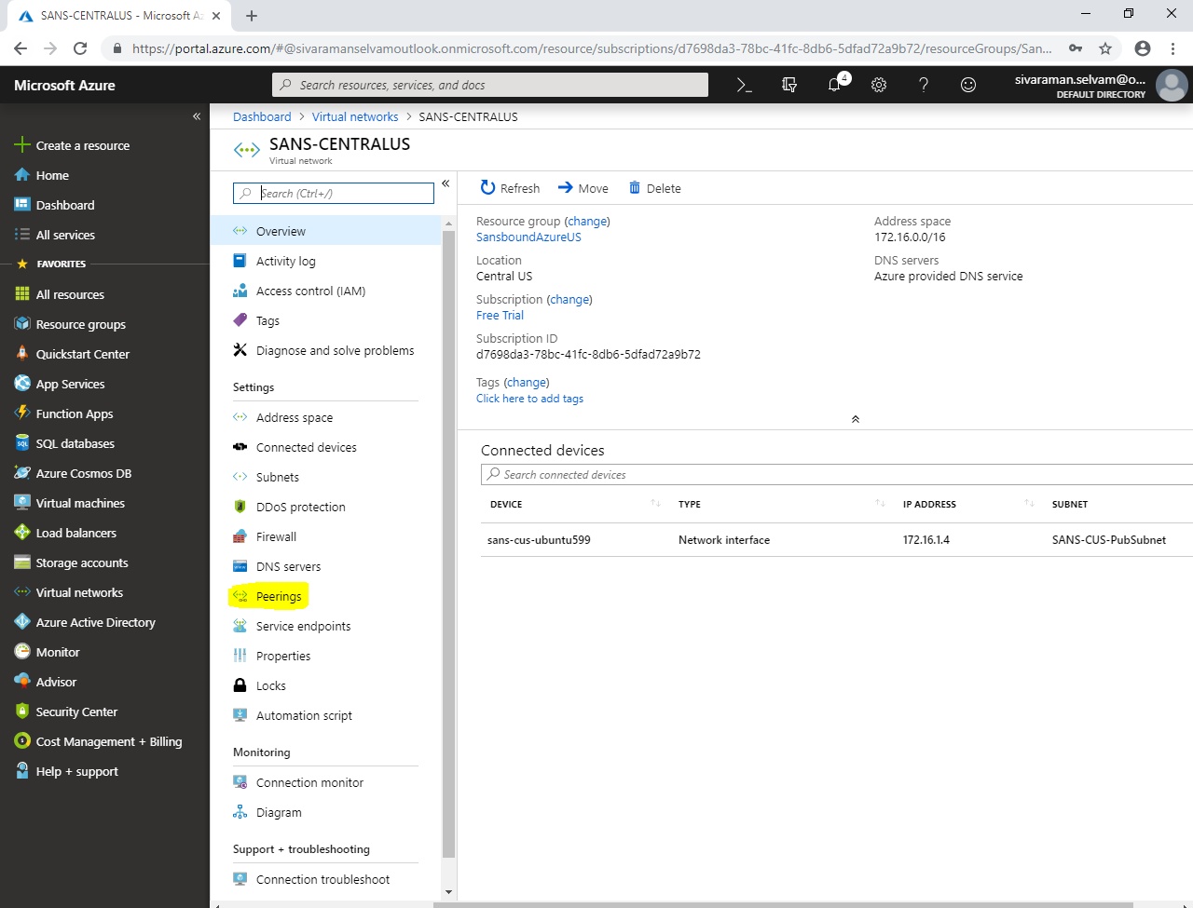

Click **“Add”**.

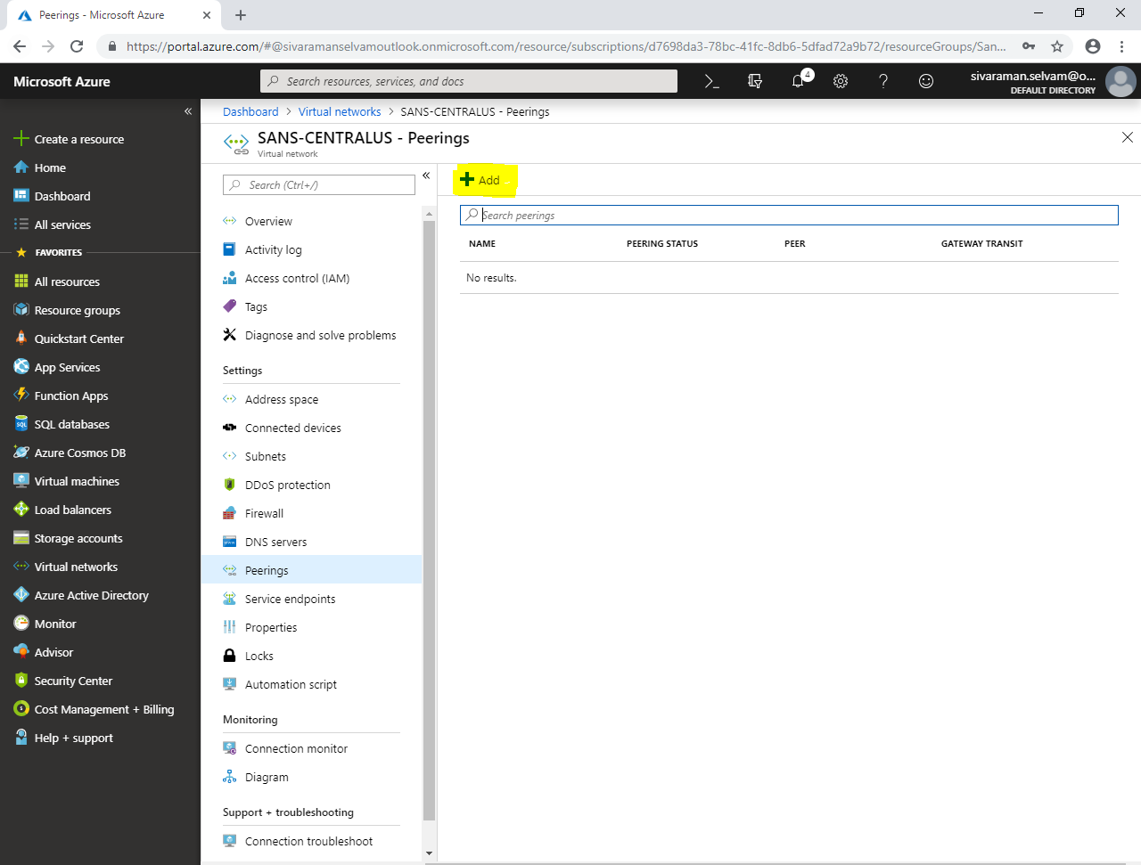

While **“Add peering”**,

Type **“Name”** as **“SANS-US-IND”**.

In **“Virtual network deployment model”** click **“Resource manager”**.

Select **“Subscription”** as **“Free Trial”**.

Select **“Virtual network”** as **“SANS-SOUTHINDIA”** (Remote Virtual network).

Need to Check **“Allow forwarded traffic”**.

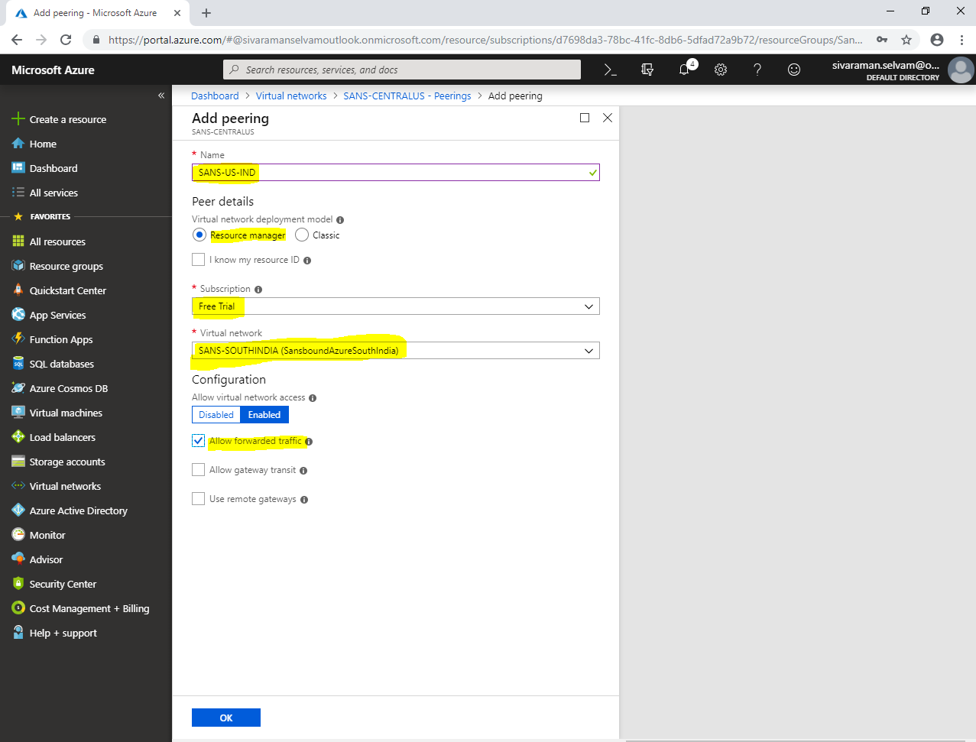

Click **“Ok”**.

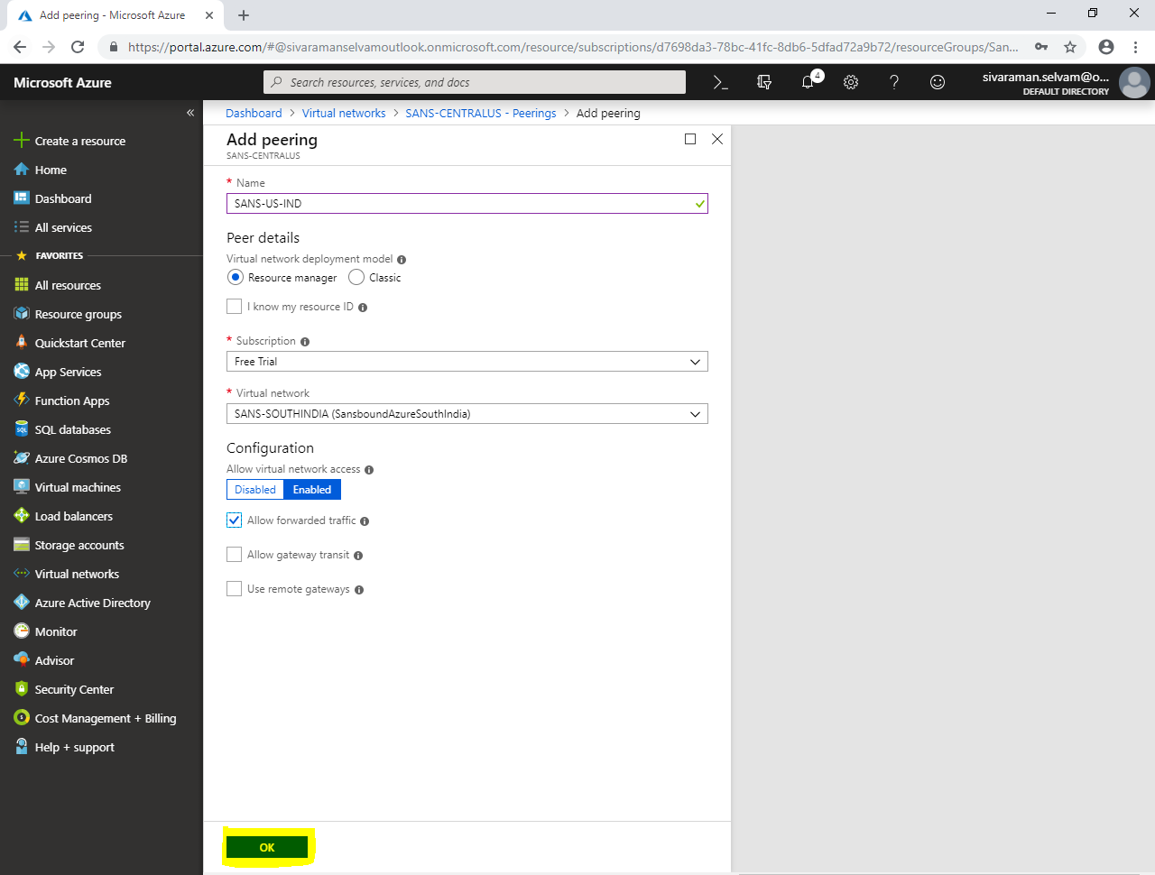

By default you are not able to view peering details in Peerings. You have required clicking any other options like “Overview”.

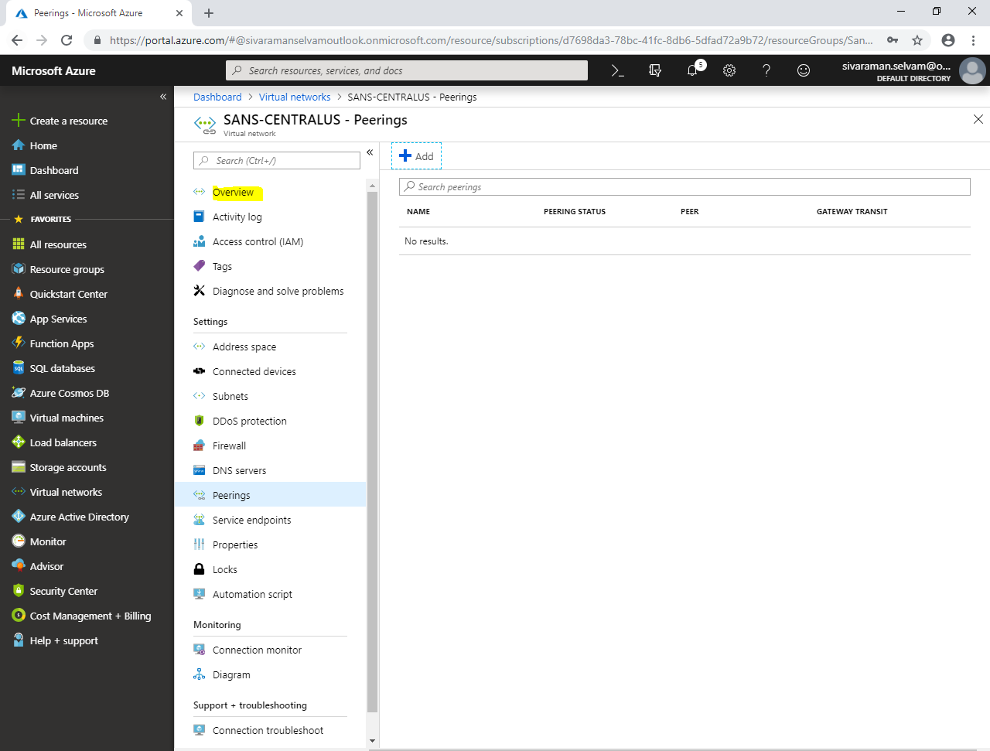

Click **“Peerings”**.

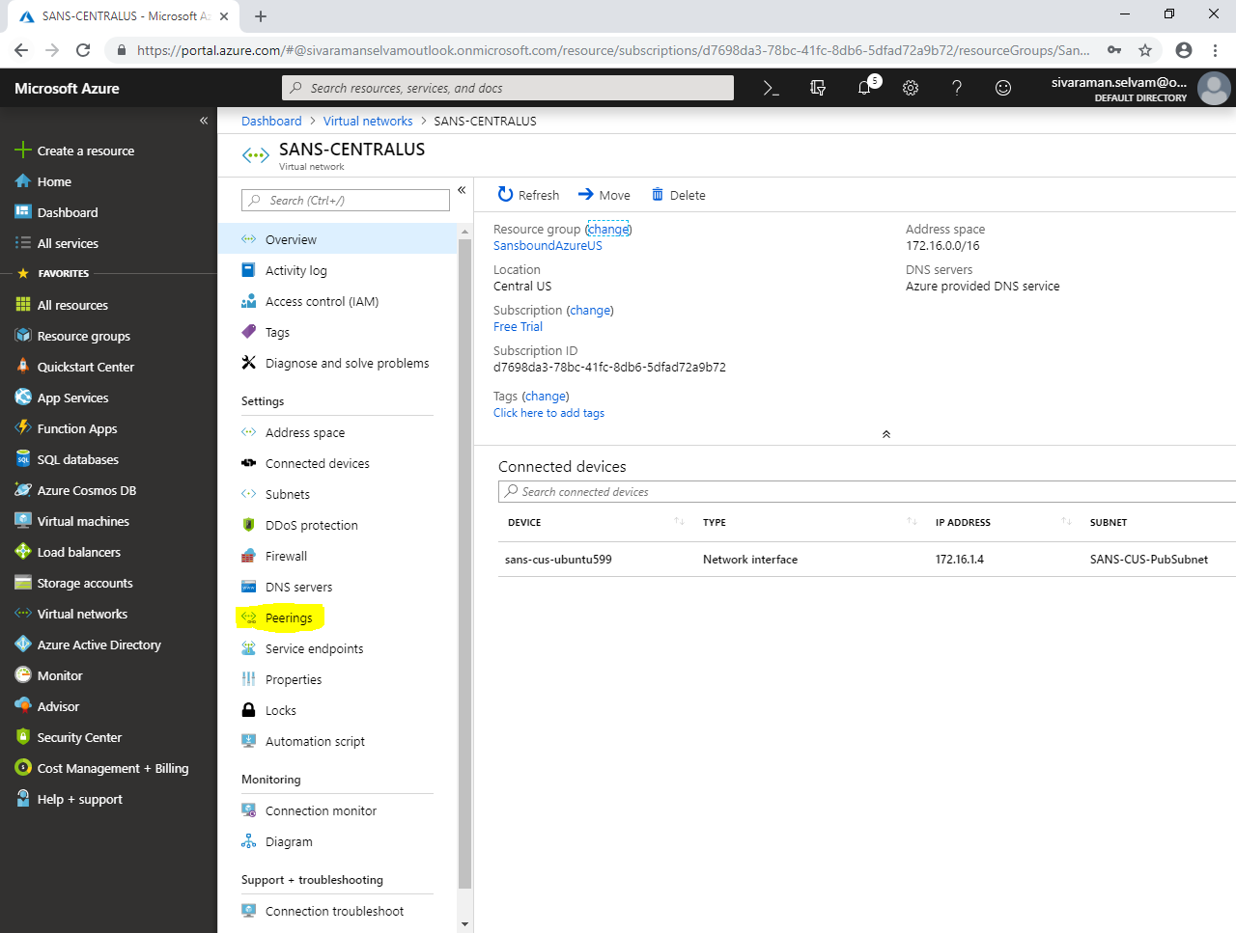

Now you are able to see that you have configured Peerings successfully in **SANS-CENTRALUS** virtual network.

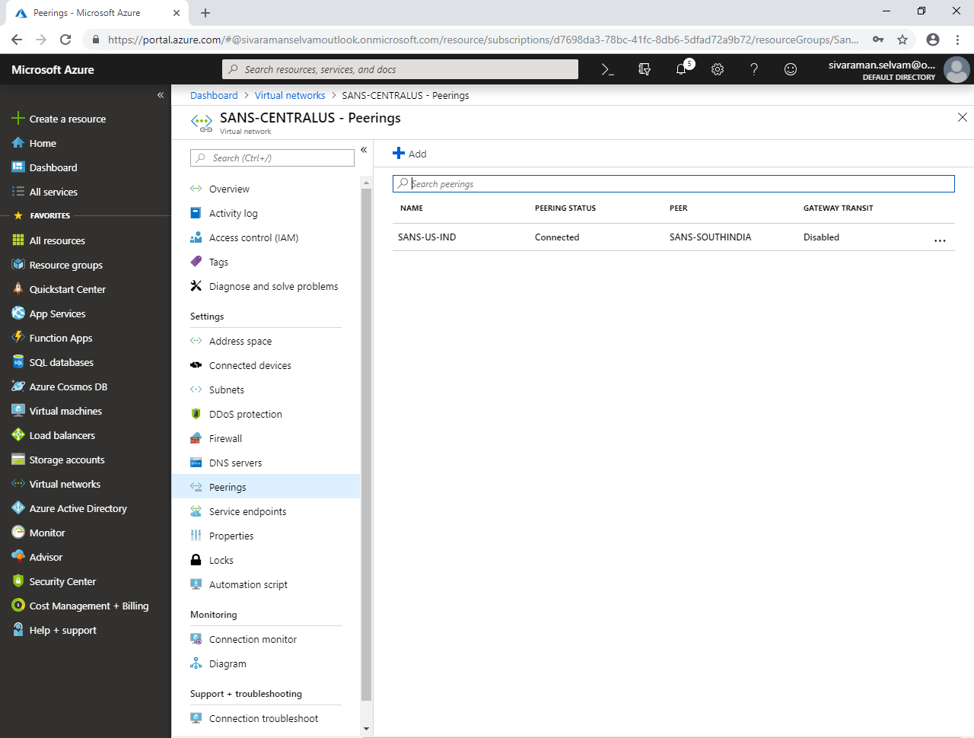

In “Windows 2008 R2 server”,

Type **“firewall.cpl”** in Run box and press **“Enter”**.

Click **“Turn Windows Firewall on or off”**.

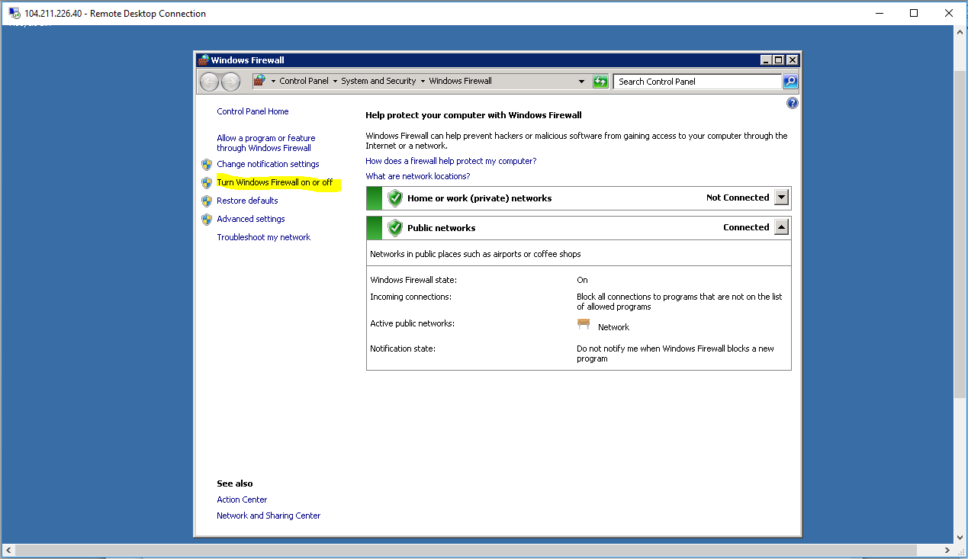

You have required to turn off the windows firewall.

Click **“Ok”**.

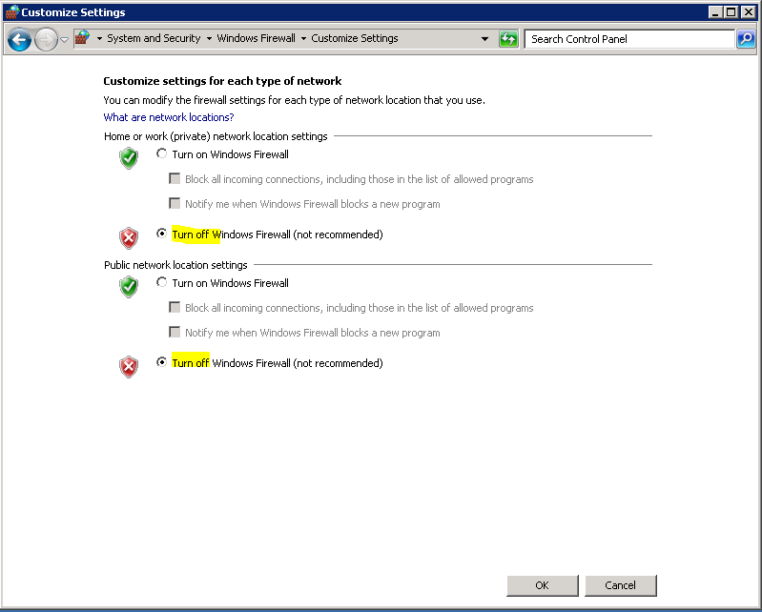

Type Public IP address of the Ubuntu server and click **“Open”**.

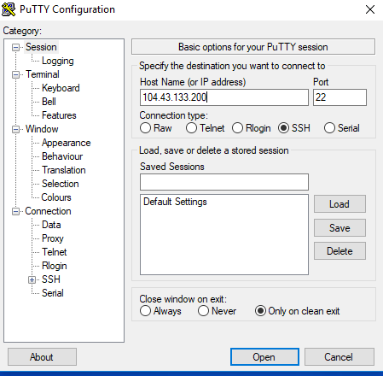

Login to Ubuntu server.

Once you have successfully logged into the Ubuntu,

Type **ping 10.0.1.4** and press **“Enter”**. 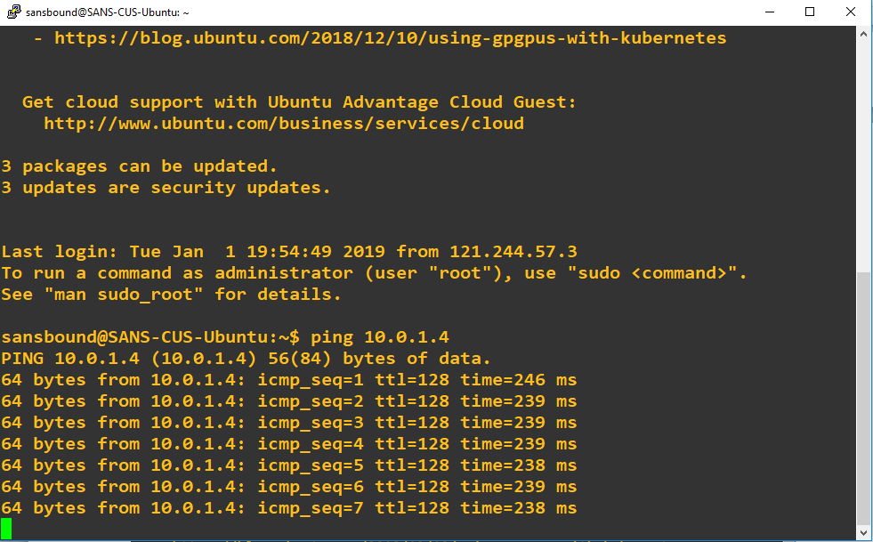

**You have got reply now, because we have configured VNET peering between South India and Central US regions successfully.**